BRCA

Juan Henao

October 17, 2025

Abstract

Text of abstract

# No noise

## Number of nodes

### Single-omics

library(tidyverse)  
library(data.table)  
library(reshape)  
library(ggplot2)  
library(dplyr)  
library(viridis)  
  
#general setup  
dir <- "/workspaces/phd_dissertation/kimono/analysis/data/derived_data/"  
  
#load library  
setwd(dir)  
  
dat_raw <- fread("220411_all_project_info.csv")  
  
#dat_raw <- cbind(dat_raw[,c(1,2,3,16,18)],nodes=dat_raw$V6+dat_raw$V8+dat_raw$V10)  
#dat_raw <- dat_raw[dat_raw$iteration == 1,]  
  
dat_raw$method <- gsub(pattern = "_moran|_mos|_mor|_so|_sor",replacement = "",x = dat_raw$method)  
  
dat <- dat_raw[tolower(dat_raw$method) %in% c("galasso_false","galasso_true","knn_kimono","salasso_false","salasso_true","cocolasso","hmlasso"),]  
  
  
#ggplot(dat, aes(x=clustering, y=n_genes+n_methylation+n_cnv, color=as.factor(method)) )+  
# geom_point(alpha=0.5) + facet_grid(experiment~noise)  
  
#ggplot(dat, aes(y=clustering, x=missingness, color=as.factor(method)) )+  
# geom_point(alpha=0.5) + facet_grid(experiment~noise)  
  
#ggplot(dat, aes(x=missingness, y=clustering,fill=as.factor(method)))+  
# scale_y_continuous(trans='sqrt') + geom_boxplot() + facet_grid(experiment~noise)  
  
  
dat$method <- as.factor(dat$method)   
dat <- dat %>% mutate(method = fct_relevel(method, "knn_kimono", "galasso_false" ,"galasso_true" , "salasso_false" , "salasso_true" ,"cocolasso", "hmlasso" ))  
dat$experiment <- as.factor(dat$experiment)  
dat <- dat %>% mutate(experiment = fct_relevel(experiment, "so", "moran" ,"mos" , "sor" , "mor"))  
  
palette_OkabeIto <- c( "#CC79A7", "#D55E00", "#E69F00","#0072B2", "#56B4E9", "#009E73", "#F0E442")  
  
dat <- aggregate(dat[, -c(1:8)], list('noise'=dat$noise,  
 'missingness'=dat$missingness,  
 'method'=dat$method,  
 'experiment'=dat$experiment), function(x){mean(x,na.rm=TRUE)})  
  
dat_raw$method <- as.factor(dat_raw$method)   
dat_raw <- dat_raw %>% mutate(method = fct_relevel(method, "knn_kimono", "galasso_false" ,"galasso_true" , "salasso_false" , "salasso_true" ,"cocolasso", "hmlasso" ))  
dat_raw$experiment <- as.factor(dat_raw$experiment)  
dat_raw <- dat_raw %>% mutate(experiment = fct_relevel(experiment, "so", "moran" ,"mos" , "sor" , "mor"))  
  
dat_raw <- dat_raw[ dat_raw$noise==0 & dat_raw$experiment %in% 'so' & !dat_raw$method %in% "bdcoco_lasso",]  
dat <- dat[ dat$noise==0 & dat$experiment %in% 'so' & !dat$method %in% "bdcoco_lasso",]  
  
dat_raw$adaptive <- grepl(pattern = "true",x = dat_raw$method)  
dat$adaptive <- grepl(pattern = "true",x = dat$method)  
  
p <- ggplot(dat_raw,   
 aes(y= (n_cnv+n_genes+n_methylation), x=missingness,color=as.factor(method)))+  
   
 geom_line(aes( group = interaction(method, iteration),linetype=adaptive),alpha = 0.2)+  
 facet_grid(noise~experiment, scales="free")+  
 scale_color_manual(values = palette_OkabeIto)+  
 scale_fill_manual(values = palette_OkabeIto)+   
 theme_light() +  
 theme(legend.position="bottom",  
 axis.text.x = element_text(size = 8),  
 axis.text.y = element_text(size = 8),  
 strip.background = element_blank(),   
 plot.margin = unit(c(-0.5, -0.5, 0, 0), "cm")  
 ) +  
 ylab("#Nodes")   
  
to.plot1 <- p + geom_line(data = dat,   
 aes(y= (n_cnv+n_genes+n_methylation), x=missingness, color=as.factor(method),linetype=adaptive)) +   
 theme(strip.background = element_blank(), panel.grid.minor = element_blank(),  
 legend.position = "none",  
 axis.title.x=element_blank(),  
 #axis.text.x=element_blank(),  
 #axis.ticks.x=element_blank(),  
 axis.title.y=element_blank(),  
 #axis.text.y=element_blank(),  
 #axis.ticks.y=element_blank(),   
 plot.margin = unit(c(-0.5, -0.5, 0, 0), "cm")  
 )  
  
to.plot1

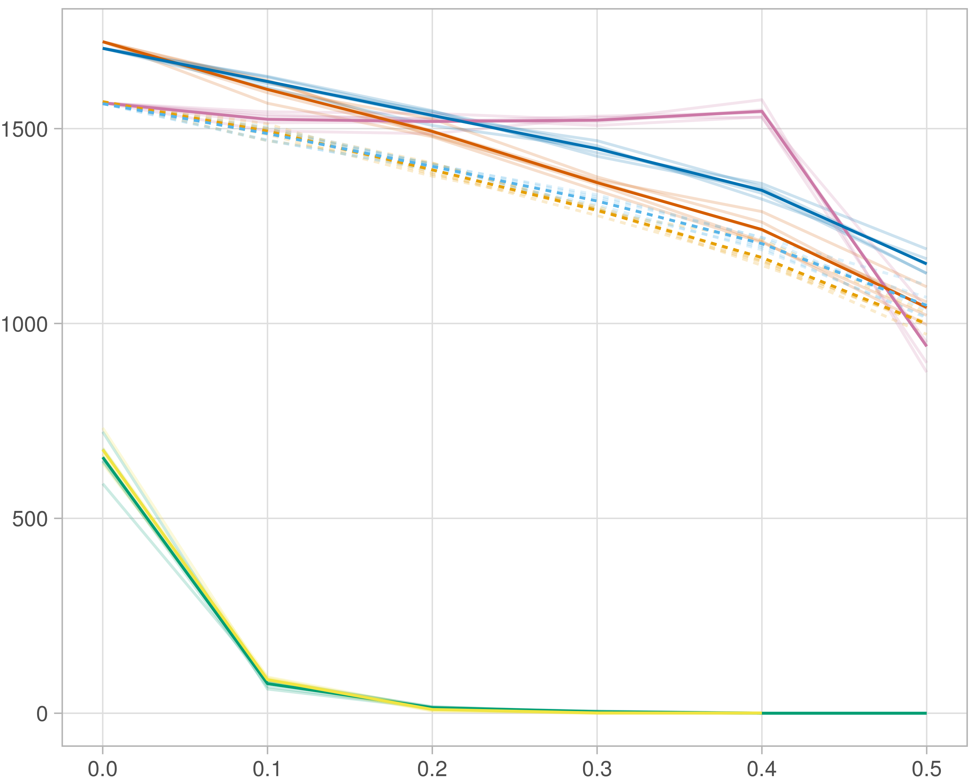

### Multi-omics

#general setup  
dir <- "/workspaces/phd_dissertation/kimono/analysis/data/derived_data/"  
  
#load library  
setwd(dir)  
  
dat_raw <- fread("220411_all_project_info.csv")  
  
#dat_raw <- cbind(dat_raw[,c(1,2,3,16,18)],nodes=dat_raw$V6+dat_raw$V8+dat_raw$V10)  
#dat_raw <- dat_raw[dat_raw$iteration == 1,]  
  
dat_raw$method <- gsub(pattern = "_moran|_mos|_mor|_so|_sor",replacement = "",x = dat_raw$method)  
  
dat <- dat_raw[tolower(dat_raw$method) %in% c("galasso_false","galasso_true","knn_kimono","salasso_false","salasso_true","cocolasso","hmlasso"),]  
  
  
#ggplot(dat, aes(x=clustering, y=n_genes+n_methylation+n_cnv, color=as.factor(method)) )+  
# geom_point(alpha=0.5) + facet_grid(experiment~noise)  
  
#ggplot(dat, aes(y=clustering, x=missingness, color=as.factor(method)) )+  
# geom_point(alpha=0.5) + facet_grid(experiment~noise)  
  
#ggplot(dat, aes(x=missingness, y=clustering,fill=as.factor(method)))+  
# scale_y_continuous(trans='sqrt') + geom_boxplot() + facet_grid(experiment~noise)  
  
  
dat$method <- as.factor(dat$method)   
dat <- dat %>% mutate(method = fct_relevel(method, "knn_kimono", "galasso_false" ,"galasso_true" , "salasso_false" , "salasso_true" ,"cocolasso", "hmlasso" ))  
dat$experiment <- as.factor(dat$experiment)  
dat <- dat %>% mutate(experiment = fct_relevel(experiment, "so", "moran" ,"mos" , "sor" , "mor"))  
  
palette_OkabeIto <- c( "#CC79A7", "#D55E00", "#E69F00","#0072B2", "#56B4E9", "#009E73", "#F0E442")  
  
dat <- aggregate(dat[, -c(1:8)], list('noise'=dat$noise,  
 'missingness'=dat$missingness,  
 'method'=dat$method,  
 'experiment'=dat$experiment), function(x){mean(x,na.rm=TRUE)})  
  
dat_raw$method <- as.factor(dat_raw$method)   
dat_raw <- dat_raw %>% mutate(method = fct_relevel(method, "knn_kimono", "galasso_false" ,"galasso_true" , "salasso_false" , "salasso_true" ,"cocolasso", "hmlasso" ))  
dat_raw$experiment <- as.factor(dat_raw$experiment)  
dat_raw <- dat_raw %>% mutate(experiment = fct_relevel(experiment, "so", "moran" ,"mos" , "sor" , "mor"))  
  
dat_raw <- dat_raw[ dat_raw$noise==0 & dat_raw$experiment %in% 'moran' & !dat_raw$method %in% "bdcoco_lasso",]  
dat <- dat[ dat$noise==0 & dat$experiment %in% 'moran' & !dat$method %in% "bdcoco_lasso",]  
  
dat_raw$adaptive <- grepl(pattern = "true",x = dat_raw$method)  
dat$adaptive <- grepl(pattern = "true",x = dat$method)  
  
p <- ggplot(dat_raw,   
 aes(y= (n_cnv+n_genes+n_methylation), x=missingness,color=as.factor(method)))+  
   
 geom_line(aes( group = interaction(method, iteration),linetype=adaptive),alpha = 0.2)+  
 facet_grid(noise~experiment, scales="free")+  
 scale_color_manual(values = palette_OkabeIto)+  
 scale_fill_manual(values = palette_OkabeIto)+   
 theme_light() +  
 theme(legend.position="bottom",  
 axis.text.x = element_text(size = 8),  
 axis.text.y = element_text(size = 8),  
 strip.background = element_blank(),   
 plot.margin = unit(c(-0.5, -0.5, 0, 0), "cm")  
 ) +  
 ylab("#Nodes")   
  
to.plot1 <- p + geom_line(data = dat,   
 aes(y= (n_cnv+n_genes+n_methylation), x=missingness, color=as.factor(method),linetype=adaptive)) +   
 theme(strip.background = element_blank(), panel.grid.minor = element_blank(),  
 legend.position = "none",  
 axis.title.x=element_blank(),  
 #axis.text.x=element_blank(),  
 #axis.ticks.x=element_blank(),  
 axis.title.y=element_blank(),  
 #axis.text.y=element_blank(),  
 #axis.ticks.y=element_blank(),   
 plot.margin = unit(c(-0.5, -0.5, 0, 0), "cm")  
 )  
  
to.plot1

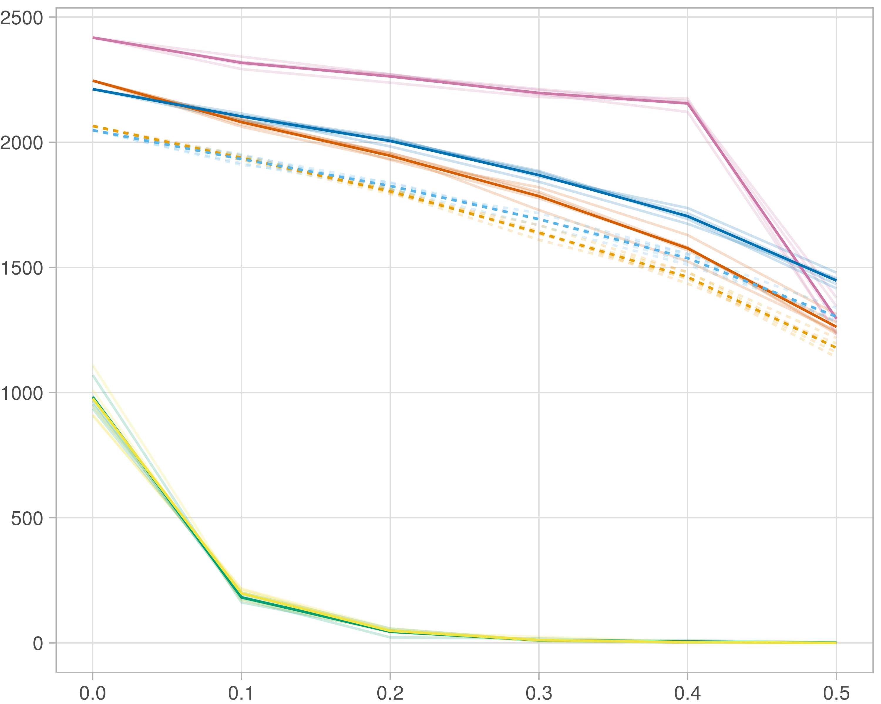

### Block-wise

#general setup  
dir <- "/workspaces/phd_dissertation/kimono/analysis/data/derived_data/"  
  
#load library  
setwd(dir)  
  
dat_raw <- fread("220411_all_project_info.csv")  
  
#dat_raw <- cbind(dat_raw[,c(1,2,3,16,18)],nodes=dat_raw$V6+dat_raw$V8+dat_raw$V10)  
#dat_raw <- dat_raw[dat_raw$iteration == 1,]  
  
dat_raw$method <- gsub(pattern = "_moran|_mos|_mor|_so|_sor",replacement = "",x = dat_raw$method)  
  
dat <- dat_raw[tolower(dat_raw$method) %in% c("galasso_false","galasso_true","knn_kimono","salasso_false","salasso_true","cocolasso","hmlasso"),]  
  
  
#ggplot(dat, aes(x=clustering, y=n_genes+n_methylation+n_cnv, color=as.factor(method)) )+  
# geom_point(alpha=0.5) + facet_grid(experiment~noise)  
  
#ggplot(dat, aes(y=clustering, x=missingness, color=as.factor(method)) )+  
# geom_point(alpha=0.5) + facet_grid(experiment~noise)  
  
#ggplot(dat, aes(x=missingness, y=clustering,fill=as.factor(method)))+  
# scale_y_continuous(trans='sqrt') + geom_boxplot() + facet_grid(experiment~noise)  
  
  
dat$method <- as.factor(dat$method)   
dat <- dat %>% mutate(method = fct_relevel(method, "knn_kimono", "galasso_false" ,"galasso_true" , "salasso_false" , "salasso_true" ,"cocolasso", "hmlasso" ))  
dat$experiment <- as.factor(dat$experiment)  
dat <- dat %>% mutate(experiment = fct_relevel(experiment, "so", "moran" ,"mos" , "sor" , "mor"))  
  
palette_OkabeIto <- c( "#CC79A7", "#D55E00", "#E69F00","#0072B2", "#56B4E9", "#009E73", "#F0E442")  
  
dat <- aggregate(dat[, -c(1:8)], list('noise'=dat$noise,  
 'missingness'=dat$missingness,  
 'method'=dat$method,  
 'experiment'=dat$experiment), function(x){mean(x,na.rm=TRUE)})  
  
dat_raw$method <- as.factor(dat_raw$method)   
dat_raw <- dat_raw %>% mutate(method = fct_relevel(method, "knn_kimono", "galasso_false" ,"galasso_true" , "salasso_false" , "salasso_true" ,"cocolasso", "hmlasso" ))  
dat_raw$experiment <- as.factor(dat_raw$experiment)  
dat_raw <- dat_raw %>% mutate(experiment = fct_relevel(experiment, "so", "moran" ,"mos" , "sor" , "mor"))  
  
dat_raw <- dat_raw[ dat_raw$noise==0 & dat_raw$experiment %in% 'mos' & !dat_raw$method %in% "bdcoco_lasso",]  
dat <- dat[ dat$noise==0 & dat$experiment %in% 'mos' & !dat$method %in% "bdcoco_lasso",]  
  
dat_raw$adaptive <- grepl(pattern = "true",x = dat_raw$method)  
dat$adaptive <- grepl(pattern = "true",x = dat$method)  
  
p <- ggplot(dat_raw,   
 aes(y= (n_cnv+n_genes+n_methylation), x=missingness,color=as.factor(method)))+  
   
 geom_line(aes( group = interaction(method, iteration),linetype=adaptive),alpha = 0.2)+  
 facet_grid(noise~experiment, scales="free")+  
 scale_color_manual(values = palette_OkabeIto)+  
 scale_fill_manual(values = palette_OkabeIto)+   
 theme_light() +  
 theme(legend.position="bottom",  
 axis.text.x = element_text(size = 8),  
 axis.text.y = element_text(size = 8),  
 strip.background = element_blank(),   
 plot.margin = unit(c(-0.5, -0.5, 0, 0), "cm")  
 ) +  
 ylab("#Nodes")   
  
to.plot1 <- p + geom_line(data = dat,   
 aes(y= (n_cnv+n_genes+n_methylation), x=missingness, color=as.factor(method),linetype=adaptive)) +   
 theme(strip.background = element_blank(), panel.grid.minor = element_blank(),  
 legend.position = "none",  
 axis.title.x=element_blank(),  
 #axis.text.x=element_blank(),  
 #axis.ticks.x=element_blank(),  
 axis.title.y=element_blank(),  
 #axis.text.y=element_blank(),  
 #axis.ticks.y=element_blank(),   
 plot.margin = unit(c(-0.5, -0.5, 0, 0), "cm")  
 )  
  
to.plot1

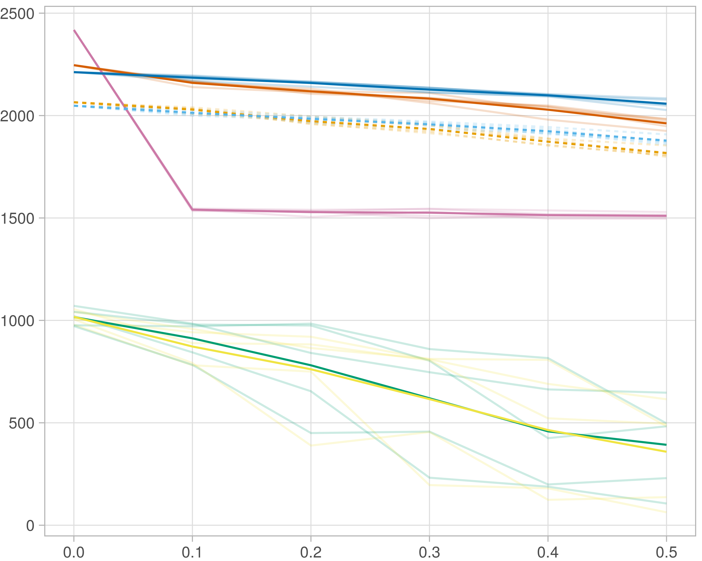

## Transitivity

### Single-omics

#general setup  
dir <- "/workspaces/phd_dissertation/kimono/analysis/data/derived_data/"  
  
#load library  
setwd(dir)  
  
dat_raw <- fread("220411_all_project_info.csv")  
  
#dat_raw <- cbind(dat_raw[,c(1,2,3,16,18)],nodes=dat_raw$V6+dat_raw$V8+dat_raw$V10)  
#dat_raw <- dat_raw[dat_raw$iteration == 1,]  
  
dat_raw$method <- gsub(pattern = "_moran|_mos|_mor|_so|_sor",replacement = "",x = dat_raw$method)  
  
dat <- dat_raw[tolower(dat_raw$method) %in% c("galasso_false","galasso_true","knn_kimono","salasso_false","salasso_true","cocolasso","hmlasso"),]  
  
  
#ggplot(dat, aes(x=clustering, y=n_genes+n_methylation+n_cnv, color=as.factor(method)) )+  
# geom_point(alpha=0.5) + facet_grid(experiment~noise)  
  
#ggplot(dat, aes(y=clustering, x=missingness, color=as.factor(method)) )+  
# geom_point(alpha=0.5) + facet_grid(experiment~noise)  
  
#ggplot(dat, aes(x=missingness, y=clustering,fill=as.factor(method)))+  
# scale_y_continuous(trans='sqrt') + geom_boxplot() + facet_grid(experiment~noise)  
  
  
dat$method <- as.factor(dat$method)   
dat <- dat %>% mutate(method = fct_relevel(method, "knn_kimono", "galasso_false" ,"galasso_true" , "salasso_false" , "salasso_true" ,"cocolasso", "hmlasso" ))  
dat$experiment <- as.factor(dat$experiment)  
dat <- dat %>% mutate(experiment = fct_relevel(experiment, "so", "moran" ,"mos" , "sor" , "mor"))  
  
palette_OkabeIto <- c( "#CC79A7", "#D55E00", "#E69F00","#0072B2", "#56B4E9", "#009E73", "#F0E442")  
  
dat <- aggregate(dat[, -c(1:8)], list('noise'=dat$noise,  
 'missingness'=dat$missingness,  
 'method'=dat$method,  
 'experiment'=dat$experiment), function(x){mean(x,na.rm=TRUE)})  
  
dat_raw$method <- as.factor(dat_raw$method)   
dat_raw <- dat_raw %>% mutate(method = fct_relevel(method, "knn_kimono", "galasso_false" ,"galasso_true" , "salasso_false" , "salasso_true" ,"cocolasso", "hmlasso" ))  
dat_raw$experiment <- as.factor(dat_raw$experiment)  
dat_raw <- dat_raw %>% mutate(experiment = fct_relevel(experiment, "so", "moran" ,"mos" , "sor" , "mor"))  
  
dat_raw <- dat_raw[ dat_raw$noise==0 & dat_raw$experiment %in% 'so' & !dat_raw$method %in% "bdcoco_lasso",]  
dat <- dat[ dat$noise==0 & dat$experiment %in% 'so' & !dat$method %in% "bdcoco_lasso",]  
  
dat_raw$adaptive <- grepl(pattern = "true",x = dat_raw$method)  
dat$adaptive <- grepl(pattern = "true",x = dat$method)  
  
p <- ggplot(dat_raw,   
 aes(y= (clustering), x=missingness,color=as.factor(method)))+  
   
 geom_line(aes( group = interaction(method, iteration),linetype=adaptive),alpha = 0.2)+  
 facet_grid(noise~experiment, scales="free")+  
 scale_color_manual(values = palette_OkabeIto)+  
 scale_fill_manual(values = palette_OkabeIto)+   
 theme_light() +  
 theme(legend.position="bottom",  
 axis.text.x = element_text(size = 8),  
 axis.text.y = element_text(size = 8),  
 strip.background = element_blank(),   
 plot.margin = unit(c(-0.5, -0.5, 0, 0), "cm")  
 ) +  
 ylab("#Nodes")   
  
to.plot2 <- p + geom_line(data = dat,   
 aes(y= (clustering), x=missingness, color=as.factor(method),linetype=adaptive)) +   
 theme(strip.background = element_blank(), panel.grid.minor = element_blank(),  
 legend.position = "none",  
 axis.title.x=element_blank(),  
 #axis.text.x=element_blank(),  
 #axis.ticks.x=element_blank(),  
 axis.title.y=element_blank(),  
 #axis.text.y=element_blank(),  
 #axis.ticks.y=element_blank(),   
 plot.margin = unit(c(-0.5, -0.5, 0, 0), "cm")  
 )  
  
to.plot2

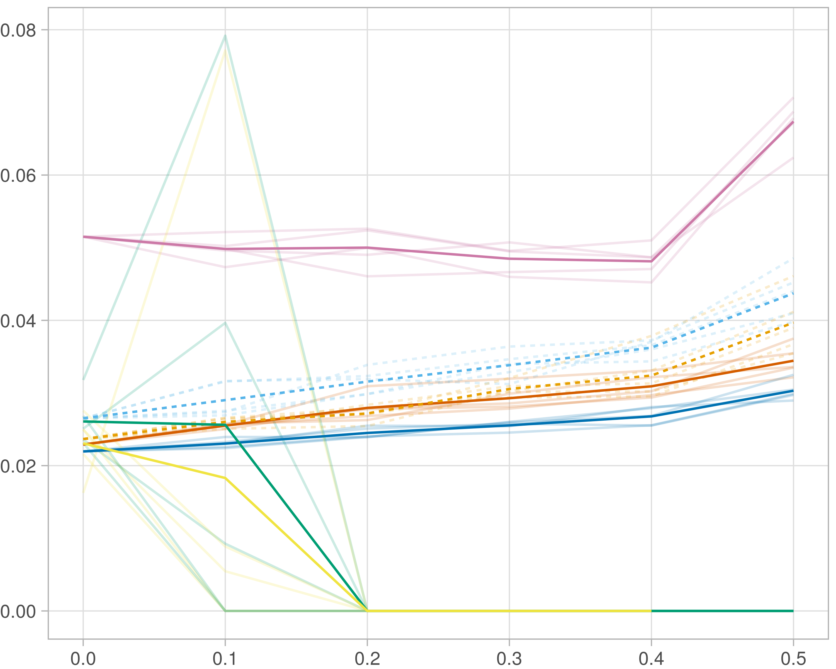

### Multi-omics

#general setup  
dir <- "/workspaces/phd_dissertation/kimono/analysis/data/derived_data/"  
  
#load library  
setwd(dir)  
  
dat_raw <- fread("220411_all_project_info.csv")  
  
#dat_raw <- cbind(dat_raw[,c(1,2,3,16,18)],nodes=dat_raw$V6+dat_raw$V8+dat_raw$V10)  
#dat_raw <- dat_raw[dat_raw$iteration == 1,]  
  
dat_raw$method <- gsub(pattern = "_moran|_mos|_mor|_so|_sor",replacement = "",x = dat_raw$method)  
  
dat <- dat_raw[tolower(dat_raw$method) %in% c("galasso_false","galasso_true","knn_kimono","salasso_false","salasso_true","cocolasso","hmlasso"),]  
  
  
#ggplot(dat, aes(x=clustering, y=n_genes+n_methylation+n_cnv, color=as.factor(method)) )+  
# geom_point(alpha=0.5) + facet_grid(experiment~noise)  
  
#ggplot(dat, aes(y=clustering, x=missingness, color=as.factor(method)) )+  
# geom_point(alpha=0.5) + facet_grid(experiment~noise)  
  
#ggplot(dat, aes(x=missingness, y=clustering,fill=as.factor(method)))+  
# scale_y_continuous(trans='sqrt') + geom_boxplot() + facet_grid(experiment~noise)  
  
  
dat$method <- as.factor(dat$method)   
dat <- dat %>% mutate(method = fct_relevel(method, "knn_kimono", "galasso_false" ,"galasso_true" , "salasso_false" , "salasso_true" ,"cocolasso", "hmlasso" ))  
dat$experiment <- as.factor(dat$experiment)  
dat <- dat %>% mutate(experiment = fct_relevel(experiment, "so", "moran" ,"mos" , "sor" , "mor"))  
  
palette_OkabeIto <- c( "#CC79A7", "#D55E00", "#E69F00","#0072B2", "#56B4E9", "#009E73", "#F0E442")  
  
dat <- aggregate(dat[, -c(1:8)], list('noise'=dat$noise,  
 'missingness'=dat$missingness,  
 'method'=dat$method,  
 'experiment'=dat$experiment), function(x){mean(x,na.rm=TRUE)})  
  
dat_raw$method <- as.factor(dat_raw$method)   
dat_raw <- dat_raw %>% mutate(method = fct_relevel(method, "knn_kimono", "galasso_false" ,"galasso_true" , "salasso_false" , "salasso_true" ,"cocolasso", "hmlasso" ))  
dat_raw$experiment <- as.factor(dat_raw$experiment)  
dat_raw <- dat_raw %>% mutate(experiment = fct_relevel(experiment, "so", "moran" ,"mos" , "sor" , "mor"))  
  
dat_raw <- dat_raw[ dat_raw$noise==0 & dat_raw$experiment %in% 'moran' & !dat_raw$method %in% "bdcoco_lasso",]  
dat <- dat[ dat$noise==0 & dat$experiment %in% 'moran' & !dat$method %in% "bdcoco_lasso",]  
  
dat_raw$adaptive <- grepl(pattern = "true",x = dat_raw$method)  
dat$adaptive <- grepl(pattern = "true",x = dat$method)  
  
p <- ggplot(dat_raw,   
 aes(y= (clustering), x=missingness,color=as.factor(method)))+  
   
 geom_line(aes( group = interaction(method, iteration),linetype=adaptive),alpha = 0.2)+  
 facet_grid(noise~experiment, scales="free")+  
 scale_color_manual(values = palette_OkabeIto)+  
 scale_fill_manual(values = palette_OkabeIto)+   
 theme_light() +  
 theme(legend.position="bottom",  
 axis.text.x = element_text(size = 8),  
 axis.text.y = element_text(size = 8),  
 strip.background = element_blank(),   
 plot.margin = unit(c(-0.5, -0.5, 0, 0), "cm")  
 ) +  
 ylab("#Nodes")   
  
to.plot2 <- p + geom_line(data = dat,   
 aes(y= (clustering), x=missingness, color=as.factor(method),linetype=adaptive)) +   
 theme(strip.background = element_blank(), panel.grid.minor = element_blank(),  
 legend.position = "none",  
 axis.title.x=element_blank(),  
 #axis.text.x=element_blank(),  
 #axis.ticks.x=element_blank(),  
 axis.title.y=element_blank(),  
 #axis.text.y=element_blank(),  
 #axis.ticks.y=element_blank(),   
 plot.margin = unit(c(-0.5, -0.5, 0, 0), "cm")  
 )  
  
to.plot2

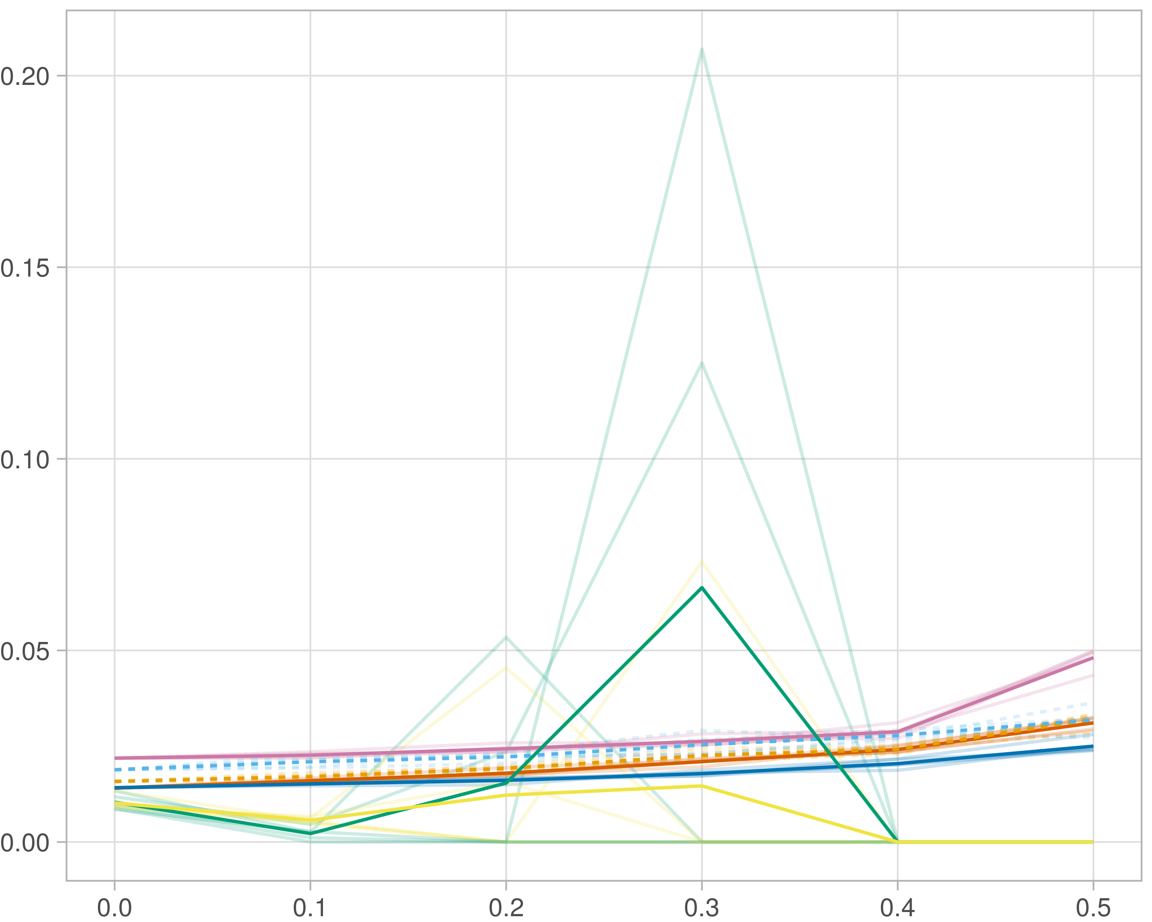

### Block-wise

#general setup  
dir <- "/workspaces/phd_dissertation/kimono/analysis/data/derived_data/"  
  
#load library  
setwd(dir)  
  
dat_raw <- fread("220411_all_project_info.csv")  
  
#dat_raw <- cbind(dat_raw[,c(1,2,3,16,18)],nodes=dat_raw$V6+dat_raw$V8+dat_raw$V10)  
#dat_raw <- dat_raw[dat_raw$iteration == 1,]  
  
dat_raw$method <- gsub(pattern = "_moran|_mos|_mor|_so|_sor",replacement = "",x = dat_raw$method)  
  
dat <- dat_raw[tolower(dat_raw$method) %in% c("galasso_false","galasso_true","knn_kimono","salasso_false","salasso_true","cocolasso","hmlasso"),]  
  
  
#ggplot(dat, aes(x=clustering, y=n_genes+n_methylation+n_cnv, color=as.factor(method)) )+  
# geom_point(alpha=0.5) + facet_grid(experiment~noise)  
  
#ggplot(dat, aes(y=clustering, x=missingness, color=as.factor(method)) )+  
# geom_point(alpha=0.5) + facet_grid(experiment~noise)  
  
#ggplot(dat, aes(x=missingness, y=clustering,fill=as.factor(method)))+  
# scale_y_continuous(trans='sqrt') + geom_boxplot() + facet_grid(experiment~noise)  
  
  
dat$method <- as.factor(dat$method)   
dat <- dat %>% mutate(method = fct_relevel(method, "knn_kimono", "galasso_false" ,"galasso_true" , "salasso_false" , "salasso_true" ,"cocolasso", "hmlasso" ))  
dat$experiment <- as.factor(dat$experiment)  
dat <- dat %>% mutate(experiment = fct_relevel(experiment, "so", "moran" ,"mos" , "sor" , "mor"))  
  
palette_OkabeIto <- c( "#CC79A7", "#D55E00", "#E69F00","#0072B2", "#56B4E9", "#009E73", "#F0E442")  
  
dat <- aggregate(dat[, -c(1:8)], list('noise'=dat$noise,  
 'missingness'=dat$missingness,  
 'method'=dat$method,  
 'experiment'=dat$experiment), function(x){mean(x,na.rm=TRUE)})  
  
dat_raw$method <- as.factor(dat_raw$method)   
dat_raw <- dat_raw %>% mutate(method = fct_relevel(method, "knn_kimono", "galasso_false" ,"galasso_true" , "salasso_false" , "salasso_true" ,"cocolasso", "hmlasso" ))  
dat_raw$experiment <- as.factor(dat_raw$experiment)  
dat_raw <- dat_raw %>% mutate(experiment = fct_relevel(experiment, "so", "moran" ,"mos" , "sor" , "mor"))  
  
dat_raw <- dat_raw[ dat_raw$noise==0 & dat_raw$experiment %in% 'mos' & !dat_raw$method %in% "bdcoco_lasso",]  
dat <- dat[ dat$noise==0 & dat$experiment %in% 'mos' & !dat$method %in% "bdcoco_lasso",]  
  
dat_raw$adaptive <- grepl(pattern = "true",x = dat_raw$method)  
dat$adaptive <- grepl(pattern = "true",x = dat$method)  
  
p <- ggplot(dat_raw,   
 aes(y= (clustering), x=missingness,color=as.factor(method)))+  
   
 geom_line(aes( group = interaction(method, iteration),linetype=adaptive),alpha = 0.2)+  
 facet_grid(noise~experiment, scales="free")+  
 scale_color_manual(values = palette_OkabeIto)+  
 scale_fill_manual(values = palette_OkabeIto)+   
 theme_light() +  
 theme(legend.position="bottom",  
 axis.text.x = element_text(size = 8),  
 axis.text.y = element_text(size = 8),  
 strip.background = element_blank(),   
 plot.margin = unit(c(-0.5, -0.5, 0, 0), "cm")  
 ) +  
 ylab("#Nodes")   
  
to.plot2 <- p + geom_line(data = dat,   
 aes(y= (clustering), x=missingness, color=as.factor(method),linetype=adaptive)) +   
 theme(strip.background = element_blank(), panel.grid.minor = element_blank(),  
 legend.position = "none",  
 axis.title.x=element_blank(),  
 #axis.text.x=element_blank(),  
 #axis.ticks.x=element_blank(),  
 axis.title.y=element_blank(),  
 #axis.text.y=element_blank(),  
 #axis.ticks.y=element_blank(),   
 plot.margin = unit(c(-0.5, -0.5, 0, 0), "cm")  
 )  
  
to.plot2

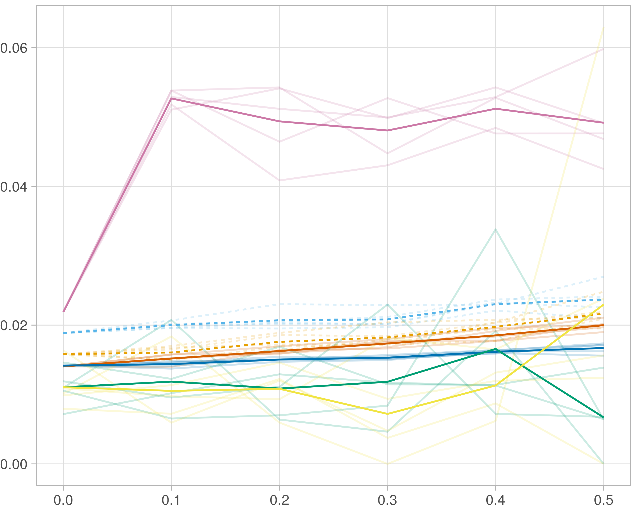

## Median R-squared

### Single-omics

#general setup  
dir <- "/workspaces/phd_dissertation/kimono/analysis/data/derived_data/"  
  
#load library  
setwd(dir)  
  
dat_raw <- fread("220411_all_project_info.csv")  
  
#dat_raw <- cbind(dat_raw[,c(1,2,3,16,18)],nodes=dat_raw$V6+dat_raw$V8+dat_raw$V10)  
#dat_raw <- dat_raw[dat_raw$iteration == 1,]  
  
dat_raw$method <- gsub(pattern = "_moran|_mos|_mor|_so|_sor",replacement = "",x = dat_raw$method)  
  
dat <- dat_raw[tolower(dat_raw$method) %in% c("galasso_false","galasso_true","knn_kimono","salasso_false","salasso_true","cocolasso","hmlasso"),]  
  
  
#ggplot(dat, aes(x=clustering, y=n_genes+n_methylation+n_cnv, color=as.factor(method)) )+  
# geom_point(alpha=0.5) + facet_grid(experiment~noise)  
  
#ggplot(dat, aes(y=clustering, x=missingness, color=as.factor(method)) )+  
# geom_point(alpha=0.5) + facet_grid(experiment~noise)  
  
#ggplot(dat, aes(x=missingness, y=clustering,fill=as.factor(method)))+  
# scale_y_continuous(trans='sqrt') + geom_boxplot() + facet_grid(experiment~noise)  
  
  
dat$method <- as.factor(dat$method)   
dat <- dat %>% mutate(method = fct_relevel(method, "knn_kimono", "galasso_false" ,"galasso_true" , "salasso_false" , "salasso_true" ,"cocolasso", "hmlasso" ))  
dat$experiment <- as.factor(dat$experiment)  
dat <- dat %>% mutate(experiment = fct_relevel(experiment, "so", "moran" ,"mos" , "sor" , "mor"))  
  
palette_OkabeIto <- c( "#CC79A7", "#D55E00", "#E69F00","#0072B2", "#56B4E9", "#009E73", "#F0E442")  
  
dat <- aggregate(dat[, -c(1:8)], list('noise'=dat$noise,  
 'missingness'=dat$missingness,  
 'method'=dat$method,  
 'experiment'=dat$experiment), function(x){mean(x,na.rm=TRUE)})  
  
dat_raw$method <- as.factor(dat_raw$method)   
dat_raw <- dat_raw %>% mutate(method = fct_relevel(method, "knn_kimono", "galasso_false" ,"galasso_true" , "salasso_false" , "salasso_true" ,"cocolasso", "hmlasso" ))  
dat_raw$experiment <- as.factor(dat_raw$experiment)  
dat_raw <- dat_raw %>% mutate(experiment = fct_relevel(experiment, "so", "moran" ,"mos" , "sor" , "mor"))  
  
dat_raw <- dat_raw[ dat_raw$noise==0 & dat_raw$experiment %in% 'so' & !dat_raw$method %in% "bdcoco_lasso",]  
dat <- dat[ dat$noise==0 & dat$experiment %in% 'so' & !dat$method %in% "bdcoco_lasso",]  
  
dat_raw$adaptive <- grepl(pattern = "true",x = dat_raw$method)  
dat$adaptive <- grepl(pattern = "true",x = dat$method)  
  
p <- ggplot(dat_raw,   
 aes(y= (median_r2), x=missingness,color=as.factor(method)))+  
   
 geom_line(aes( group = interaction(method, iteration),linetype=adaptive),alpha = 0.2)+  
 facet_grid(noise~experiment, scales="free")+  
 scale_color_manual(values = palette_OkabeIto)+  
 scale_fill_manual(values = palette_OkabeIto)+   
 theme_light() +  
 theme(legend.position="bottom",  
 axis.text.x = element_text(size = 8),  
 axis.text.y = element_text(size = 8),  
 strip.background = element_blank(),   
 plot.margin = unit(c(-0.5, -0.5, 0, 0), "cm")  
 ) +  
 ylab("#Nodes")   
  
to.plot3 <- p + geom_line(data = dat,   
 aes(y= (median_r2), x=missingness, color=as.factor(method),linetype=adaptive)) +   
 theme(strip.background = element_blank(), panel.grid.minor = element_blank(),  
 legend.position = "none",  
 axis.title.x=element_blank(),  
 #axis.text.x=element_blank(),  
 #axis.ticks.x=element_blank(),  
 axis.title.y=element_blank(),  
 #axis.text.y=element_blank(),  
 #axis.ticks.y=element_blank(),   
 plot.margin = unit(c(-0.5, -0.5, 0, 0), "cm")  
 )  
  
to.plot3

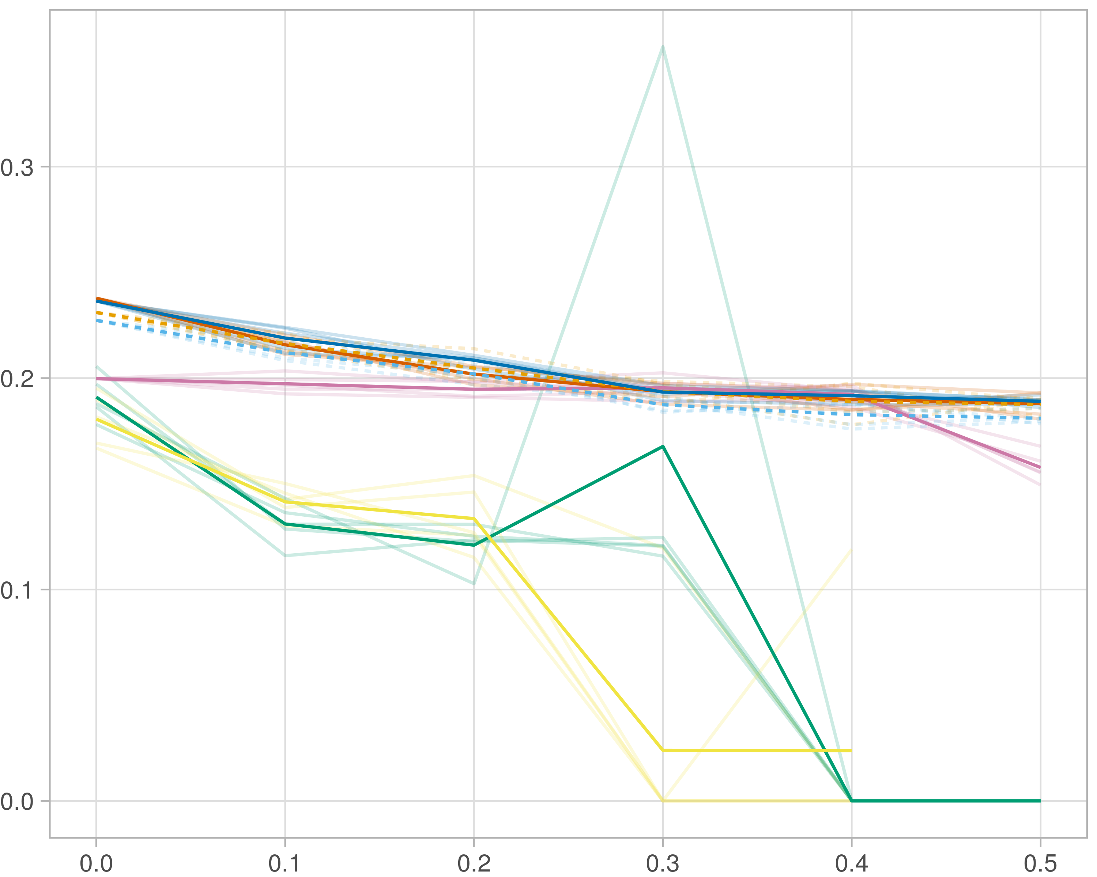

### Multi_omics

#general setup  
dir <- "/workspaces/phd_dissertation/kimono/analysis/data/derived_data/"  
  
#load library  
setwd(dir)  
  
dat_raw <- fread("220411_all_project_info.csv")  
  
#dat_raw <- cbind(dat_raw[,c(1,2,3,16,18)],nodes=dat_raw$V6+dat_raw$V8+dat_raw$V10)  
#dat_raw <- dat_raw[dat_raw$iteration == 1,]  
  
dat_raw$method <- gsub(pattern = "_moran|_mos|_mor|_so|_sor",replacement = "",x = dat_raw$method)  
  
dat <- dat_raw[tolower(dat_raw$method) %in% c("galasso_false","galasso_true","knn_kimono","salasso_false","salasso_true","cocolasso","hmlasso"),]  
  
  
#ggplot(dat, aes(x=clustering, y=n_genes+n_methylation+n_cnv, color=as.factor(method)) )+  
# geom_point(alpha=0.5) + facet_grid(experiment~noise)  
  
#ggplot(dat, aes(y=clustering, x=missingness, color=as.factor(method)) )+  
# geom_point(alpha=0.5) + facet_grid(experiment~noise)  
  
#ggplot(dat, aes(x=missingness, y=clustering,fill=as.factor(method)))+  
# scale_y_continuous(trans='sqrt') + geom_boxplot() + facet_grid(experiment~noise)  
  
  
dat$method <- as.factor(dat$method)   
dat <- dat %>% mutate(method = fct_relevel(method, "knn_kimono", "galasso_false" ,"galasso_true" , "salasso_false" , "salasso_true" ,"cocolasso", "hmlasso" ))  
dat$experiment <- as.factor(dat$experiment)  
dat <- dat %>% mutate(experiment = fct_relevel(experiment, "so", "moran" ,"mos" , "sor" , "mor"))  
  
palette_OkabeIto <- c( "#CC79A7", "#D55E00", "#E69F00","#0072B2", "#56B4E9", "#009E73", "#F0E442")  
  
dat <- aggregate(dat[, -c(1:8)], list('noise'=dat$noise,  
 'missingness'=dat$missingness,  
 'method'=dat$method,  
 'experiment'=dat$experiment), function(x){mean(x,na.rm=TRUE)})  
  
dat_raw$method <- as.factor(dat_raw$method)   
dat_raw <- dat_raw %>% mutate(method = fct_relevel(method, "knn_kimono", "galasso_false" ,"galasso_true" , "salasso_false" , "salasso_true" ,"cocolasso", "hmlasso" ))  
dat_raw$experiment <- as.factor(dat_raw$experiment)  
dat_raw <- dat_raw %>% mutate(experiment = fct_relevel(experiment, "so", "moran" ,"mos" , "sor" , "mor"))  
  
dat_raw <- dat_raw[ dat_raw$noise==0 & dat_raw$experiment %in% 'moran' & !dat_raw$method %in% "bdcoco_lasso",]  
dat <- dat[ dat$noise==0 & dat$experiment %in% 'moran' & !dat$method %in% "bdcoco_lasso",]  
  
dat_raw$adaptive <- grepl(pattern = "true",x = dat_raw$method)  
dat$adaptive <- grepl(pattern = "true",x = dat$method)  
  
p <- ggplot(dat_raw,   
 aes(y= (median_r2), x=missingness,color=as.factor(method)))+  
   
 geom_line(aes( group = interaction(method, iteration),linetype=adaptive),alpha = 0.2)+  
 facet_grid(noise~experiment, scales="free")+  
 scale_color_manual(values = palette_OkabeIto)+  
 scale_fill_manual(values = palette_OkabeIto)+   
 theme_light() +  
 theme(legend.position="bottom",  
 axis.text.x = element_text(size = 8),  
 axis.text.y = element_text(size = 8),  
 strip.background = element_blank(),   
 plot.margin = unit(c(-0.5, -0.5, 0, 0), "cm")  
 ) +  
 ylab("#Nodes")   
  
to.plot3 <- p + geom_line(data = dat,   
 aes(y= (median_r2), x=missingness, color=as.factor(method),linetype=adaptive)) +   
 theme(strip.background = element_blank(), panel.grid.minor = element_blank(),  
 legend.position = "none",  
 axis.title.x=element_blank(),  
 #axis.text.x=element_blank(),  
 #axis.ticks.x=element_blank(),  
 axis.title.y=element_blank(),  
 #axis.text.y=element_blank(),  
 #axis.ticks.y=element_blank(),   
 plot.margin = unit(c(-0.5, -0.5, 0, 0), "cm")  
 )  
  
to.plot3

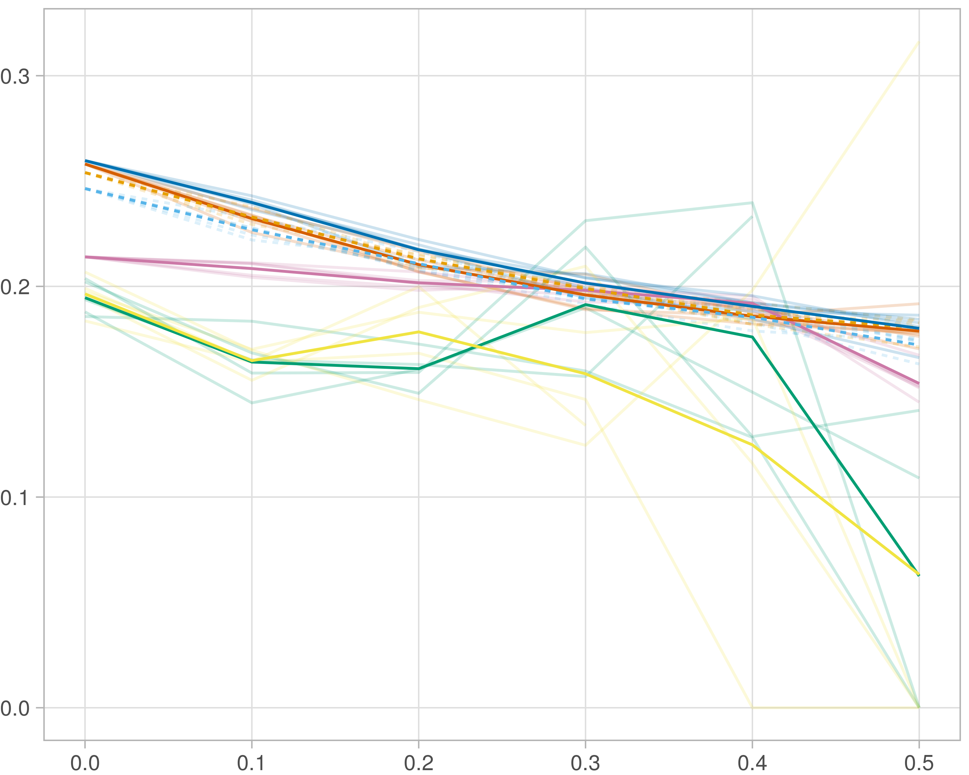

### Block-wise

#general setup  
dir <- "/workspaces/phd_dissertation/kimono/analysis/data/derived_data/"  
  
#load library  
setwd(dir)  
  
dat_raw <- fread("220411_all_project_info.csv")  
  
#dat_raw <- cbind(dat_raw[,c(1,2,3,16,18)],nodes=dat_raw$V6+dat_raw$V8+dat_raw$V10)  
#dat_raw <- dat_raw[dat_raw$iteration == 1,]  
  
dat_raw$method <- gsub(pattern = "_moran|_mos|_mor|_so|_sor",replacement = "",x = dat_raw$method)  
  
dat <- dat_raw[tolower(dat_raw$method) %in% c("galasso_false","galasso_true","knn_kimono","salasso_false","salasso_true","cocolasso","hmlasso"),]  
  
  
#ggplot(dat, aes(x=clustering, y=n_genes+n_methylation+n_cnv, color=as.factor(method)) )+  
# geom_point(alpha=0.5) + facet_grid(experiment~noise)  
  
#ggplot(dat, aes(y=clustering, x=missingness, color=as.factor(method)) )+  
# geom_point(alpha=0.5) + facet_grid(experiment~noise)  
  
#ggplot(dat, aes(x=missingness, y=clustering,fill=as.factor(method)))+  
# scale_y_continuous(trans='sqrt') + geom_boxplot() + facet_grid(experiment~noise)  
  
  
dat$method <- as.factor(dat$method)   
dat <- dat %>% mutate(method = fct_relevel(method, "knn_kimono", "galasso_false" ,"galasso_true" , "salasso_false" , "salasso_true" ,"cocolasso", "hmlasso" ))  
dat$experiment <- as.factor(dat$experiment)  
dat <- dat %>% mutate(experiment = fct_relevel(experiment, "so", "moran" ,"mos" , "sor" , "mor"))  
  
palette_OkabeIto <- c( "#CC79A7", "#D55E00", "#E69F00","#0072B2", "#56B4E9", "#009E73", "#F0E442")  
  
dat <- aggregate(dat[, -c(1:8)], list('noise'=dat$noise,  
 'missingness'=dat$missingness,  
 'method'=dat$method,  
 'experiment'=dat$experiment), function(x){mean(x,na.rm=TRUE)})  
  
dat_raw$method <- as.factor(dat_raw$method)   
dat_raw <- dat_raw %>% mutate(method = fct_relevel(method, "knn_kimono", "galasso_false" ,"galasso_true" , "salasso_false" , "salasso_true" ,"cocolasso", "hmlasso" ))  
dat_raw$experiment <- as.factor(dat_raw$experiment)  
dat_raw <- dat_raw %>% mutate(experiment = fct_relevel(experiment, "so", "moran" ,"mos" , "sor" , "mor"))  
  
dat_raw <- dat_raw[ dat_raw$noise==0 & dat_raw$experiment %in% 'mos' & !dat_raw$method %in% "bdcoco_lasso",]  
dat <- dat[ dat$noise==0 & dat$experiment %in% 'mos' & !dat$method %in% "bdcoco_lasso",]  
  
dat_raw$adaptive <- grepl(pattern = "true",x = dat_raw$method)  
dat$adaptive <- grepl(pattern = "true",x = dat$method)  
  
p <- ggplot(dat_raw,   
 aes(y= (median_r2), x=missingness,color=as.factor(method)))+  
   
 geom_line(aes( group = interaction(method, iteration),linetype=adaptive),alpha = 0.2)+  
 facet_grid(noise~experiment, scales="free")+  
 scale_color_manual(values = palette_OkabeIto)+  
 scale_fill_manual(values = palette_OkabeIto)+   
 theme_light() +  
 theme(legend.position="bottom",  
 axis.text.x = element_text(size = 8),  
 axis.text.y = element_text(size = 8),  
 strip.background = element_blank(),   
 plot.margin = unit(c(-0.5, -0.5, 0, 0), "cm")  
 ) +  
 ylab("#Nodes")   
  
to.plot3 <- p + geom_line(data = dat,   
 aes(y= (median_r2), x=missingness, color=as.factor(method),linetype=adaptive)) +   
 theme(strip.background = element_blank(), panel.grid.minor = element_blank(),  
 legend.position = "none",  
 axis.title.x=element_blank(),  
 #axis.text.x=element_blank(),  
 #axis.ticks.x=element_blank(),  
 axis.title.y=element_blank(),  
 #axis.text.y=element_blank(),  
 #axis.ticks.y=element_blank(),   
 plot.margin = unit(c(-0.5, -0.5, 0, 0), "cm")  
 )  
  
to.plot3

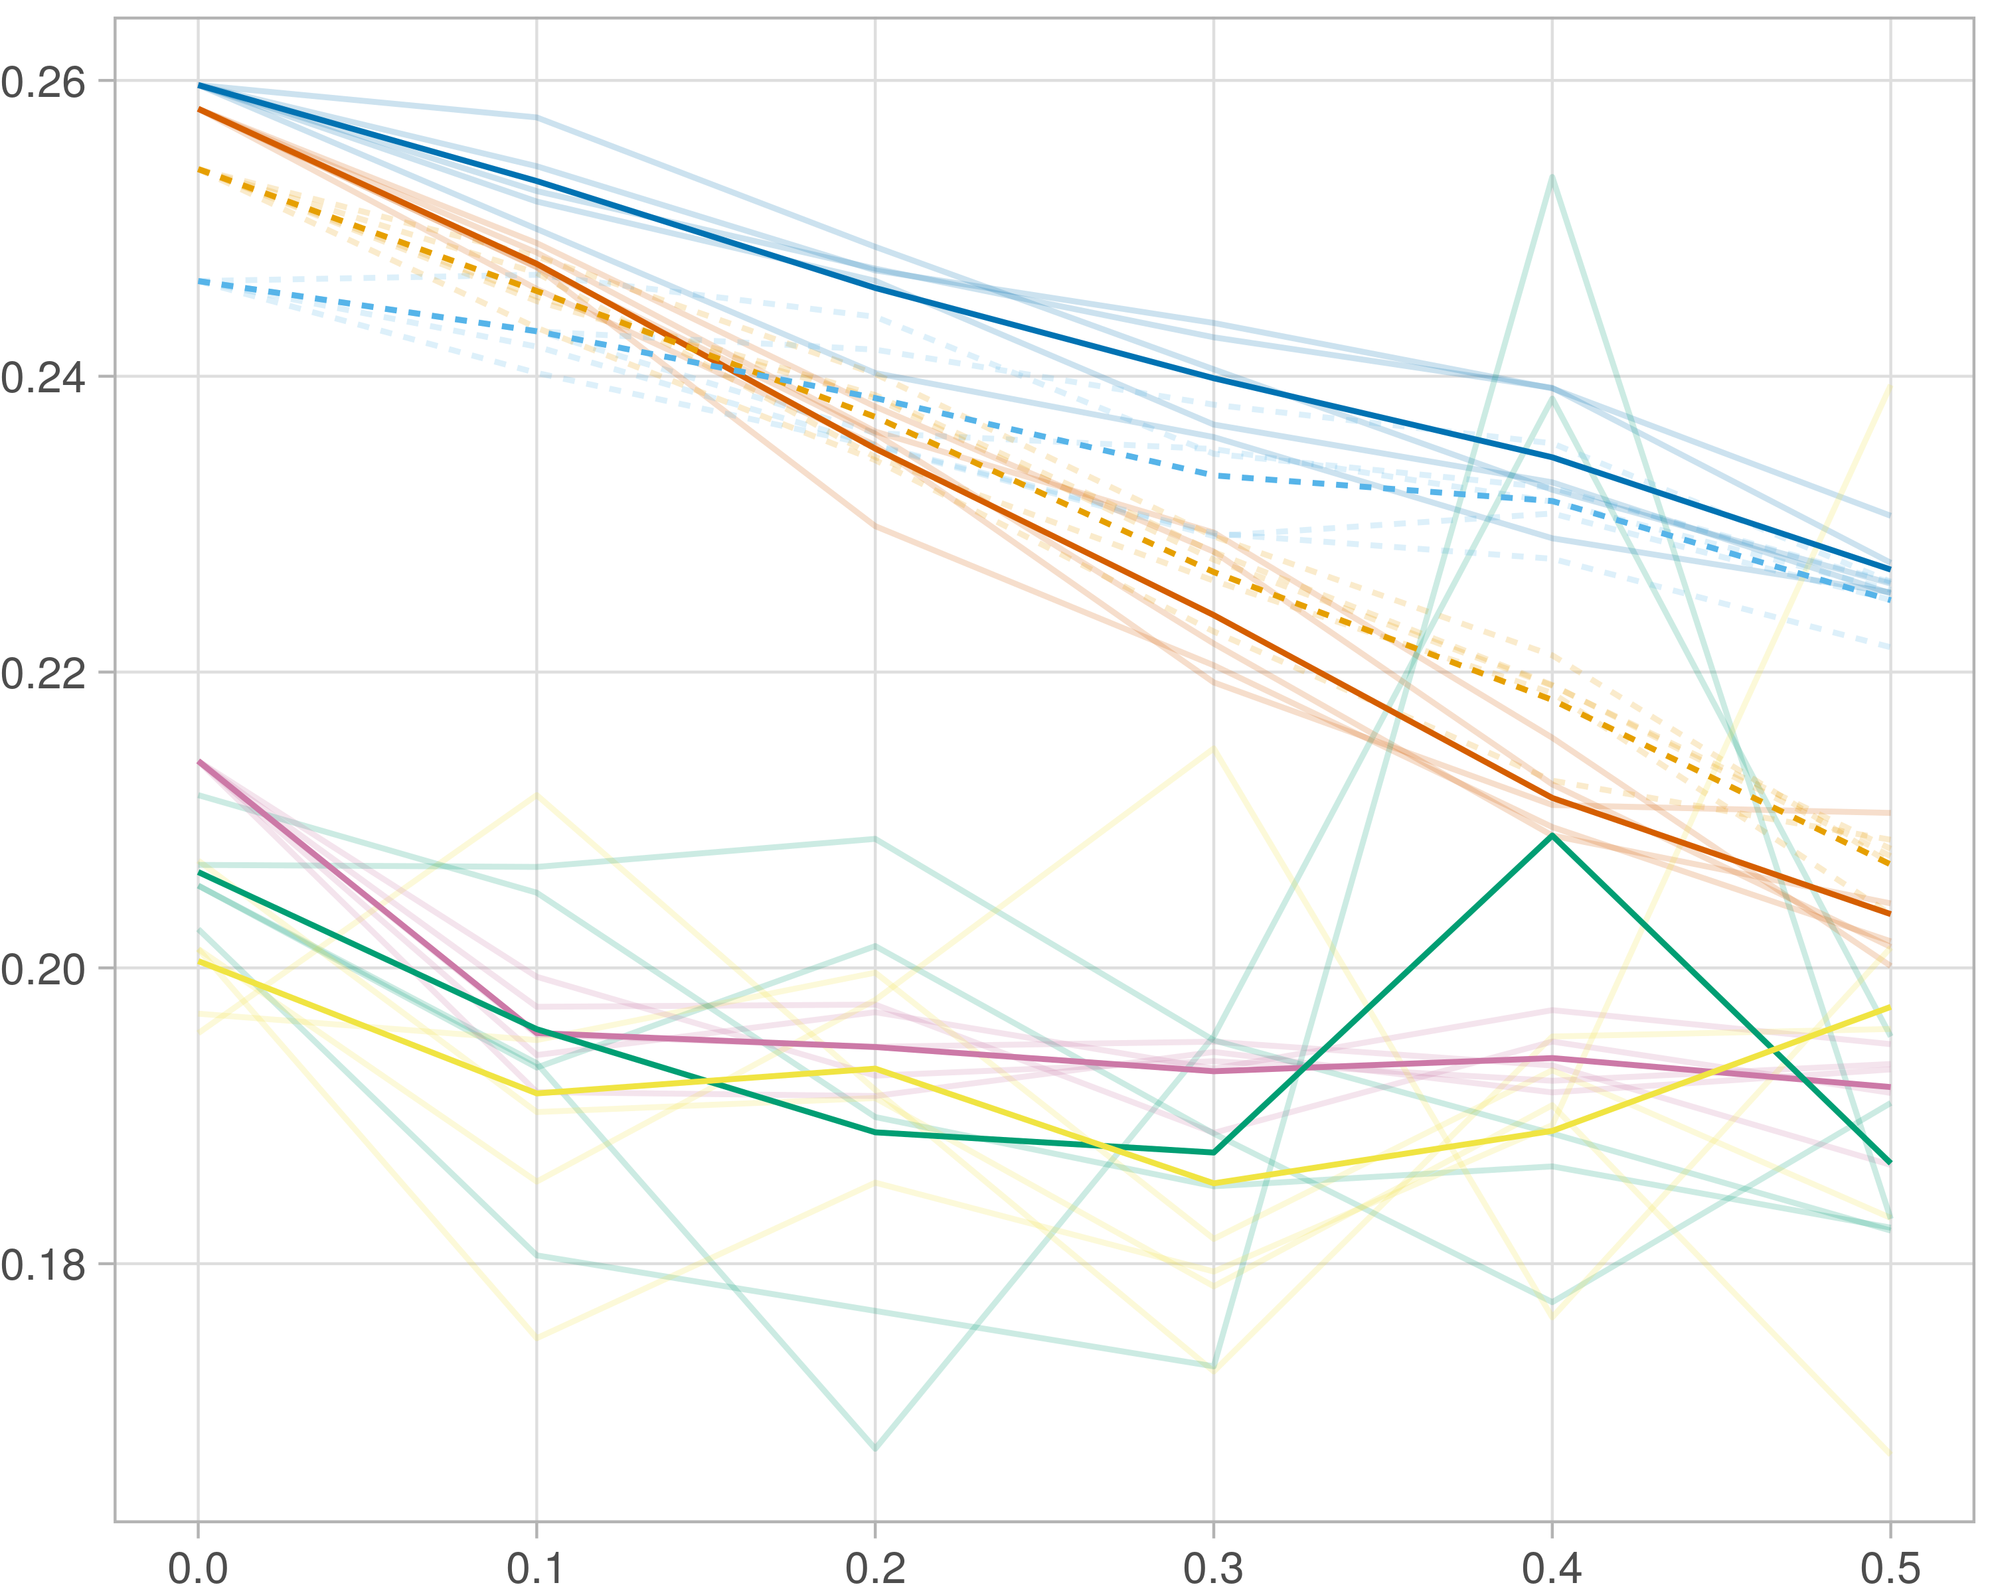

## F1-score (reference)

### Single-omics

#general setup  
dir <- "/workspaces/phd_dissertation/kimono/analysis/data/derived_data/"  
  
#load library  
setwd(dir)  
  
dat_raw <- fread("220411_all_project_info.csv")  
  
#dat_raw <- cbind(dat_raw[,c(1,2,3,16,18)],nodes=dat_raw$V6+dat_raw$V8+dat_raw$V10)  
#dat_raw <- dat_raw[dat_raw$iteration == 1,]  
  
dat_raw$method <- gsub(pattern = "_moran|_mos|_mor|_so|_sor",replacement = "",x = dat_raw$method)  
  
dat <- dat_raw[tolower(dat_raw$method) %in% c("galasso_false","galasso_true","knn_kimono","salasso_false","salasso_true","cocolasso","hmlasso"),]  
  
  
#ggplot(dat, aes(x=clustering, y=n_genes+n_methylation+n_cnv, color=as.factor(method)) )+  
# geom_point(alpha=0.5) + facet_grid(experiment~noise)  
  
#ggplot(dat, aes(y=clustering, x=missingness, color=as.factor(method)) )+  
# geom_point(alpha=0.5) + facet_grid(experiment~noise)  
  
#ggplot(dat, aes(x=missingness, y=clustering,fill=as.factor(method)))+  
# scale_y_continuous(trans='sqrt') + geom_boxplot() + facet_grid(experiment~noise)  
  
  
dat$method <- as.factor(dat$method)   
dat <- dat %>% mutate(method = fct_relevel(method, "knn_kimono", "galasso_false" ,"galasso_true" , "salasso_false" , "salasso_true" ,"cocolasso", "hmlasso" ))  
dat$experiment <- as.factor(dat$experiment)  
dat <- dat %>% mutate(experiment = fct_relevel(experiment, "so", "moran" ,"mos" , "sor" , "mor"))  
  
palette_OkabeIto <- c( "#CC79A7", "#D55E00", "#E69F00","#0072B2", "#56B4E9", "#009E73", "#F0E442")  
  
dat <- aggregate(dat[, -c(1:8)], list('noise'=dat$noise,  
 'missingness'=dat$missingness,  
 'method'=dat$method,  
 'experiment'=dat$experiment), function(x){mean(x,na.rm=TRUE)})  
  
dat_raw$method <- as.factor(dat_raw$method)   
dat_raw <- dat_raw %>% mutate(method = fct_relevel(method, "knn_kimono", "galasso_false" ,"galasso_true" , "salasso_false" , "salasso_true" ,"cocolasso", "hmlasso" ))  
dat_raw$experiment <- as.factor(dat_raw$experiment)  
dat_raw <- dat_raw %>% mutate(experiment = fct_relevel(experiment, "so", "moran" ,"mos" , "sor" , "mor"))  
  
dat_raw <- dat_raw[ dat_raw$noise==0 & dat_raw$experiment %in% 'so' & !dat_raw$method %in% "bdcoco_lasso",]  
dat <- dat[ dat$noise==0 & dat$experiment %in% 'so' & !dat$method %in% "bdcoco_lasso",]  
  
dat_raw$adaptive <- grepl(pattern = "true",x = dat_raw$method)  
dat$adaptive <- grepl(pattern = "true",x = dat$method)  
  
p <- ggplot(dat_raw,   
 aes(y= (f1_score_reference), x=missingness,color=as.factor(method)))+  
   
 geom_line(aes( group = interaction(method, iteration),linetype=adaptive),alpha = 0.2)+  
 facet_grid(noise~experiment, scales="free")+  
 scale_color_manual(values = palette_OkabeIto)+  
 scale_fill_manual(values = palette_OkabeIto)+   
 theme_light() +  
 theme(legend.position="bottom",  
 axis.text.x = element_text(size = 8),  
 axis.text.y = element_text(size = 8),  
 strip.background = element_blank(),   
 plot.margin = unit(c(-0.5, -0.5, 0, 0), "cm")  
 ) +  
 ylab("#Nodes")   
  
to.plot4 <- p + geom_line(data = dat,   
 aes(y= (f1_score_reference), x=missingness, color=as.factor(method),linetype=adaptive)) +   
 theme(strip.background = element_blank(), panel.grid.minor = element_blank(),  
 legend.position = "none",  
 axis.title.x=element_blank(),  
 #axis.text.x=element_blank(),  
 #axis.ticks.x=element_blank(),  
 axis.title.y=element_blank(),  
 #axis.text.y=element_blank(),  
 #axis.ticks.y=element_blank(),   
 plot.margin = unit(c(-0.5, -0.5, 0, 0), "cm")  
 )  
  
to.plot4

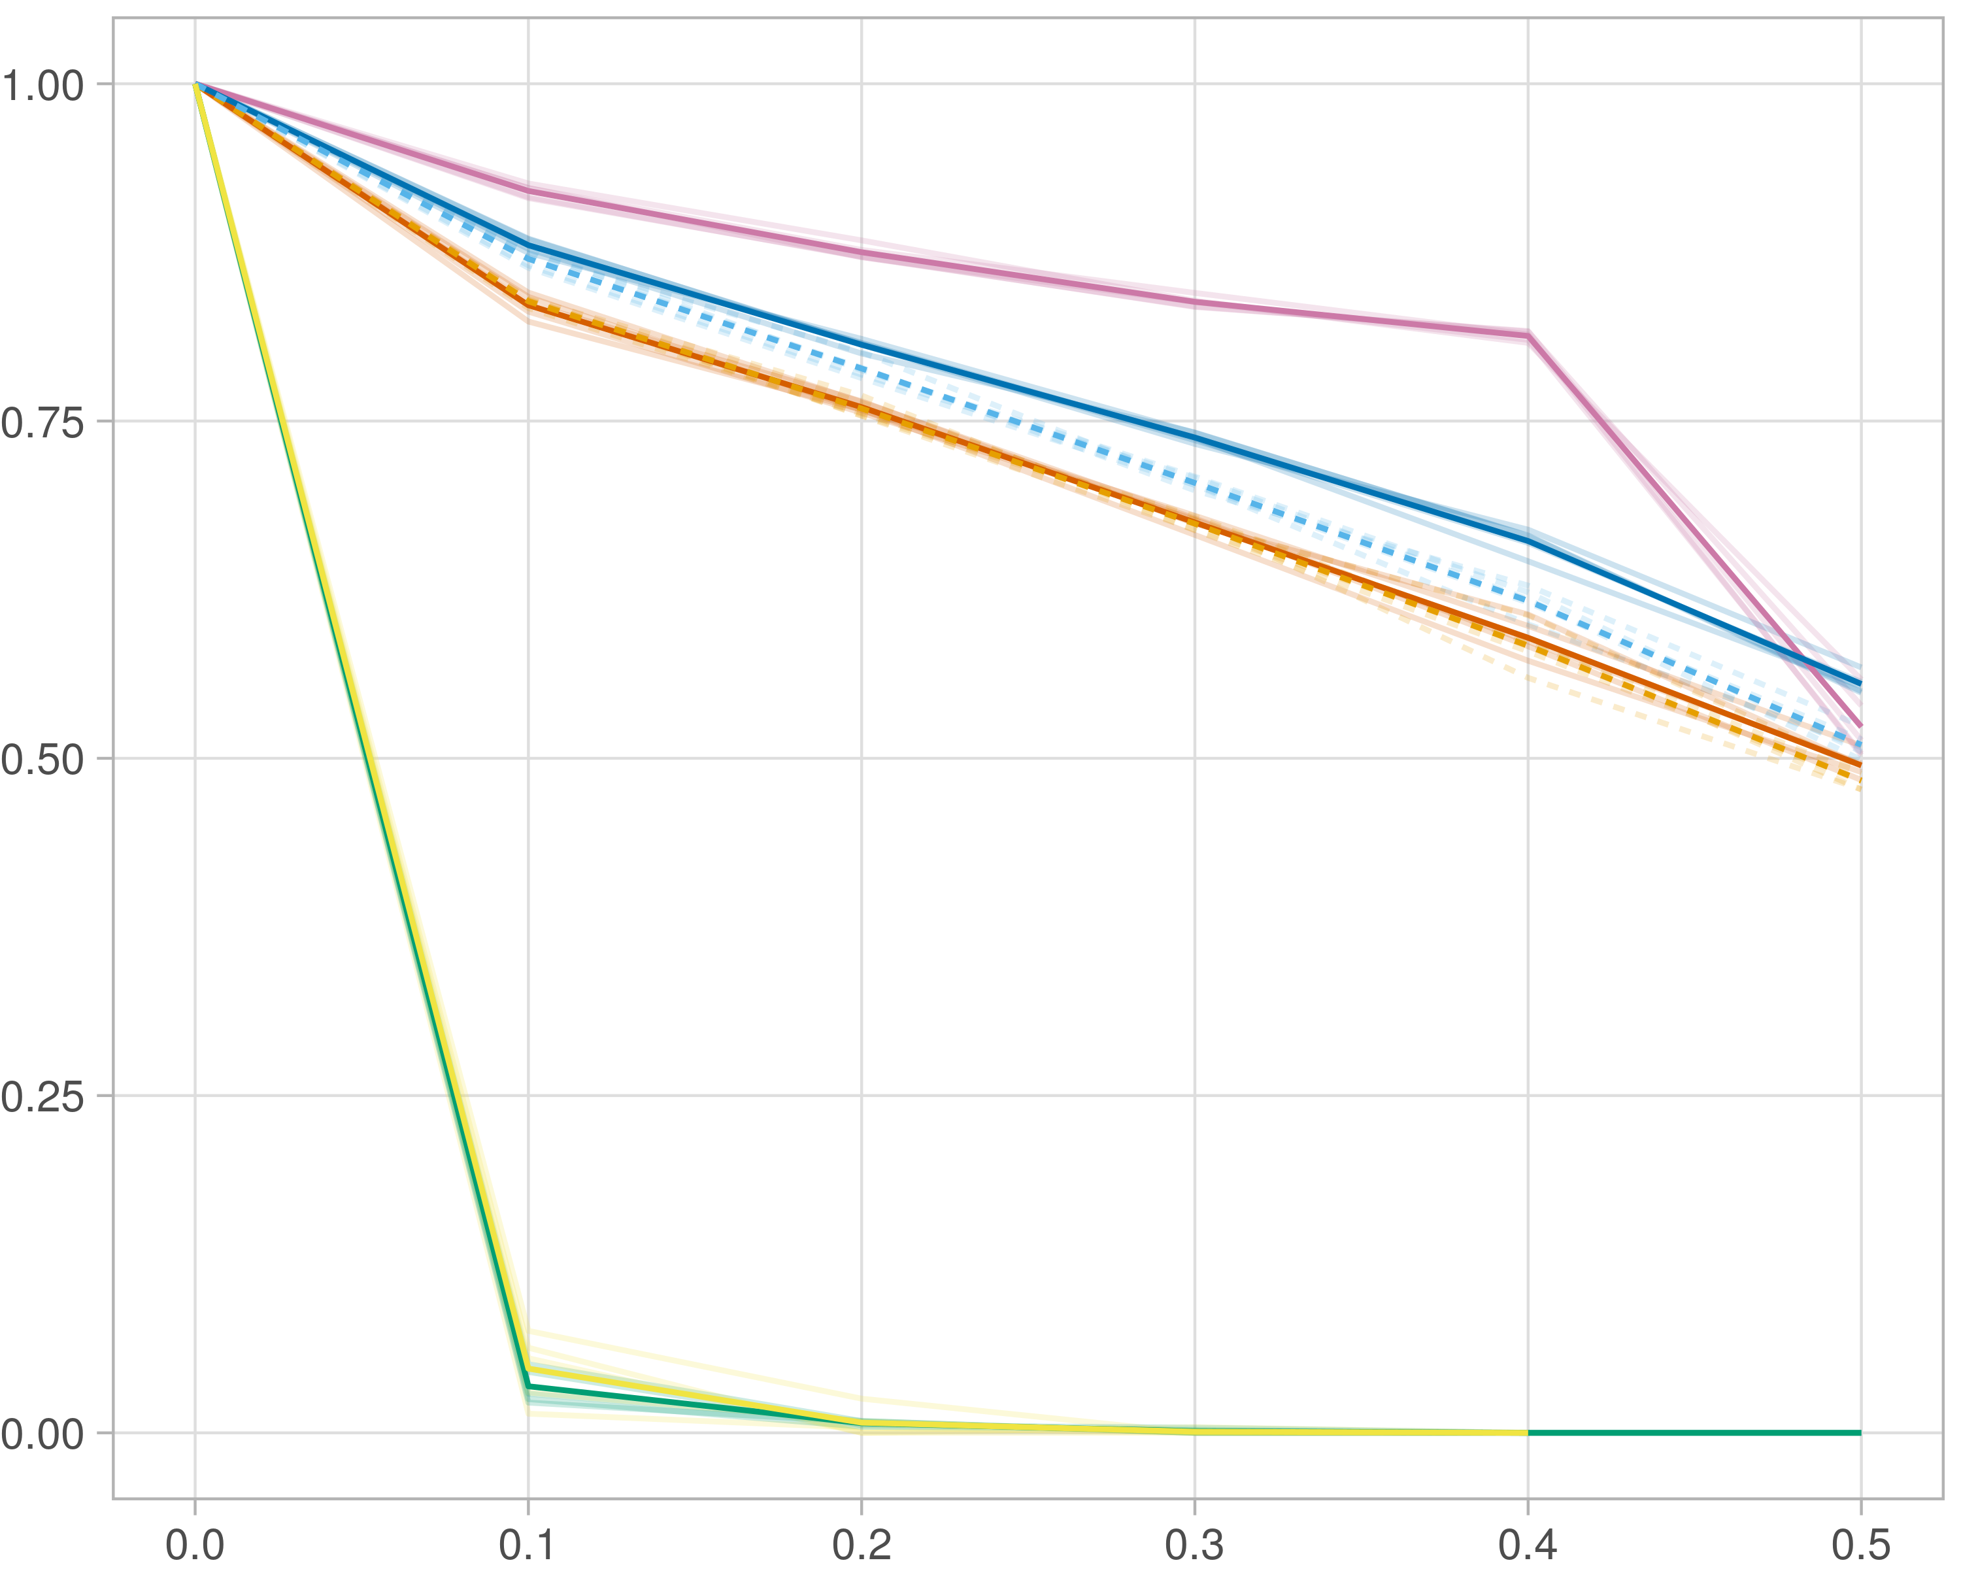

### Multi-omics

#general setup  
dir <- "/workspaces/phd_dissertation/kimono/analysis/data/derived_data/"  
  
#load library  
setwd(dir)  
  
dat_raw <- fread("220411_all_project_info.csv")  
  
#dat_raw <- cbind(dat_raw[,c(1,2,3,16,18)],nodes=dat_raw$V6+dat_raw$V8+dat_raw$V10)  
#dat_raw <- dat_raw[dat_raw$iteration == 1,]  
  
dat_raw$method <- gsub(pattern = "_moran|_mos|_mor|_so|_sor",replacement = "",x = dat_raw$method)  
  
dat <- dat_raw[tolower(dat_raw$method) %in% c("galasso_false","galasso_true","knn_kimono","salasso_false","salasso_true","cocolasso","hmlasso"),]  
  
  
#ggplot(dat, aes(x=clustering, y=n_genes+n_methylation+n_cnv, color=as.factor(method)) )+  
# geom_point(alpha=0.5) + facet_grid(experiment~noise)  
  
#ggplot(dat, aes(y=clustering, x=missingness, color=as.factor(method)) )+  
# geom_point(alpha=0.5) + facet_grid(experiment~noise)  
  
#ggplot(dat, aes(x=missingness, y=clustering,fill=as.factor(method)))+  
# scale_y_continuous(trans='sqrt') + geom_boxplot() + facet_grid(experiment~noise)  
  
  
dat$method <- as.factor(dat$method)   
dat <- dat %>% mutate(method = fct_relevel(method, "knn_kimono", "galasso_false" ,"galasso_true" , "salasso_false" , "salasso_true" ,"cocolasso", "hmlasso" ))  
dat$experiment <- as.factor(dat$experiment)  
dat <- dat %>% mutate(experiment = fct_relevel(experiment, "so", "moran" ,"mos" , "sor" , "mor"))  
  
palette_OkabeIto <- c( "#CC79A7", "#D55E00", "#E69F00","#0072B2", "#56B4E9", "#009E73", "#F0E442")  
  
dat <- aggregate(dat[, -c(1:8)], list('noise'=dat$noise,  
 'missingness'=dat$missingness,  
 'method'=dat$method,  
 'experiment'=dat$experiment), function(x){mean(x,na.rm=TRUE)})  
  
dat_raw$method <- as.factor(dat_raw$method)   
dat_raw <- dat_raw %>% mutate(method = fct_relevel(method, "knn_kimono", "galasso_false" ,"galasso_true" , "salasso_false" , "salasso_true" ,"cocolasso", "hmlasso" ))  
dat_raw$experiment <- as.factor(dat_raw$experiment)  
dat_raw <- dat_raw %>% mutate(experiment = fct_relevel(experiment, "so", "moran" ,"mos" , "sor" , "mor"))  
  
dat_raw <- dat_raw[ dat_raw$noise==0 & dat_raw$experiment %in% 'moran' & !dat_raw$method %in% "bdcoco_lasso",]  
dat <- dat[ dat$noise==0 & dat$experiment %in% 'moran' & !dat$method %in% "bdcoco_lasso",]  
  
dat_raw$adaptive <- grepl(pattern = "true",x = dat_raw$method)  
dat$adaptive <- grepl(pattern = "true",x = dat$method)  
  
p <- ggplot(dat_raw,   
 aes(y= (f1_score_reference), x=missingness,color=as.factor(method)))+  
   
 geom_line(aes( group = interaction(method, iteration),linetype=adaptive),alpha = 0.2)+  
 facet_grid(noise~experiment, scales="free")+  
 scale_color_manual(values = palette_OkabeIto)+  
 scale_fill_manual(values = palette_OkabeIto)+   
 theme_light() +  
 theme(legend.position="bottom",  
 axis.text.x = element_text(size = 8),  
 axis.text.y = element_text(size = 8),  
 strip.background = element_blank(),   
 plot.margin = unit(c(-0.5, -0.5, 0, 0), "cm")  
 ) +  
 ylab("#Nodes")   
  
to.plot4 <- p + geom_line(data = dat,   
 aes(y= (f1_score_reference), x=missingness, color=as.factor(method),linetype=adaptive)) +   
 theme(strip.background = element_blank(), panel.grid.minor = element_blank(),  
 legend.position = "none",  
 axis.title.x=element_blank(),  
 #axis.text.x=element_blank(),  
 #axis.ticks.x=element_blank(),  
 axis.title.y=element_blank(),  
 #axis.text.y=element_blank(),  
 #axis.ticks.y=element_blank(),   
 plot.margin = unit(c(-0.5, -0.5, 0, 0), "cm")  
 )  
  
to.plot4

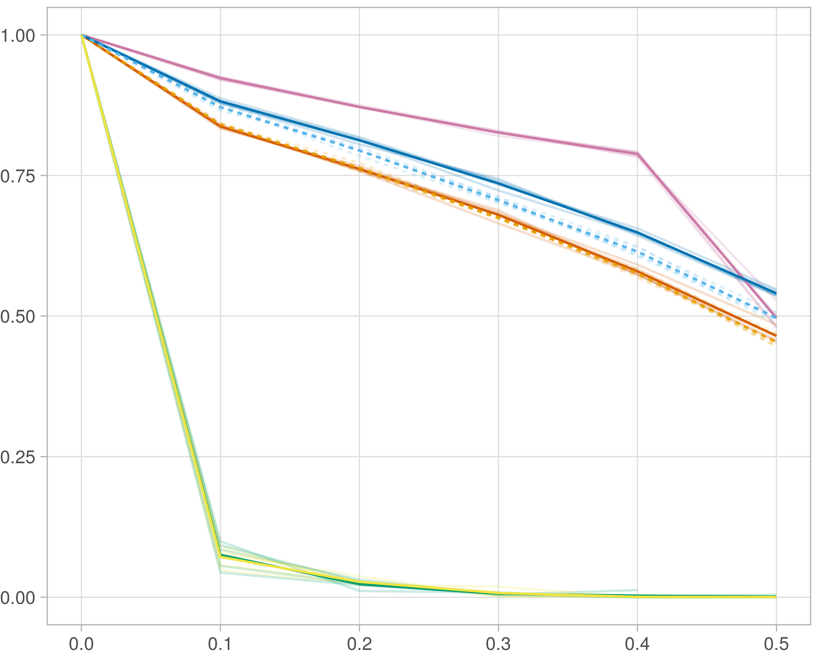

### Block-wise

#general setup  
dir <- "/workspaces/phd_dissertation/kimono/analysis/data/derived_data/"  
  
#load library  
setwd(dir)  
  
dat_raw <- fread("220411_all_project_info.csv")  
  
#dat_raw <- cbind(dat_raw[,c(1,2,3,16,18)],nodes=dat_raw$V6+dat_raw$V8+dat_raw$V10)  
#dat_raw <- dat_raw[dat_raw$iteration == 1,]  
  
dat_raw$method <- gsub(pattern = "_moran|_mos|_mor|_so|_sor",replacement = "",x = dat_raw$method)  
  
dat <- dat_raw[tolower(dat_raw$method) %in% c("galasso_false","galasso_true","knn_kimono","salasso_false","salasso_true","cocolasso","hmlasso"),]  
  
  
#ggplot(dat, aes(x=clustering, y=n_genes+n_methylation+n_cnv, color=as.factor(method)) )+  
# geom_point(alpha=0.5) + facet_grid(experiment~noise)  
  
#ggplot(dat, aes(y=clustering, x=missingness, color=as.factor(method)) )+  
# geom_point(alpha=0.5) + facet_grid(experiment~noise)  
  
#ggplot(dat, aes(x=missingness, y=clustering,fill=as.factor(method)))+  
# scale_y_continuous(trans='sqrt') + geom_boxplot() + facet_grid(experiment~noise)  
  
  
dat$method <- as.factor(dat$method)   
dat <- dat %>% mutate(method = fct_relevel(method, "knn_kimono", "galasso_false" ,"galasso_true" , "salasso_false" , "salasso_true" ,"cocolasso", "hmlasso" ))  
dat$experiment <- as.factor(dat$experiment)  
dat <- dat %>% mutate(experiment = fct_relevel(experiment, "so", "moran" ,"mos" , "sor" , "mor"))  
  
palette_OkabeIto <- c( "#CC79A7", "#D55E00", "#E69F00","#0072B2", "#56B4E9", "#009E73", "#F0E442")  
  
dat <- aggregate(dat[, -c(1:8)], list('noise'=dat$noise,  
 'missingness'=dat$missingness,  
 'method'=dat$method,  
 'experiment'=dat$experiment), function(x){mean(x,na.rm=TRUE)})  
  
dat_raw$method <- as.factor(dat_raw$method)   
dat_raw <- dat_raw %>% mutate(method = fct_relevel(method, "knn_kimono", "galasso_false" ,"galasso_true" , "salasso_false" , "salasso_true" ,"cocolasso", "hmlasso" ))  
dat_raw$experiment <- as.factor(dat_raw$experiment)  
dat_raw <- dat_raw %>% mutate(experiment = fct_relevel(experiment, "so", "moran" ,"mos" , "sor" , "mor"))  
  
dat_raw <- dat_raw[ dat_raw$noise==0 & dat_raw$experiment %in% 'mos' & !dat_raw$method %in% "bdcoco_lasso",]  
dat <- dat[ dat$noise==0 & dat$experiment %in% 'mos' & !dat$method %in% "bdcoco_lasso",]  
  
dat_raw$adaptive <- grepl(pattern = "true",x = dat_raw$method)  
dat$adaptive <- grepl(pattern = "true",x = dat$method)  
  
p <- ggplot(dat_raw,   
 aes(y= (f1_score_reference), x=missingness,color=as.factor(method)))+  
   
 geom_line(aes( group = interaction(method, iteration),linetype=adaptive),alpha = 0.2)+  
 facet_grid(noise~experiment, scales="free")+  
 scale_color_manual(values = palette_OkabeIto)+  
 scale_fill_manual(values = palette_OkabeIto)+   
 theme_light() +  
 theme(legend.position="bottom",  
 axis.text.x = element_text(size = 8),  
 axis.text.y = element_text(size = 8),  
 strip.background = element_blank(),   
 plot.margin = unit(c(-0.5, -0.5, 0, 0), "cm")  
 ) +  
 ylab("#Nodes")   
  
to.plot4 <- p + geom_line(data = dat,   
 aes(y= (f1_score_reference), x=missingness, color=as.factor(method),linetype=adaptive)) +   
 theme(strip.background = element_blank(), panel.grid.minor = element_blank(),  
 legend.position = "none",  
 axis.title.x=element_blank(),  
 #axis.text.x=element_blank(),  
 #axis.ticks.x=element_blank(),  
 axis.title.y=element_blank(),  
 #axis.text.y=element_blank(),  
 #axis.ticks.y=element_blank(),   
 plot.margin = unit(c(-0.5, -0.5, 0, 0), "cm")  
 )  
  
to.plot4

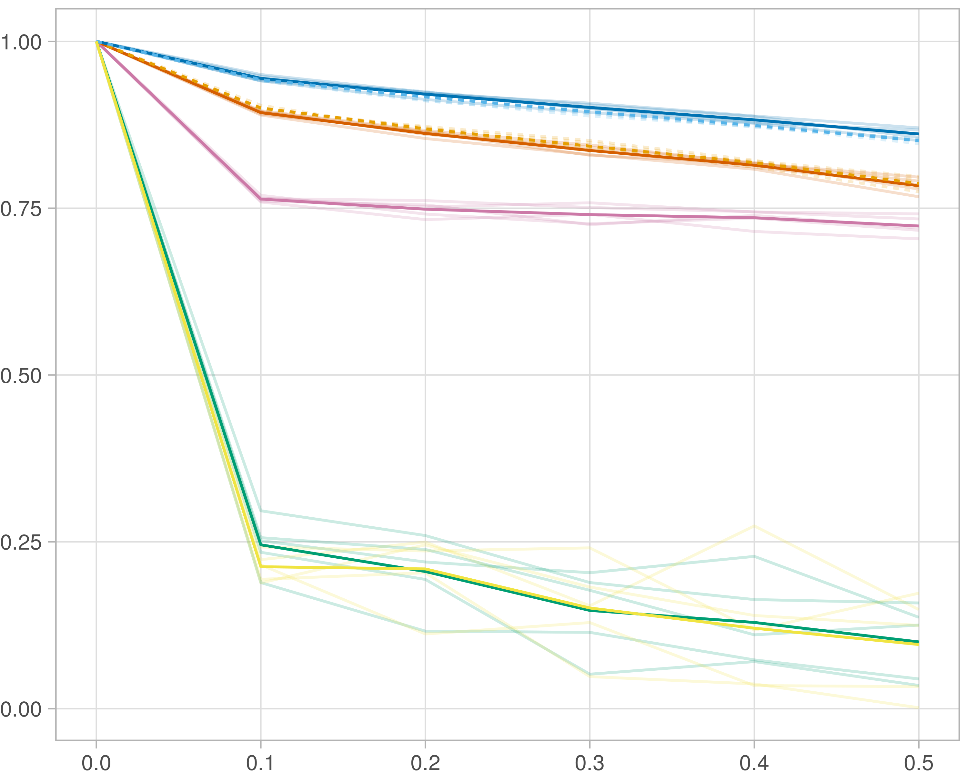

## F1-score (stability selection)

### Single-omics

#general setup  
dir <- "/workspaces/phd_dissertation/kimono/analysis/data/derived_data/"  
  
#load library  
setwd(dir)  
  
dat_raw <- fread("220411_all_project_info.csv")  
  
#dat_raw <- cbind(dat_raw[,c(1,2,3,16,18)],nodes=dat_raw$V6+dat_raw$V8+dat_raw$V10)  
#dat_raw <- dat_raw[dat_raw$iteration == 1,]  
  
dat_raw$method <- gsub(pattern = "_moran|_mos|_mor|_so|_sor",replacement = "",x = dat_raw$method)  
  
dat <- dat_raw[tolower(dat_raw$method) %in% c("galasso_false","galasso_true","knn_kimono","salasso_false","salasso_true","cocolasso","hmlasso"),]  
  
  
#ggplot(dat, aes(x=clustering, y=n_genes+n_methylation+n_cnv, color=as.factor(method)) )+  
# geom_point(alpha=0.5) + facet_grid(experiment~noise)  
  
#ggplot(dat, aes(y=clustering, x=missingness, color=as.factor(method)) )+  
# geom_point(alpha=0.5) + facet_grid(experiment~noise)  
  
#ggplot(dat, aes(x=missingness, y=clustering,fill=as.factor(method)))+  
# scale_y_continuous(trans='sqrt') + geom_boxplot() + facet_grid(experiment~noise)  
  
  
dat$method <- as.factor(dat$method)   
dat <- dat %>% mutate(method = fct_relevel(method, "knn_kimono", "galasso_false" ,"galasso_true" , "salasso_false" , "salasso_true" ,"cocolasso", "hmlasso" ))  
dat$experiment <- as.factor(dat$experiment)  
dat <- dat %>% mutate(experiment = fct_relevel(experiment, "so", "moran" ,"mos" , "sor" , "mor"))  
  
palette_OkabeIto <- c( "#CC79A7", "#D55E00", "#E69F00","#0072B2", "#56B4E9", "#009E73", "#F0E442")  
  
dat <- aggregate(dat[, -c(1:8)], list('noise'=dat$noise,  
 'missingness'=dat$missingness,  
 'method'=dat$method,  
 'experiment'=dat$experiment), function(x){mean(x,na.rm=TRUE)})  
  
dat_raw$method <- as.factor(dat_raw$method)   
dat_raw <- dat_raw %>% mutate(method = fct_relevel(method, "knn_kimono", "galasso_false" ,"galasso_true" , "salasso_false" , "salasso_true" ,"cocolasso", "hmlasso" ))  
dat_raw$experiment <- as.factor(dat_raw$experiment)  
dat_raw <- dat_raw %>% mutate(experiment = fct_relevel(experiment, "so", "moran" ,"mos" , "sor" , "mor"))  
  
dat_raw <- dat_raw[ dat_raw$noise==0 & dat_raw$experiment %in% 'so' & !dat_raw$method %in% "bdcoco_lasso",]  
dat <- dat[ dat$noise==0 & dat$experiment %in% 'so' & !dat$method %in% "bdcoco_lasso",]  
  
dat_raw$adaptive <- grepl(pattern = "true",x = dat_raw$method)  
dat$adaptive <- grepl(pattern = "true",x = dat$method)  
  
p <- ggplot(dat_raw,   
 aes(y= (f1_score_stability), x=missingness,color=as.factor(method)))+  
   
 geom_line(aes( group = interaction(method, iteration),linetype=adaptive),alpha = 0.2)+  
 facet_grid(noise~experiment, scales="free")+  
 scale_color_manual(values = palette_OkabeIto)+  
 scale_fill_manual(values = palette_OkabeIto)+   
 theme_light() +  
 theme(legend.position="bottom",  
 axis.text.x = element_text(size = 8),  
 axis.text.y = element_text(size = 8),  
 strip.background = element_blank(),   
 plot.margin = unit(c(-0.5, -0.5, 0, 0), "cm")  
 ) +  
 ylab("#Nodes")   
  
to.plot5 <- p + geom_line(data = dat,   
 aes(y= (f1_score_stability), x=missingness, color=as.factor(method),linetype=adaptive)) +   
 theme(strip.background = element_blank(), panel.grid.minor = element_blank(),  
 legend.position = "none",  
 axis.title.x=element_blank(),  
 #axis.text.x=element_blank(),  
 #axis.ticks.x=element_blank(),  
 axis.title.y=element_blank(),  
 #axis.text.y=element_blank(),  
 #axis.ticks.y=element_blank(),   
 plot.margin = unit(c(-0.5, -0.5, 0, 0), "cm")  
 )  
  
to.plot5

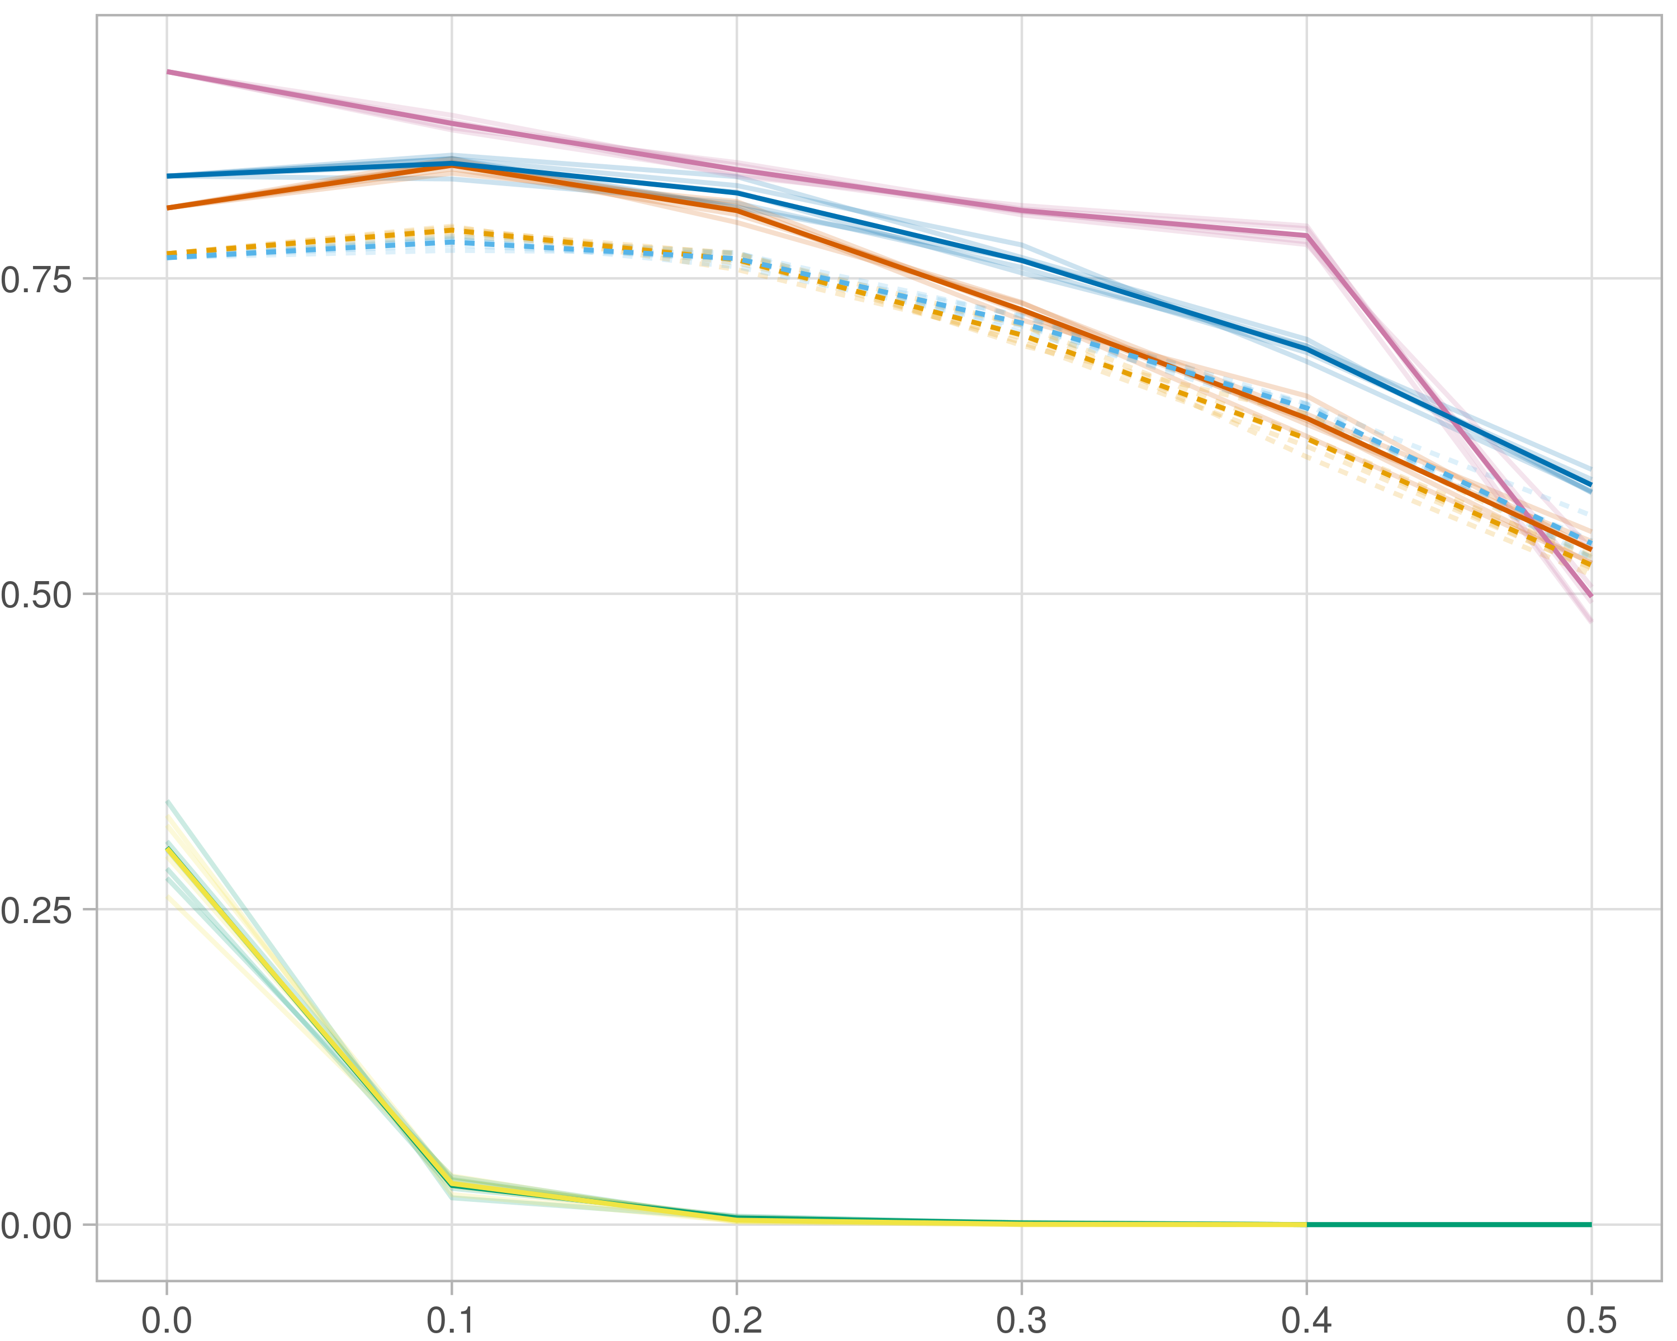

### Multi-omics

#general setup  
dir <- "/workspaces/phd_dissertation/kimono/analysis/data/derived_data/"  
  
#load library  
setwd(dir)  
  
dat_raw <- fread("220411_all_project_info.csv")  
  
#dat_raw <- cbind(dat_raw[,c(1,2,3,16,18)],nodes=dat_raw$V6+dat_raw$V8+dat_raw$V10)  
#dat_raw <- dat_raw[dat_raw$iteration == 1,]  
  
dat_raw$method <- gsub(pattern = "_moran|_mos|_mor|_so|_sor",replacement = "",x = dat_raw$method)  
  
dat <- dat_raw[tolower(dat_raw$method) %in% c("galasso_false","galasso_true","knn_kimono","salasso_false","salasso_true","cocolasso","hmlasso"),]  
  
  
#ggplot(dat, aes(x=clustering, y=n_genes+n_methylation+n_cnv, color=as.factor(method)) )+  
# geom_point(alpha=0.5) + facet_grid(experiment~noise)  
  
#ggplot(dat, aes(y=clustering, x=missingness, color=as.factor(method)) )+  
# geom_point(alpha=0.5) + facet_grid(experiment~noise)  
  
#ggplot(dat, aes(x=missingness, y=clustering,fill=as.factor(method)))+  
# scale_y_continuous(trans='sqrt') + geom_boxplot() + facet_grid(experiment~noise)  
  
  
dat$method <- as.factor(dat$method)   
dat <- dat %>% mutate(method = fct_relevel(method, "knn_kimono", "galasso_false" ,"galasso_true" , "salasso_false" , "salasso_true" ,"cocolasso", "hmlasso" ))  
dat$experiment <- as.factor(dat$experiment)  
dat <- dat %>% mutate(experiment = fct_relevel(experiment, "so", "moran" ,"mos" , "sor" , "mor"))  
  
palette_OkabeIto <- c( "#CC79A7", "#D55E00", "#E69F00","#0072B2", "#56B4E9", "#009E73", "#F0E442")  
  
dat <- aggregate(dat[, -c(1:8)], list('noise'=dat$noise,  
 'missingness'=dat$missingness,  
 'method'=dat$method,  
 'experiment'=dat$experiment), function(x){mean(x,na.rm=TRUE)})  
  
dat_raw$method <- as.factor(dat_raw$method)   
dat_raw <- dat_raw %>% mutate(method = fct_relevel(method, "knn_kimono", "galasso_false" ,"galasso_true" , "salasso_false" , "salasso_true" ,"cocolasso", "hmlasso" ))  
dat_raw$experiment <- as.factor(dat_raw$experiment)  
dat_raw <- dat_raw %>% mutate(experiment = fct_relevel(experiment, "so", "moran" ,"mos" , "sor" , "mor"))  
  
dat_raw <- dat_raw[ dat_raw$noise==0 & dat_raw$experiment %in% 'moran' & !dat_raw$method %in% "bdcoco_lasso",]  
dat <- dat[ dat$noise==0 & dat$experiment %in% 'moran' & !dat$method %in% "bdcoco_lasso",]  
  
dat_raw$adaptive <- grepl(pattern = "true",x = dat_raw$method)  
dat$adaptive <- grepl(pattern = "true",x = dat$method)  
  
p <- ggplot(dat_raw,   
 aes(y= (f1_score_stability), x=missingness,color=as.factor(method)))+  
   
 geom_line(aes( group = interaction(method, iteration),linetype=adaptive),alpha = 0.2)+  
 facet_grid(noise~experiment, scales="free")+  
 scale_color_manual(values = palette_OkabeIto)+  
 scale_fill_manual(values = palette_OkabeIto)+   
 theme_light() +  
 theme(legend.position="bottom",  
 axis.text.x = element_text(size = 8),  
 axis.text.y = element_text(size = 8),  
 strip.background = element_blank(),   
 plot.margin = unit(c(-0.5, -0.5, 0, 0), "cm")  
 ) +  
 ylab("#Nodes")   
  
to.plot5 <- p + geom_line(data = dat,   
 aes(y= (f1_score_stability), x=missingness, color=as.factor(method),linetype=adaptive)) +   
 theme(strip.background = element_blank(), panel.grid.minor = element_blank(),  
 legend.position = "none",  
 axis.title.x=element_blank(),  
 #axis.text.x=element_blank(),  
 #axis.ticks.x=element_blank(),  
 axis.title.y=element_blank(),  
 #axis.text.y=element_blank(),  
 #axis.ticks.y=element_blank(),   
 plot.margin = unit(c(-0.5, -0.5, 0, 0), "cm")  
 )  
  
to.plot5

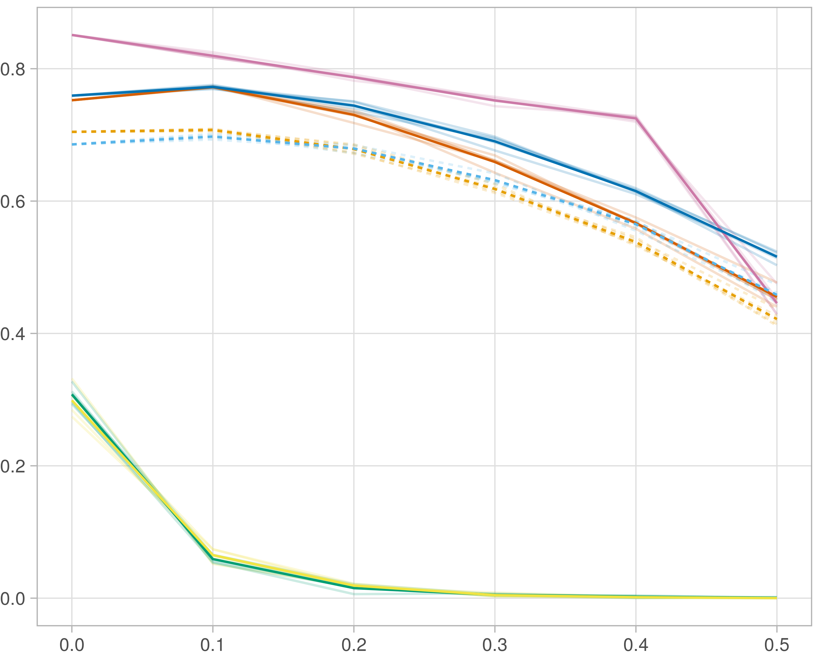

### Block-wise

#general setup  
dir <- "/workspaces/phd_dissertation/kimono/analysis/data/derived_data/"  
  
#load library  
setwd(dir)  
  
dat_raw <- fread("220411_all_project_info.csv")  
  
#dat_raw <- cbind(dat_raw[,c(1,2,3,16,18)],nodes=dat_raw$V6+dat_raw$V8+dat_raw$V10)  
#dat_raw <- dat_raw[dat_raw$iteration == 1,]  
  
dat_raw$method <- gsub(pattern = "_moran|_mos|_mor|_so|_sor",replacement = "",x = dat_raw$method)  
  
dat <- dat_raw[tolower(dat_raw$method) %in% c("galasso_false","galasso_true","knn_kimono","salasso_false","salasso_true","cocolasso","hmlasso"),]  
  
  
#ggplot(dat, aes(x=clustering, y=n_genes+n_methylation+n_cnv, color=as.factor(method)) )+  
# geom_point(alpha=0.5) + facet_grid(experiment~noise)  
  
#ggplot(dat, aes(y=clustering, x=missingness, color=as.factor(method)) )+  
# geom_point(alpha=0.5) + facet_grid(experiment~noise)  
  
#ggplot(dat, aes(x=missingness, y=clustering,fill=as.factor(method)))+  
# scale_y_continuous(trans='sqrt') + geom_boxplot() + facet_grid(experiment~noise)  
  
  
dat$method <- as.factor(dat$method)   
dat <- dat %>% mutate(method = fct_relevel(method, "knn_kimono", "galasso_false" ,"galasso_true" , "salasso_false" , "salasso_true" ,"cocolasso", "hmlasso" ))  
dat$experiment <- as.factor(dat$experiment)  
dat <- dat %>% mutate(experiment = fct_relevel(experiment, "so", "moran" ,"mos" , "sor" , "mor"))  
  
palette_OkabeIto <- c( "#CC79A7", "#D55E00", "#E69F00","#0072B2", "#56B4E9", "#009E73", "#F0E442")  
  
dat <- aggregate(dat[, -c(1:8)], list('noise'=dat$noise,  
 'missingness'=dat$missingness,  
 'method'=dat$method,  
 'experiment'=dat$experiment), function(x){mean(x,na.rm=TRUE)})  
  
dat_raw$method <- as.factor(dat_raw$method)   
dat_raw <- dat_raw %>% mutate(method = fct_relevel(method, "knn_kimono", "galasso_false" ,"galasso_true" , "salasso_false" , "salasso_true" ,"cocolasso", "hmlasso" ))  
dat_raw$experiment <- as.factor(dat_raw$experiment)  
dat_raw <- dat_raw %>% mutate(experiment = fct_relevel(experiment, "so", "moran" ,"mos" , "sor" , "mor"))  
  
dat_raw <- dat_raw[ dat_raw$noise==0 & dat_raw$experiment %in% 'mos' & !dat_raw$method %in% "bdcoco_lasso",]  
dat <- dat[ dat$noise==0 & dat$experiment %in% 'mos' & !dat$method %in% "bdcoco_lasso",]  
  
dat_raw$adaptive <- grepl(pattern = "true",x = dat_raw$method)  
dat$adaptive <- grepl(pattern = "true",x = dat$method)  
  
p <- ggplot(dat_raw,   
 aes(y= (f1_score_stability), x=missingness,color=as.factor(method)))+  
   
 geom_line(aes( group = interaction(method, iteration),linetype=adaptive),alpha = 0.2)+  
 facet_grid(noise~experiment, scales="free")+  
 scale_color_manual(values = palette_OkabeIto)+  
 scale_fill_manual(values = palette_OkabeIto)+   
 theme_light() +  
 theme(legend.position="bottom",  
 axis.text.x = element_text(size = 8),  
 axis.text.y = element_text(size = 8),  
 strip.background = element_blank(),   
 plot.margin = unit(c(-0.5, -0.5, 0, 0), "cm")  
 ) +  
 ylab("#Nodes")   
  
to.plot5 <- p + geom_line(data = dat,   
 aes(y= (f1_score_stability), x=missingness, color=as.factor(method),linetype=adaptive)) +   
 theme(strip.background = element_blank(), panel.grid.minor = element_blank(),  
 legend.position = "none",  
 axis.title.x=element_blank(),  
 #axis.text.x=element_blank(),  
 #axis.ticks.x=element_blank(),  
 axis.title.y=element_blank(),  
 #axis.text.y=element_blank(),  
 #axis.ticks.y=element_blank(),   
 plot.margin = unit(c(-0.5, -0.5, 0, 0), "cm")  
 )  
  
to.plot5

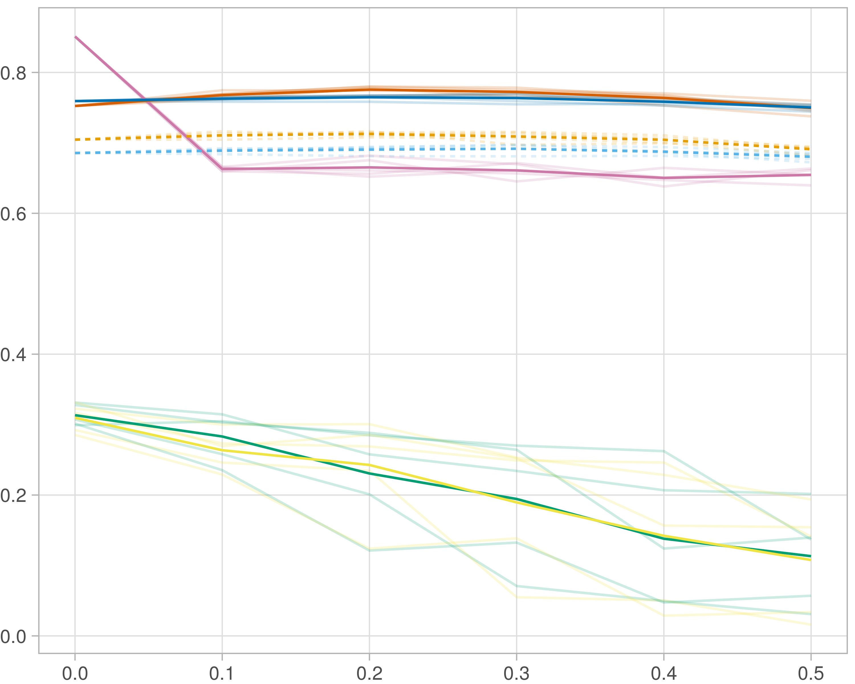

# Noise

## Number of nodes

### Single-omics

library(tidyverse)  
library(data.table)  
library(reshape)  
library(ggplot2)  
library(dplyr)  
library(viridis)  
  
#general setup  
dir <- "/workspaces/phd_dissertation/kimono/analysis/data/derived_data/"  
  
#load library  
setwd(dir)  
  
dat_raw <- fread("220411_all_project_info.csv")  
  
#dat_raw <- cbind(dat_raw[,c(1,2,3,16,18)],nodes=dat_raw$V6+dat_raw$V8+dat_raw$V10)  
#dat_raw <- dat_raw[dat_raw$iteration == 1,]  
  
dat_raw$method <- gsub(pattern = "_moran|_mos|_mor|_so|_sor",replacement = "",x = dat_raw$method)  
  
dat <- dat_raw[tolower(dat_raw$method) %in% c("galasso_false","galasso_true","knn_kimono","salasso_false","salasso_true","cocolasso","hmlasso"),]  
  
  
#ggplot(dat, aes(x=clustering, y=n_genes+n_methylation+n_cnv, color=as.factor(method)) )+  
# geom_point(alpha=0.5) + facet_grid(experiment~noise)  
  
#ggplot(dat, aes(y=clustering, x=missingness, color=as.factor(method)) )+  
# geom_point(alpha=0.5) + facet_grid(experiment~noise)  
  
#ggplot(dat, aes(x=missingness, y=clustering,fill=as.factor(method)))+  
# scale_y_continuous(trans='sqrt') + geom_boxplot() + facet_grid(experiment~noise)  
  
  
dat$method <- as.factor(dat$method)   
dat <- dat %>% mutate(method = fct_relevel(method, "knn_kimono", "galasso_false" ,"galasso_true" , "salasso_false" , "salasso_true" ,"cocolasso", "hmlasso" ))  
dat$experiment <- as.factor(dat$experiment)  
dat <- dat %>% mutate(experiment = fct_relevel(experiment, "so", "moran" ,"mos" , "sor" , "mor"))  
  
palette_OkabeIto <- c( "#CC79A7", "#D55E00", "#E69F00","#0072B2", "#56B4E9", "#009E73", "#F0E442")  
  
dat <- aggregate(dat[, -c(1:8)], list('noise'=dat$noise,  
 'missingness'=dat$missingness,  
 'method'=dat$method,  
 'experiment'=dat$experiment), function(x){mean(x,na.rm=TRUE)})  
  
dat_raw$method <- as.factor(dat_raw$method)   
dat_raw <- dat_raw %>% mutate(method = fct_relevel(method, "knn_kimono", "galasso_false" ,"galasso_true" , "salasso_false" , "salasso_true" ,"cocolasso", "hmlasso" ))  
dat_raw$experiment <- as.factor(dat_raw$experiment)  
dat_raw <- dat_raw %>% mutate(experiment = fct_relevel(experiment, "so", "moran" ,"mos" , "sor" , "mor"))  
  
dat_raw <- dat_raw[ dat_raw$noise==1.5 & dat_raw$experiment %in% 'so' & !dat_raw$method %in% "bdcoco_lasso",]  
dat <- dat[ dat$noise==1.5 & dat$experiment %in% 'so' & !dat$method %in% "bdcoco_lasso",]  
  
dat_raw$adaptive <- grepl(pattern = "true",x = dat_raw$method)  
dat$adaptive <- grepl(pattern = "true",x = dat$method)  
  
p <- ggplot(dat_raw,   
 aes(y= (n_cnv+n_genes+n_methylation), x=missingness,color=as.factor(method)))+  
   
 geom_line(aes( group = interaction(method, iteration),linetype=adaptive),alpha = 0.2)+  
 facet_grid(noise~experiment, scales="free")+  
 scale_color_manual(values = palette_OkabeIto)+  
 scale_fill_manual(values = palette_OkabeIto)+   
 theme_light() +  
 theme(legend.position="bottom",  
 axis.text.x = element_text(size = 8),  
 axis.text.y = element_text(size = 8),  
 strip.background = element_blank(),   
 plot.margin = unit(c(-0.5, -0.5, 0, 0), "cm")  
 ) +  
 ylab("#Nodes")   
  
to.plot1 <- p + geom_line(data = dat,   
 aes(y= (n_cnv+n_genes+n_methylation), x=missingness, color=as.factor(method),linetype=adaptive)) +   
 theme(strip.background = element_blank(), panel.grid.minor = element_blank(),  
 legend.position = "none",  
 axis.title.x=element_blank(),  
 #axis.text.x=element_blank(),  
 #axis.ticks.x=element_blank(),  
 axis.title.y=element_blank(),  
 #axis.text.y=element_blank(),  
 #axis.ticks.y=element_blank(),   
 plot.margin = unit(c(-0.5, -0.5, 0, 0), "cm")  
 )  
  
to.plot1

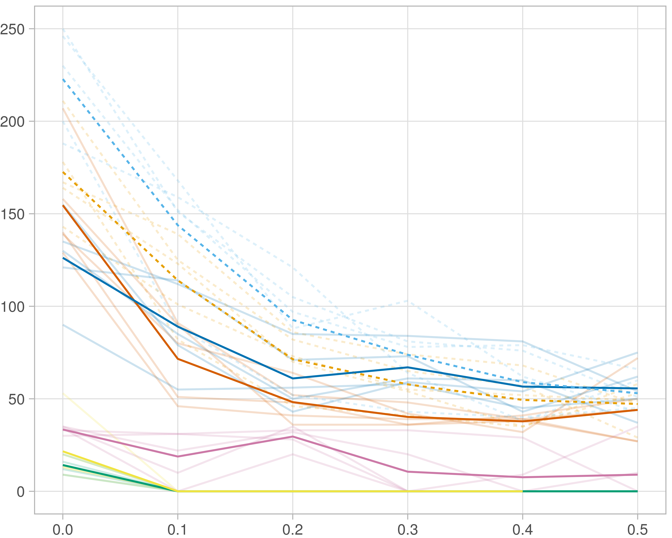

### Multi-omics

#general setup  
dir <- "/workspaces/phd_dissertation/kimono/analysis/data/derived_data/"  
  
#load library  
setwd(dir)  
  
dat_raw <- fread("220411_all_project_info.csv")  
  
#dat_raw <- cbind(dat_raw[,c(1,2,3,16,18)],nodes=dat_raw$V6+dat_raw$V8+dat_raw$V10)  
#dat_raw <- dat_raw[dat_raw$iteration == 1,]  
  
dat_raw$method <- gsub(pattern = "_moran|_mos|_mor|_so|_sor",replacement = "",x = dat_raw$method)  
  
dat <- dat_raw[tolower(dat_raw$method) %in% c("galasso_false","galasso_true","knn_kimono","salasso_false","salasso_true","cocolasso","hmlasso"),]  
  
  
#ggplot(dat, aes(x=clustering, y=n_genes+n_methylation+n_cnv, color=as.factor(method)) )+  
# geom_point(alpha=0.5) + facet_grid(experiment~noise)  
  
#ggplot(dat, aes(y=clustering, x=missingness, color=as.factor(method)) )+  
# geom_point(alpha=0.5) + facet_grid(experiment~noise)  
  
#ggplot(dat, aes(x=missingness, y=clustering,fill=as.factor(method)))+  
# scale_y_continuous(trans='sqrt') + geom_boxplot() + facet_grid(experiment~noise)  
  
  
dat$method <- as.factor(dat$method)   
dat <- dat %>% mutate(method = fct_relevel(method, "knn_kimono", "galasso_false" ,"galasso_true" , "salasso_false" , "salasso_true" ,"cocolasso", "hmlasso" ))  
dat$experiment <- as.factor(dat$experiment)  
dat <- dat %>% mutate(experiment = fct_relevel(experiment, "so", "moran" ,"mos" , "sor" , "mor"))  
  
palette_OkabeIto <- c( "#CC79A7", "#D55E00", "#E69F00","#0072B2", "#56B4E9", "#009E73", "#F0E442")  
  
dat <- aggregate(dat[, -c(1:8)], list('noise'=dat$noise,  
 'missingness'=dat$missingness,  
 'method'=dat$method,  
 'experiment'=dat$experiment), function(x){mean(x,na.rm=TRUE)})  
  
dat_raw$method <- as.factor(dat_raw$method)   
dat_raw <- dat_raw %>% mutate(method = fct_relevel(method, "knn_kimono", "galasso_false" ,"galasso_true" , "salasso_false" , "salasso_true" ,"cocolasso", "hmlasso" ))  
dat_raw$experiment <- as.factor(dat_raw$experiment)  
dat_raw <- dat_raw %>% mutate(experiment = fct_relevel(experiment, "so", "moran" ,"mos" , "sor" , "mor"))  
  
dat_raw <- dat_raw[ dat_raw$noise==1.5 & dat_raw$experiment %in% 'moran' & !dat_raw$method %in% "bdcoco_lasso",]  
dat <- dat[ dat$noise==1.5 & dat$experiment %in% 'moran' & !dat$method %in% "bdcoco_lasso",]  
  
dat_raw$adaptive <- grepl(pattern = "true",x = dat_raw$method)  
dat$adaptive <- grepl(pattern = "true",x = dat$method)  
  
p <- ggplot(dat_raw,   
 aes(y= (n_cnv+n_genes+n_methylation), x=missingness,color=as.factor(method)))+  
   
 geom_line(aes( group = interaction(method, iteration),linetype=adaptive),alpha = 0.2)+  
 facet_grid(noise~experiment, scales="free")+  
 scale_color_manual(values = palette_OkabeIto)+  
 scale_fill_manual(values = palette_OkabeIto)+   
 theme_light() +  
 theme(legend.position="bottom",  
 axis.text.x = element_text(size = 8),  
 axis.text.y = element_text(size = 8),  
 strip.background = element_blank(),   
 plot.margin = unit(c(-0.5, -0.5, 0, 0), "cm")  
 ) +  
 ylab("#Nodes")   
  
to.plot1 <- p + geom_line(data = dat,   
 aes(y= (n_cnv+n_genes+n_methylation), x=missingness, color=as.factor(method),linetype=adaptive)) +   
 theme(strip.background = element_blank(), panel.grid.minor = element_blank(),  
 legend.position = "none",  
 axis.title.x=element_blank(),  
 #axis.text.x=element_blank(),  
 #axis.ticks.x=element_blank(),  
 axis.title.y=element_blank(),  
 #axis.text.y=element_blank(),  
 #axis.ticks.y=element_blank(),   
 plot.margin = unit(c(-0.5, -0.5, 0, 0), "cm")  
 )  
  
to.plot1

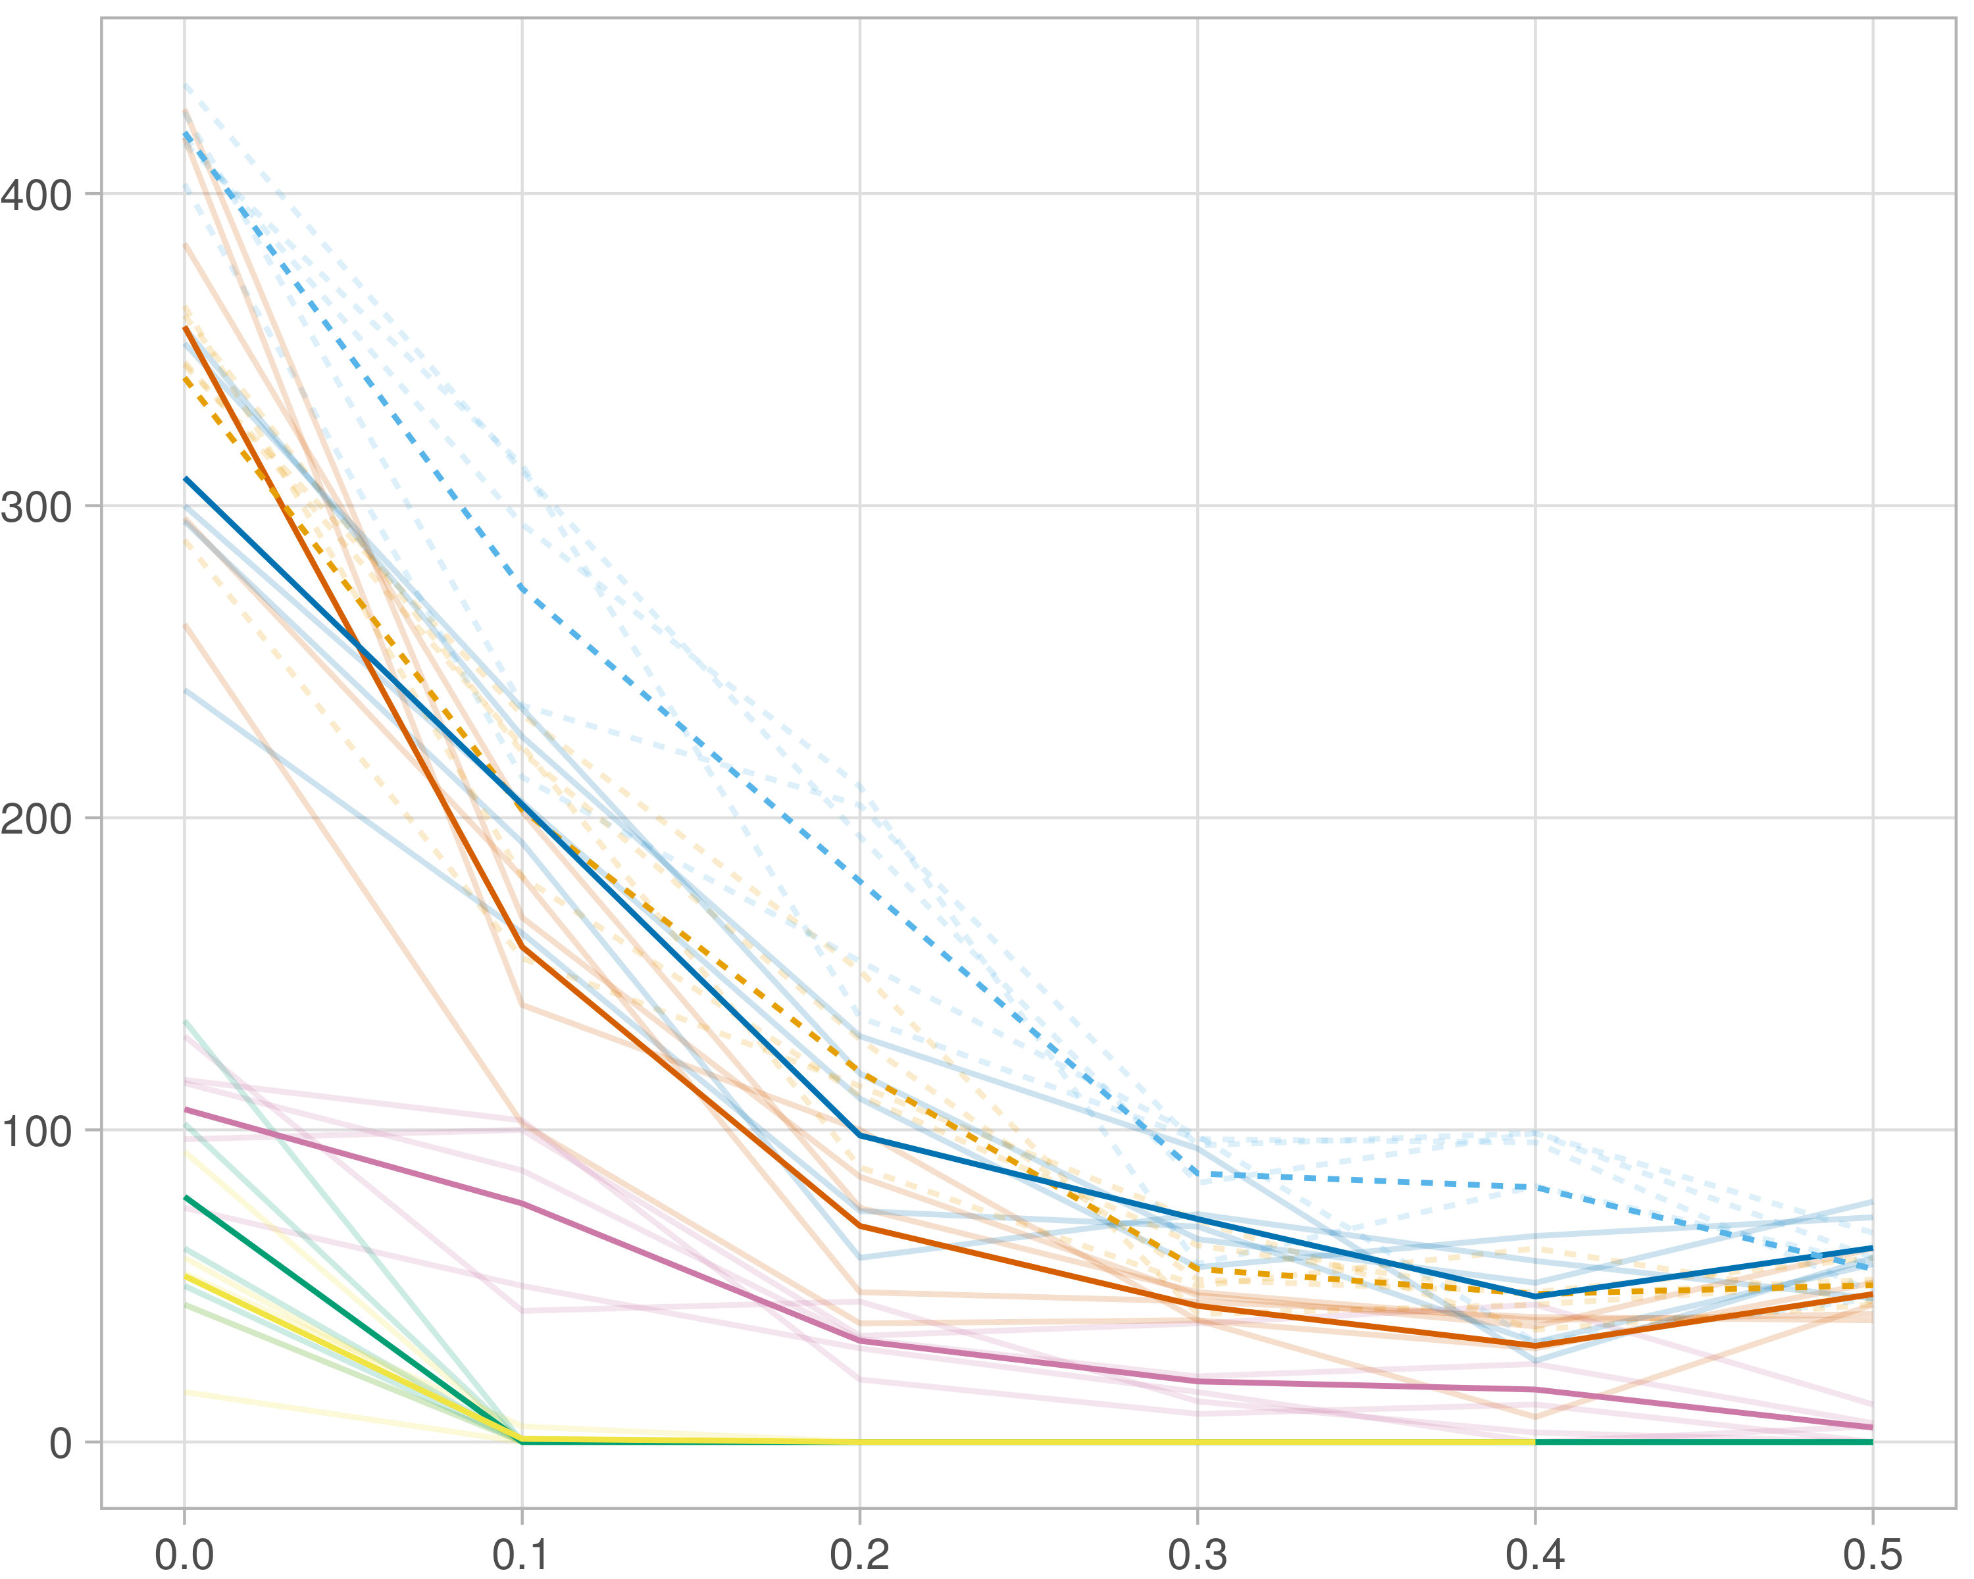

### Block-wise

#general setup  
dir <- "/workspaces/phd_dissertation/kimono/analysis/data/derived_data/"  
  
#load library  
setwd(dir)  
  
dat_raw <- fread("220411_all_project_info.csv")  
  
#dat_raw <- cbind(dat_raw[,c(1,2,3,16,18)],nodes=dat_raw$V6+dat_raw$V8+dat_raw$V10)  
#dat_raw <- dat_raw[dat_raw$iteration == 1,]  
  
dat_raw$method <- gsub(pattern = "_moran|_mos|_mor|_so|_sor",replacement = "",x = dat_raw$method)  
  
dat <- dat_raw[tolower(dat_raw$method) %in% c("galasso_false","galasso_true","knn_kimono","salasso_false","salasso_true","cocolasso","hmlasso"),]  
  
  
#ggplot(dat, aes(x=clustering, y=n_genes+n_methylation+n_cnv, color=as.factor(method)) )+  
# geom_point(alpha=0.5) + facet_grid(experiment~noise)  
  
#ggplot(dat, aes(y=clustering, x=missingness, color=as.factor(method)) )+  
# geom_point(alpha=0.5) + facet_grid(experiment~noise)  
  
#ggplot(dat, aes(x=missingness, y=clustering,fill=as.factor(method)))+  
# scale_y_continuous(trans='sqrt') + geom_boxplot() + facet_grid(experiment~noise)  
  
  
dat$method <- as.factor(dat$method)   
dat <- dat %>% mutate(method = fct_relevel(method, "knn_kimono", "galasso_false" ,"galasso_true" , "salasso_false" , "salasso_true" ,"cocolasso", "hmlasso" ))  
dat$experiment <- as.factor(dat$experiment)  
dat <- dat %>% mutate(experiment = fct_relevel(experiment, "so", "moran" ,"mos" , "sor" , "mor"))  
  
palette_OkabeIto <- c( "#CC79A7", "#D55E00", "#E69F00","#0072B2", "#56B4E9", "#009E73", "#F0E442")  
  
dat <- aggregate(dat[, -c(1:8)], list('noise'=dat$noise,  
 'missingness'=dat$missingness,  
 'method'=dat$method,  
 'experiment'=dat$experiment), function(x){mean(x,na.rm=TRUE)})  
  
dat_raw$method <- as.factor(dat_raw$method)   
dat_raw <- dat_raw %>% mutate(method = fct_relevel(method, "knn_kimono", "galasso_false" ,"galasso_true" , "salasso_false" , "salasso_true" ,"cocolasso", "hmlasso" ))  
dat_raw$experiment <- as.factor(dat_raw$experiment)  
dat_raw <- dat_raw %>% mutate(experiment = fct_relevel(experiment, "so", "moran" ,"mos" , "sor" , "mor"))  
  
dat_raw <- dat_raw[ dat_raw$noise==1.5 & dat_raw$experiment %in% 'mos' & !dat_raw$method %in% "bdcoco_lasso",]  
dat <- dat[ dat$noise==1.5 & dat$experiment %in% 'mos' & !dat$method %in% "bdcoco_lasso",]  
  
dat_raw$adaptive <- grepl(pattern = "true",x = dat_raw$method)  
dat$adaptive <- grepl(pattern = "true",x = dat$method)  
  
p <- ggplot(dat_raw,   
 aes(y= (n_cnv+n_genes+n_methylation), x=missingness,color=as.factor(method)))+  
   
 geom_line(aes( group = interaction(method, iteration),linetype=adaptive),alpha = 0.2)+  
 facet_grid(noise~experiment, scales="free")+  
 scale_color_manual(values = palette_OkabeIto)+  
 scale_fill_manual(values = palette_OkabeIto)+   
 theme_light() +  
 theme(legend.position="bottom",  
 axis.text.x = element_text(size = 8),  
 axis.text.y = element_text(size = 8),  
 strip.background = element_blank(),   
 plot.margin = unit(c(-0.5, -0.5, 0, 0), "cm")  
 ) +  
 ylab("#Nodes")   
  
to.plot1 <- p + geom_line(data = dat,   
 aes(y= (n_cnv+n_genes+n_methylation), x=missingness, color=as.factor(method),linetype=adaptive)) +   
 theme(strip.background = element_blank(), panel.grid.minor = element_blank(),  
 legend.position = "none",  
 axis.title.x=element_blank(),  
 #axis.text.x=element_blank(),  
 #axis.ticks.x=element_blank(),  
 axis.title.y=element_blank(),  
 #axis.text.y=element_blank(),  
 #axis.ticks.y=element_blank(),   
 plot.margin = unit(c(-0.5, -0.5, 0, 0), "cm")  
 )  
  
to.plot1

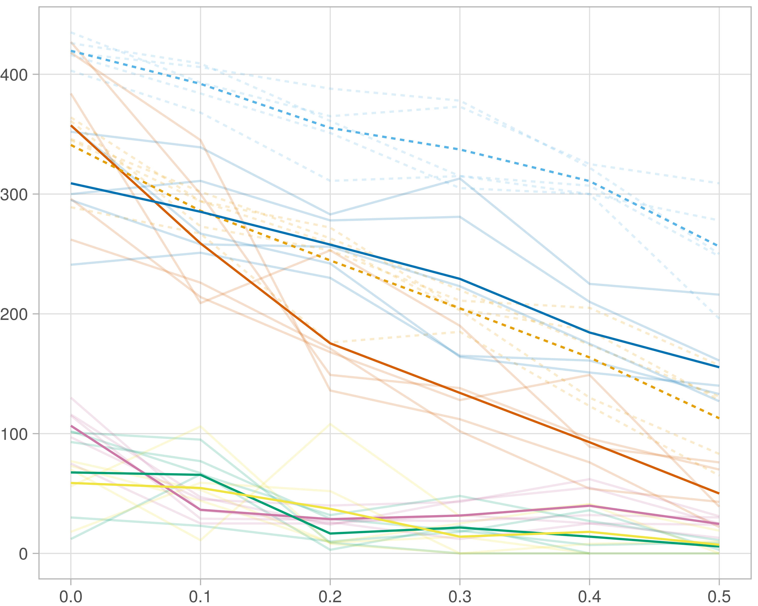

## Transitivity

### Single-omics

#general setup  
dir <- "/workspaces/phd_dissertation/kimono/analysis/data/derived_data/"  
  
#load library  
setwd(dir)  
  
dat_raw <- fread("220411_all_project_info.csv")  
  
#dat_raw <- cbind(dat_raw[,c(1,2,3,16,18)],nodes=dat_raw$V6+dat_raw$V8+dat_raw$V10)  
#dat_raw <- dat_raw[dat_raw$iteration == 1,]  
  
dat_raw$method <- gsub(pattern = "_moran|_mos|_mor|_so|_sor",replacement = "",x = dat_raw$method)  
  
dat <- dat_raw[tolower(dat_raw$method) %in% c("galasso_false","galasso_true","knn_kimono","salasso_false","salasso_true","cocolasso","hmlasso"),]  
  
  
#ggplot(dat, aes(x=clustering, y=n_genes+n_methylation+n_cnv, color=as.factor(method)) )+  
# geom_point(alpha=0.5) + facet_grid(experiment~noise)  
  
#ggplot(dat, aes(y=clustering, x=missingness, color=as.factor(method)) )+  
# geom_point(alpha=0.5) + facet_grid(experiment~noise)  
  
#ggplot(dat, aes(x=missingness, y=clustering,fill=as.factor(method)))+  
# scale_y_continuous(trans='sqrt') + geom_boxplot() + facet_grid(experiment~noise)  
  
  
dat$method <- as.factor(dat$method)   
dat <- dat %>% mutate(method = fct_relevel(method, "knn_kimono", "galasso_false" ,"galasso_true" , "salasso_false" , "salasso_true" ,"cocolasso", "hmlasso" ))  
dat$experiment <- as.factor(dat$experiment)  
dat <- dat %>% mutate(experiment = fct_relevel(experiment, "so", "moran" ,"mos" , "sor" , "mor"))  
  
palette_OkabeIto <- c( "#CC79A7", "#D55E00", "#E69F00","#0072B2", "#56B4E9", "#009E73", "#F0E442")  
  
dat <- aggregate(dat[, -c(1:8)], list('noise'=dat$noise,  
 'missingness'=dat$missingness,  
 'method'=dat$method,  
 'experiment'=dat$experiment), function(x){mean(x,na.rm=TRUE)})  
  
dat_raw$method <- as.factor(dat_raw$method)   
dat_raw <- dat_raw %>% mutate(method = fct_relevel(method, "knn_kimono", "galasso_false" ,"galasso_true" , "salasso_false" , "salasso_true" ,"cocolasso", "hmlasso" ))  
dat_raw$experiment <- as.factor(dat_raw$experiment)  
dat_raw <- dat_raw %>% mutate(experiment = fct_relevel(experiment, "so", "moran" ,"mos" , "sor" , "mor"))  
  
dat_raw <- dat_raw[ dat_raw$noise==1.5 & dat_raw$experiment %in% 'so' & !dat_raw$method %in% "bdcoco_lasso",]  
dat <- dat[ dat$noise==1.5 & dat$experiment %in% 'so' & !dat$method %in% "bdcoco_lasso",]  
  
dat_raw$adaptive <- grepl(pattern = "true",x = dat_raw$method)  
dat$adaptive <- grepl(pattern = "true",x = dat$method)  
  
p <- ggplot(dat_raw,   
 aes(y= (clustering), x=missingness,color=as.factor(method)))+  
   
 geom_line(aes( group = interaction(method, iteration),linetype=adaptive),alpha = 0.2)+  
 facet_grid(noise~experiment, scales="free")+  
 scale_color_manual(values = palette_OkabeIto)+  
 scale_fill_manual(values = palette_OkabeIto)+   
 theme_light() +  
 theme(legend.position="bottom",  
 axis.text.x = element_text(size = 8),  
 axis.text.y = element_text(size = 8),  
 strip.background = element_blank(),   
 plot.margin = unit(c(-0.5, -0.5, 0, 0), "cm")  
 ) +  
 ylab("#Nodes")   
  
to.plot2 <- p + geom_line(data = dat,   
 aes(y= (clustering), x=missingness, color=as.factor(method),linetype=adaptive)) +   
 theme(strip.background = element_blank(), panel.grid.minor = element_blank(),  
 legend.position = "none",  
 axis.title.x=element_blank(),  
 #axis.text.x=element_blank(),  
 #axis.ticks.x=element_blank(),  
 axis.title.y=element_blank(),  
 #axis.text.y=element_blank(),  
 #axis.ticks.y=element_blank(),   
 plot.margin = unit(c(-0.5, -0.5, 0, 0), "cm")  
 )  
  
to.plot2

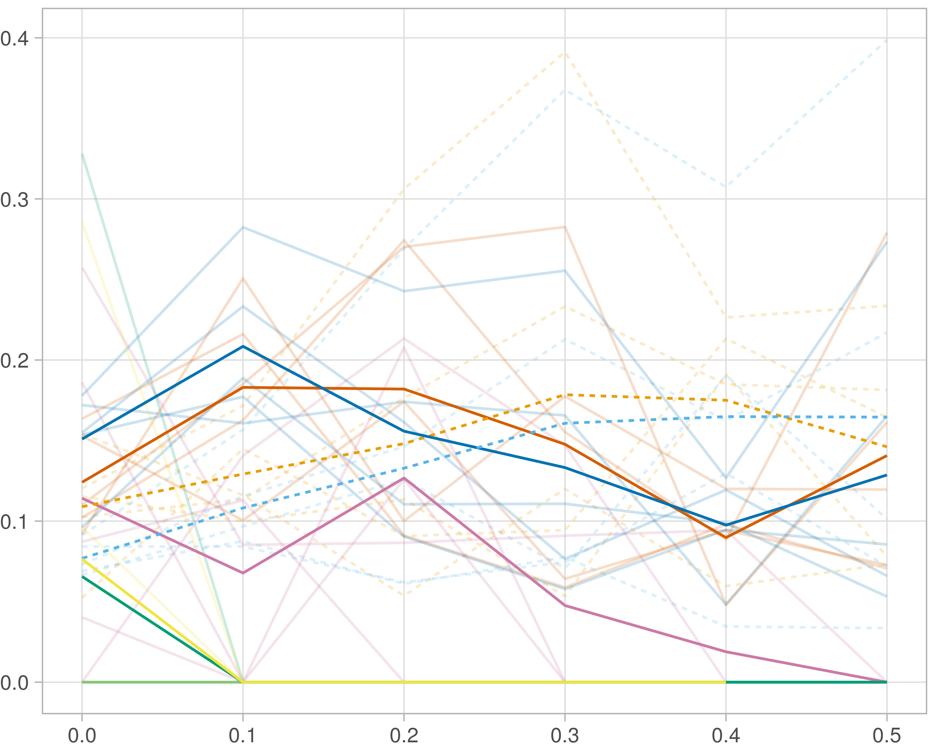

### Multi-omics

#general setup  
dir <- "/workspaces/phd_dissertation/kimono/analysis/data/derived_data/"  
  
#load library  
setwd(dir)  
  
dat_raw <- fread("220411_all_project_info.csv")  
  
#dat_raw <- cbind(dat_raw[,c(1,2,3,16,18)],nodes=dat_raw$V6+dat_raw$V8+dat_raw$V10)  
#dat_raw <- dat_raw[dat_raw$iteration == 1,]  
  
dat_raw$method <- gsub(pattern = "_moran|_mos|_mor|_so|_sor",replacement = "",x = dat_raw$method)  
  
dat <- dat_raw[tolower(dat_raw$method) %in% c("galasso_false","galasso_true","knn_kimono","salasso_false","salasso_true","cocolasso","hmlasso"),]  
  
  
#ggplot(dat, aes(x=clustering, y=n_genes+n_methylation+n_cnv, color=as.factor(method)) )+  
# geom_point(alpha=0.5) + facet_grid(experiment~noise)  
  
#ggplot(dat, aes(y=clustering, x=missingness, color=as.factor(method)) )+  
# geom_point(alpha=0.5) + facet_grid(experiment~noise)  
  
#ggplot(dat, aes(x=missingness, y=clustering,fill=as.factor(method)))+  
# scale_y_continuous(trans='sqrt') + geom_boxplot() + facet_grid(experiment~noise)  
  
  
dat$method <- as.factor(dat$method)   
dat <- dat %>% mutate(method = fct_relevel(method, "knn_kimono", "galasso_false" ,"galasso_true" , "salasso_false" , "salasso_true" ,"cocolasso", "hmlasso" ))  
dat$experiment <- as.factor(dat$experiment)  
dat <- dat %>% mutate(experiment = fct_relevel(experiment, "so", "moran" ,"mos" , "sor" , "mor"))  
  
palette_OkabeIto <- c( "#CC79A7", "#D55E00", "#E69F00","#0072B2", "#56B4E9", "#009E73", "#F0E442")  
  
dat <- aggregate(dat[, -c(1:8)], list('noise'=dat$noise,  
 'missingness'=dat$missingness,  
 'method'=dat$method,  
 'experiment'=dat$experiment), function(x){mean(x,na.rm=TRUE)})  
  
dat_raw$method <- as.factor(dat_raw$method)   
dat_raw <- dat_raw %>% mutate(method = fct_relevel(method, "knn_kimono", "galasso_false" ,"galasso_true" , "salasso_false" , "salasso_true" ,"cocolasso", "hmlasso" ))  
dat_raw$experiment <- as.factor(dat_raw$experiment)  
dat_raw <- dat_raw %>% mutate(experiment = fct_relevel(experiment, "so", "moran" ,"mos" , "sor" , "mor"))  
  
dat_raw <- dat_raw[ dat_raw$noise==1.5 & dat_raw$experiment %in% 'moran' & !dat_raw$method %in% "bdcoco_lasso",]  
dat <- dat[ dat$noise==1.5 & dat$experiment %in% 'moran' & !dat$method %in% "bdcoco_lasso",]  
  
dat_raw$adaptive <- grepl(pattern = "true",x = dat_raw$method)  
dat$adaptive <- grepl(pattern = "true",x = dat$method)  
  
p <- ggplot(dat_raw,   
 aes(y= (clustering), x=missingness,color=as.factor(method)))+  
   
 geom_line(aes( group = interaction(method, iteration),linetype=adaptive),alpha = 0.2)+  
 facet_grid(noise~experiment, scales="free")+  
 scale_color_manual(values = palette_OkabeIto)+  
 scale_fill_manual(values = palette_OkabeIto)+   
 theme_light() +  
 theme(legend.position="bottom",  
 axis.text.x = element_text(size = 8),  
 axis.text.y = element_text(size = 8),  
 strip.background = element_blank(),   
 plot.margin = unit(c(-0.5, -0.5, 0, 0), "cm")  
 ) +  
 ylab("#Nodes")   
  
to.plot2 <- p + geom_line(data = dat,   
 aes(y= (clustering), x=missingness, color=as.factor(method),linetype=adaptive)) +   
 theme(strip.background = element_blank(), panel.grid.minor = element_blank(),  
 legend.position = "none",  
 axis.title.x=element_blank(),  
 #axis.text.x=element_blank(),  
 #axis.ticks.x=element_blank(),  
 axis.title.y=element_blank(),  
 #axis.text.y=element_blank(),  
 #axis.ticks.y=element_blank(),   
 plot.margin = unit(c(-0.5, -0.5, 0, 0), "cm")  
 )  
  
to.plot2

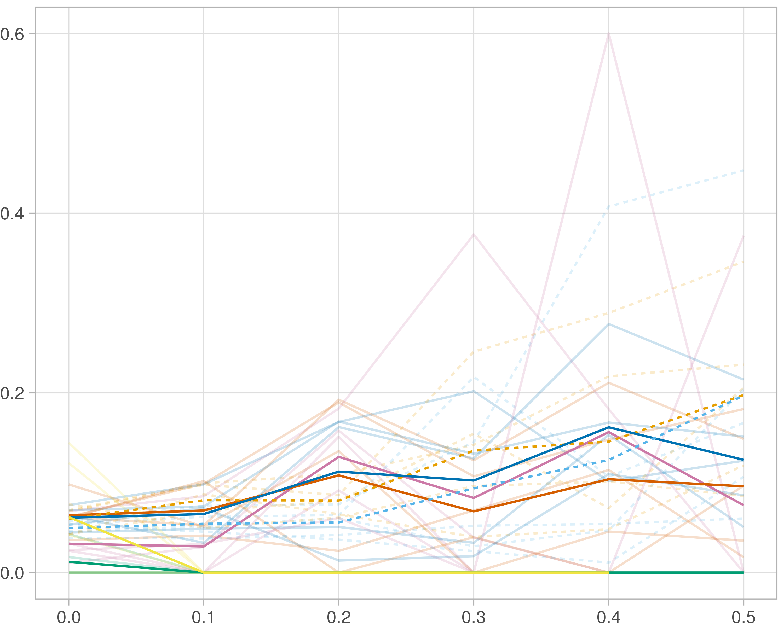

### Block-wise

#general setup  
dir <- "/workspaces/phd_dissertation/kimono/analysis/data/derived_data/"  
  
#load library  
setwd(dir)  
  
dat_raw <- fread("220411_all_project_info.csv")  
  
#dat_raw <- cbind(dat_raw[,c(1,2,3,16,18)],nodes=dat_raw$V6+dat_raw$V8+dat_raw$V10)  
#dat_raw <- dat_raw[dat_raw$iteration == 1,]  
  
dat_raw$method <- gsub(pattern = "_moran|_mos|_mor|_so|_sor",replacement = "",x = dat_raw$method)  
  
dat <- dat_raw[tolower(dat_raw$method) %in% c("galasso_false","galasso_true","knn_kimono","salasso_false","salasso_true","cocolasso","hmlasso"),]  
  
  
#ggplot(dat, aes(x=clustering, y=n_genes+n_methylation+n_cnv, color=as.factor(method)) )+  
# geom_point(alpha=0.5) + facet_grid(experiment~noise)  
  
#ggplot(dat, aes(y=clustering, x=missingness, color=as.factor(method)) )+  
# geom_point(alpha=0.5) + facet_grid(experiment~noise)  
  
#ggplot(dat, aes(x=missingness, y=clustering,fill=as.factor(method)))+  
# scale_y_continuous(trans='sqrt') + geom_boxplot() + facet_grid(experiment~noise)  
  
  
dat$method <- as.factor(dat$method)   
dat <- dat %>% mutate(method = fct_relevel(method, "knn_kimono", "galasso_false" ,"galasso_true" , "salasso_false" , "salasso_true" ,"cocolasso", "hmlasso" ))  
dat$experiment <- as.factor(dat$experiment)  
dat <- dat %>% mutate(experiment = fct_relevel(experiment, "so", "moran" ,"mos" , "sor" , "mor"))  
  
palette_OkabeIto <- c( "#CC79A7", "#D55E00", "#E69F00","#0072B2", "#56B4E9", "#009E73", "#F0E442")  
  
dat <- aggregate(dat[, -c(1:8)], list('noise'=dat$noise,  
 'missingness'=dat$missingness,  
 'method'=dat$method,  
 'experiment'=dat$experiment), function(x){mean(x,na.rm=TRUE)})  
  
dat_raw$method <- as.factor(dat_raw$method)   
dat_raw <- dat_raw %>% mutate(method = fct_relevel(method, "knn_kimono", "galasso_false" ,"galasso_true" , "salasso_false" , "salasso_true" ,"cocolasso", "hmlasso" ))  
dat_raw$experiment <- as.factor(dat_raw$experiment)  
dat_raw <- dat_raw %>% mutate(experiment = fct_relevel(experiment, "so", "moran" ,"mos" , "sor" , "mor"))  
  
dat_raw <- dat_raw[ dat_raw$noise==1.5 & dat_raw$experiment %in% 'mos' & !dat_raw$method %in% "bdcoco_lasso",]  
dat <- dat[ dat$noise==1.5 & dat$experiment %in% 'mos' & !dat$method %in% "bdcoco_lasso",]  
  
dat_raw$adaptive <- grepl(pattern = "true",x = dat_raw$method)  
dat$adaptive <- grepl(pattern = "true",x = dat$method)  
  
p <- ggplot(dat_raw,   
 aes(y= (clustering), x=missingness,color=as.factor(method)))+  
   
 geom_line(aes( group = interaction(method, iteration),linetype=adaptive),alpha = 0.2)+  
 facet_grid(noise~experiment, scales="free")+  
 scale_color_manual(values = palette_OkabeIto)+  
 scale_fill_manual(values = palette_OkabeIto)+   
 theme_light() +  
 theme(legend.position="bottom",  
 axis.text.x = element_text(size = 8),  
 axis.text.y = element_text(size = 8),  
 strip.background = element_blank(),   
 plot.margin = unit(c(-0.5, -0.5, 0, 0), "cm")  
 ) +  
 ylab("#Nodes")   
  
to.plot2 <- p + geom_line(data = dat,   
 aes(y= (clustering), x=missingness, color=as.factor(method),linetype=adaptive)) +   
 theme(strip.background = element_blank(), panel.grid.minor = element_blank(),  
 legend.position = "none",  
 axis.title.x=element_blank(),  
 #axis.text.x=element_blank(),  
 #axis.ticks.x=element_blank(),  
 axis.title.y=element_blank(),  
 #axis.text.y=element_blank(),  
 #axis.ticks.y=element_blank(),   
 plot.margin = unit(c(-0.5, -0.5, 0, 0), "cm")  
 )  
  
to.plot2

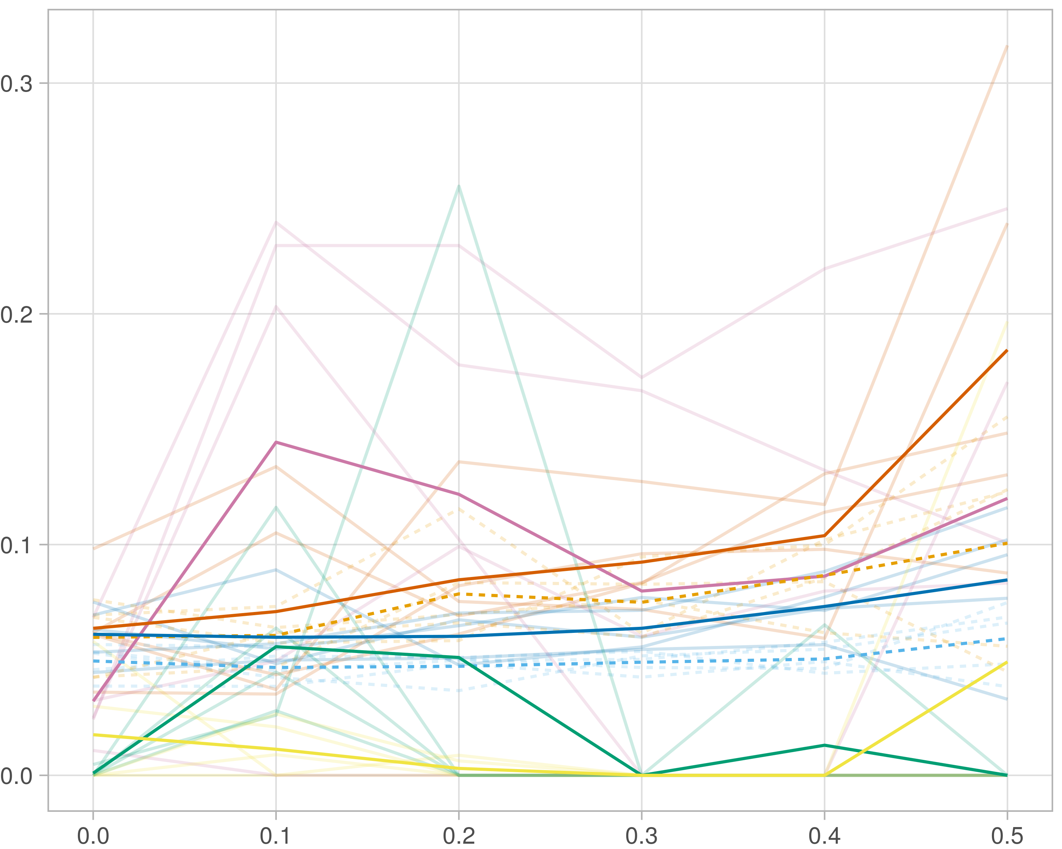

## Median R-squared

### Single-omics

#general setup  
dir <- "/workspaces/phd_dissertation/kimono/analysis/data/derived_data/"  
  
#load library  
setwd(dir)  
  
dat_raw <- fread("220411_all_project_info.csv")  
  
#dat_raw <- cbind(dat_raw[,c(1,2,3,16,18)],nodes=dat_raw$V6+dat_raw$V8+dat_raw$V10)  
#dat_raw <- dat_raw[dat_raw$iteration == 1,]  
  
dat_raw$method <- gsub(pattern = "_moran|_mos|_mor|_so|_sor",replacement = "",x = dat_raw$method)  
  
dat <- dat_raw[tolower(dat_raw$method) %in% c("galasso_false","galasso_true","knn_kimono","salasso_false","salasso_true","cocolasso","hmlasso"),]  
  
  
#ggplot(dat, aes(x=clustering, y=n_genes+n_methylation+n_cnv, color=as.factor(method)) )+  
# geom_point(alpha=0.5) + facet_grid(experiment~noise)  
  
#ggplot(dat, aes(y=clustering, x=missingness, color=as.factor(method)) )+  
# geom_point(alpha=0.5) + facet_grid(experiment~noise)  
  
#ggplot(dat, aes(x=missingness, y=clustering,fill=as.factor(method)))+  
# scale_y_continuous(trans='sqrt') + geom_boxplot() + facet_grid(experiment~noise)  
  
  
dat$method <- as.factor(dat$method)   
dat <- dat %>% mutate(method = fct_relevel(method, "knn_kimono", "galasso_false" ,"galasso_true" , "salasso_false" , "salasso_true" ,"cocolasso", "hmlasso" ))  
dat$experiment <- as.factor(dat$experiment)  
dat <- dat %>% mutate(experiment = fct_relevel(experiment, "so", "moran" ,"mos" , "sor" , "mor"))  
  
palette_OkabeIto <- c( "#CC79A7", "#D55E00", "#E69F00","#0072B2", "#56B4E9", "#009E73", "#F0E442")  
  
dat <- aggregate(dat[, -c(1:8)], list('noise'=dat$noise,  
 'missingness'=dat$missingness,  
 'method'=dat$method,  
 'experiment'=dat$experiment), function(x){mean(x,na.rm=TRUE)})  
  
dat_raw$method <- as.factor(dat_raw$method)   
dat_raw <- dat_raw %>% mutate(method = fct_relevel(method, "knn_kimono", "galasso_false" ,"galasso_true" , "salasso_false" , "salasso_true" ,"cocolasso", "hmlasso" ))  
dat_raw$experiment <- as.factor(dat_raw$experiment)  
dat_raw <- dat_raw %>% mutate(experiment = fct_relevel(experiment, "so", "moran" ,"mos" , "sor" , "mor"))  
  
dat_raw <- dat_raw[ dat_raw$noise==1.5 & dat_raw$experiment %in% 'so' & !dat_raw$method %in% "bdcoco_lasso",]  
dat <- dat[ dat$noise==1.5 & dat$experiment %in% 'so' & !dat$method %in% "bdcoco_lasso",]  
  
dat_raw$adaptive <- grepl(pattern = "true",x = dat_raw$method)  
dat$adaptive <- grepl(pattern = "true",x = dat$method)  
  
p <- ggplot(dat_raw,   
 aes(y= (median_r2), x=missingness,color=as.factor(method)))+  
   
 geom_line(aes( group = interaction(method, iteration),linetype=adaptive),alpha = 0.2)+  
 facet_grid(noise~experiment, scales="free")+  
 scale_color_manual(values = palette_OkabeIto)+  
 scale_fill_manual(values = palette_OkabeIto)+   
 theme_light() +  
 theme(legend.position="bottom",  
 axis.text.x = element_text(size = 8),  
 axis.text.y = element_text(size = 8),  
 strip.background = element_blank(),   
 plot.margin = unit(c(-0.5, -0.5, 0, 0), "cm")  
 ) +  
 ylab("#Nodes")   
  
to.plot3 <- p + geom_line(data = dat,   
 aes(y= (median_r2), x=missingness, color=as.factor(method),linetype=adaptive)) +   
 theme(strip.background = element_blank(), panel.grid.minor = element_blank(),  
 legend.position = "none",  
 axis.title.x=element_blank(),  
 #axis.text.x=element_blank(),  
 #axis.ticks.x=element_blank(),  
 axis.title.y=element_blank(),  
 #axis.text.y=element_blank(),  
 #axis.ticks.y=element_blank(),   
 plot.margin = unit(c(-0.5, -0.5, 0, 0), "cm")  
 )  
  
to.plot3

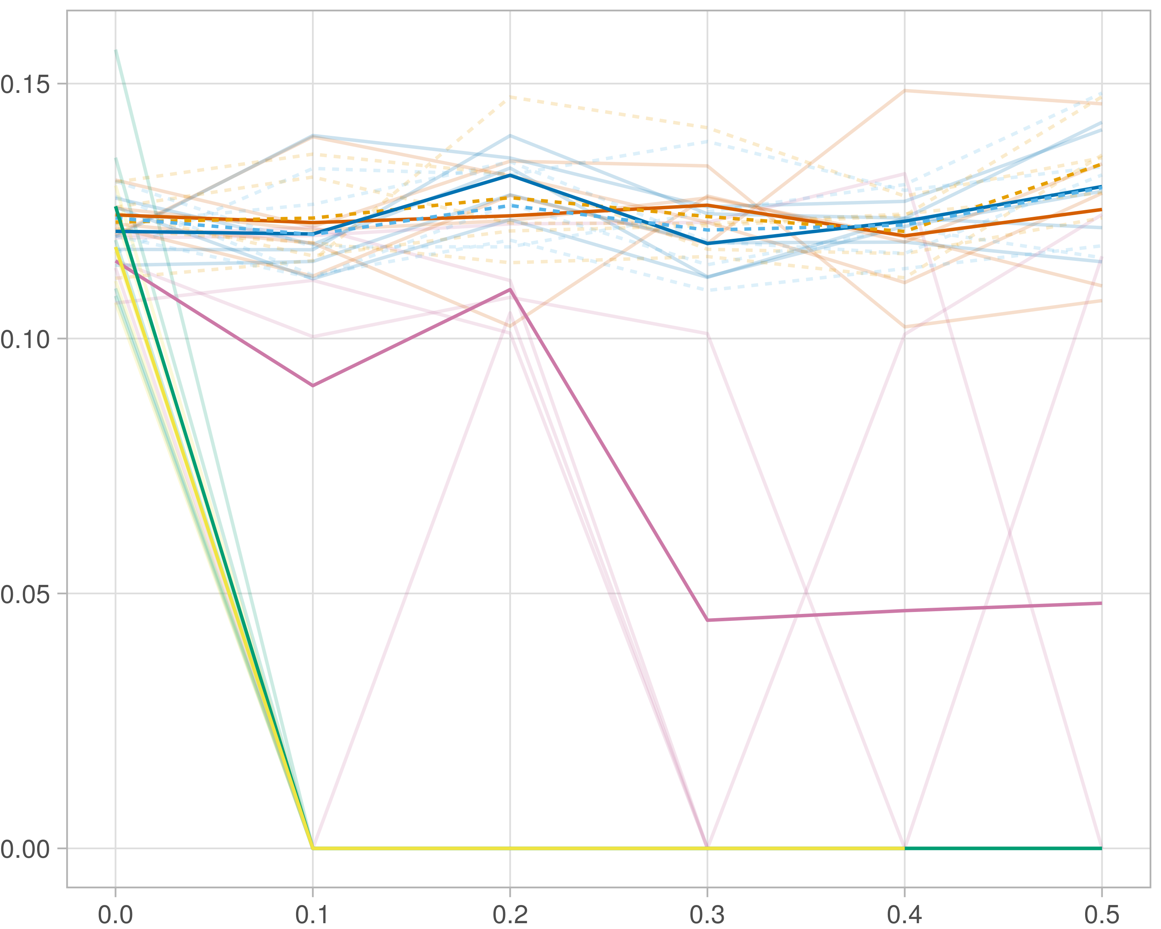

### Multi_omics

#general setup  
dir <- "/workspaces/phd_dissertation/kimono/analysis/data/derived_data/"  
  
#load library  
setwd(dir)  
  
dat_raw <- fread("220411_all_project_info.csv")  
  
#dat_raw <- cbind(dat_raw[,c(1,2,3,16,18)],nodes=dat_raw$V6+dat_raw$V8+dat_raw$V10)  
#dat_raw <- dat_raw[dat_raw$iteration == 1,]  
  
dat_raw$method <- gsub(pattern = "_moran|_mos|_mor|_so|_sor",replacement = "",x = dat_raw$method)  
  
dat <- dat_raw[tolower(dat_raw$method) %in% c("galasso_false","galasso_true","knn_kimono","salasso_false","salasso_true","cocolasso","hmlasso"),]  
  
  
#ggplot(dat, aes(x=clustering, y=n_genes+n_methylation+n_cnv, color=as.factor(method)) )+  
# geom_point(alpha=0.5) + facet_grid(experiment~noise)  
  
#ggplot(dat, aes(y=clustering, x=missingness, color=as.factor(method)) )+  
# geom_point(alpha=0.5) + facet_grid(experiment~noise)  
  
#ggplot(dat, aes(x=missingness, y=clustering,fill=as.factor(method)))+  
# scale_y_continuous(trans='sqrt') + geom_boxplot() + facet_grid(experiment~noise)  
  
  
dat$method <- as.factor(dat$method)   
dat <- dat %>% mutate(method = fct_relevel(method, "knn_kimono", "galasso_false" ,"galasso_true" , "salasso_false" , "salasso_true" ,"cocolasso", "hmlasso" ))  
dat$experiment <- as.factor(dat$experiment)  
dat <- dat %>% mutate(experiment = fct_relevel(experiment, "so", "moran" ,"mos" , "sor" , "mor"))  
  
palette_OkabeIto <- c( "#CC79A7", "#D55E00", "#E69F00","#0072B2", "#56B4E9", "#009E73", "#F0E442")  
  
dat <- aggregate(dat[, -c(1:8)], list('noise'=dat$noise,  
 'missingness'=dat$missingness,  
 'method'=dat$method,  
 'experiment'=dat$experiment), function(x){mean(x,na.rm=TRUE)})  
  
dat_raw$method <- as.factor(dat_raw$method)   
dat_raw <- dat_raw %>% mutate(method = fct_relevel(method, "knn_kimono", "galasso_false" ,"galasso_true" , "salasso_false" , "salasso_true" ,"cocolasso", "hmlasso" ))  
dat_raw$experiment <- as.factor(dat_raw$experiment)  
dat_raw <- dat_raw %>% mutate(experiment = fct_relevel(experiment, "so", "moran" ,"mos" , "sor" , "mor"))  
  
dat_raw <- dat_raw[ dat_raw$noise==1.5 & dat_raw$experiment %in% 'moran' & !dat_raw$method %in% "bdcoco_lasso",]  
dat <- dat[ dat$noise==1.5 & dat$experiment %in% 'moran' & !dat$method %in% "bdcoco_lasso",]  
  
dat_raw$adaptive <- grepl(pattern = "true",x = dat_raw$method)  
dat$adaptive <- grepl(pattern = "true",x = dat$method)  
  
p <- ggplot(dat_raw,   
 aes(y= (median_r2), x=missingness,color=as.factor(method)))+  
   
 geom_line(aes( group = interaction(method, iteration),linetype=adaptive),alpha = 0.2)+  
 facet_grid(noise~experiment, scales="free")+  
 scale_color_manual(values = palette_OkabeIto)+  
 scale_fill_manual(values = palette_OkabeIto)+   
 theme_light() +  
 theme(legend.position="bottom",  
 axis.text.x = element_text(size = 8),  
 axis.text.y = element_text(size = 8),  
 strip.background = element_blank(),   
 plot.margin = unit(c(-0.5, -0.5, 0, 0), "cm")  
 ) +  
 ylab("#Nodes")   
  
to.plot3 <- p + geom_line(data = dat,   
 aes(y= (median_r2), x=missingness, color=as.factor(method),linetype=adaptive)) +   
 theme(strip.background = element_blank(), panel.grid.minor = element_blank(),  
 legend.position = "none",  
 axis.title.x=element_blank(),  
 #axis.text.x=element_blank(),  
 #axis.ticks.x=element_blank(),  
 axis.title.y=element_blank(),  
 #axis.text.y=element_blank(),  
 #axis.ticks.y=element_blank(),   
 plot.margin = unit(c(-0.5, -0.5, 0, 0), "cm")  
 )  
  
to.plot3

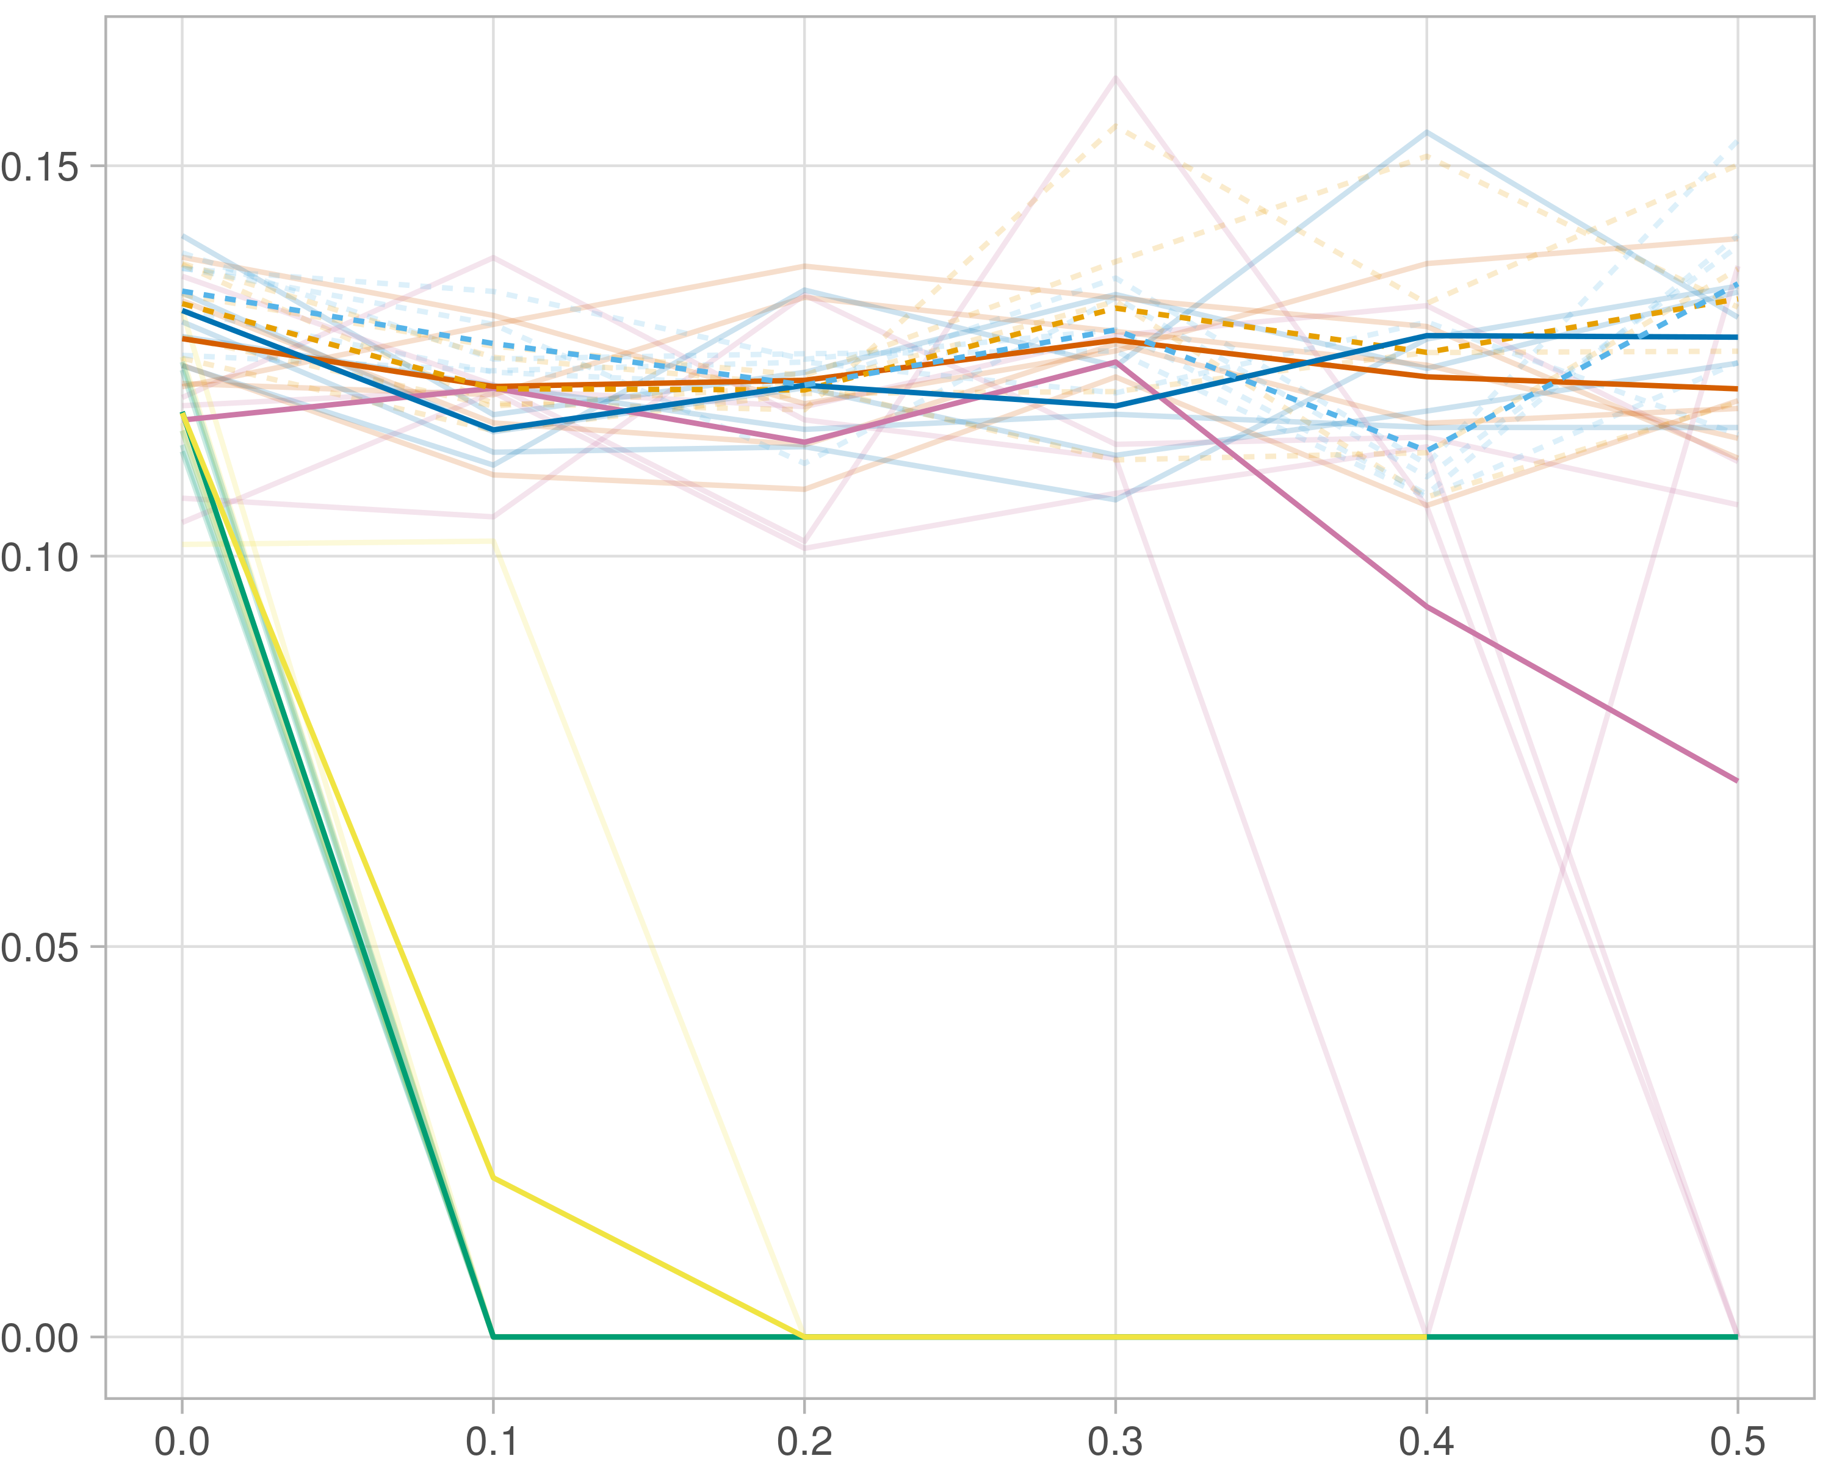

### Block-wise

#general setup  
dir <- "/workspaces/phd_dissertation/kimono/analysis/data/derived_data/"  
  
#load library  
setwd(dir)  
  
dat_raw <- fread("220411_all_project_info.csv")  
  
#dat_raw <- cbind(dat_raw[,c(1,2,3,16,18)],nodes=dat_raw$V6+dat_raw$V8+dat_raw$V10)  
#dat_raw <- dat_raw[dat_raw$iteration == 1,]  
  
dat_raw$method <- gsub(pattern = "_moran|_mos|_mor|_so|_sor",replacement = "",x = dat_raw$method)  
  
dat <- dat_raw[tolower(dat_raw$method) %in% c("galasso_false","galasso_true","knn_kimono","salasso_false","salasso_true","cocolasso","hmlasso"),]  
  
  
#ggplot(dat, aes(x=clustering, y=n_genes+n_methylation+n_cnv, color=as.factor(method)) )+  
# geom_point(alpha=0.5) + facet_grid(experiment~noise)  
  
#ggplot(dat, aes(y=clustering, x=missingness, color=as.factor(method)) )+  
# geom_point(alpha=0.5) + facet_grid(experiment~noise)  
  
#ggplot(dat, aes(x=missingness, y=clustering,fill=as.factor(method)))+  
# scale_y_continuous(trans='sqrt') + geom_boxplot() + facet_grid(experiment~noise)  
  
  
dat$method <- as.factor(dat$method)   
dat <- dat %>% mutate(method = fct_relevel(method, "knn_kimono", "galasso_false" ,"galasso_true" , "salasso_false" , "salasso_true" ,"cocolasso", "hmlasso" ))  
dat$experiment <- as.factor(dat$experiment)  
dat <- dat %>% mutate(experiment = fct_relevel(experiment, "so", "moran" ,"mos" , "sor" , "mor"))  
  
palette_OkabeIto <- c( "#CC79A7", "#D55E00", "#E69F00","#0072B2", "#56B4E9", "#009E73", "#F0E442")  
  
dat <- aggregate(dat[, -c(1:8)], list('noise'=dat$noise,  
 'missingness'=dat$missingness,  
 'method'=dat$method,  
 'experiment'=dat$experiment), function(x){mean(x,na.rm=TRUE)})  
  
dat_raw$method <- as.factor(dat_raw$method)   
dat_raw <- dat_raw %>% mutate(method = fct_relevel(method, "knn_kimono", "galasso_false" ,"galasso_true" , "salasso_false" , "salasso_true" ,"cocolasso", "hmlasso" ))  
dat_raw$experiment <- as.factor(dat_raw$experiment)  
dat_raw <- dat_raw %>% mutate(experiment = fct_relevel(experiment, "so", "moran" ,"mos" , "sor" , "mor"))  
  
dat_raw <- dat_raw[ dat_raw$noise==1.5 & dat_raw$experiment %in% 'mos' & !dat_raw$method %in% "bdcoco_lasso",]  
dat <- dat[ dat$noise==1.5 & dat$experiment %in% 'mos' & !dat$method %in% "bdcoco_lasso",]  
  
dat_raw$adaptive <- grepl(pattern = "true",x = dat_raw$method)  
dat$adaptive <- grepl(pattern = "true",x = dat$method)  
  
p <- ggplot(dat_raw,   
 aes(y= (median_r2), x=missingness,color=as.factor(method)))+  
   
 geom_line(aes( group = interaction(method, iteration),linetype=adaptive),alpha = 0.2)+  
 facet_grid(noise~experiment, scales="free")+  
 scale_color_manual(values = palette_OkabeIto)+  
 scale_fill_manual(values = palette_OkabeIto)+   
 theme_light() +  
 theme(legend.position="bottom",  
 axis.text.x = element_text(size = 8),  
 axis.text.y = element_text(size = 8),  
 strip.background = element_blank(),   
 plot.margin = unit(c(-0.5, -0.5, 0, 0), "cm")  
 ) +  
 ylab("#Nodes")   
  
to.plot3 <- p + geom_line(data = dat,   
 aes(y= (median_r2), x=missingness, color=as.factor(method),linetype=adaptive)) +   
 theme(strip.background = element_blank(), panel.grid.minor = element_blank(),  
 legend.position = "none",  
 axis.title.x=element_blank(),  
 #axis.text.x=element_blank(),  
 #axis.ticks.x=element_blank(),  
 axis.title.y=element_blank(),  
 #axis.text.y=element_blank(),  
 #axis.ticks.y=element_blank(),   
 plot.margin = unit(c(-0.5, -0.5, 0, 0), "cm")  
 )  
  
to.plot3

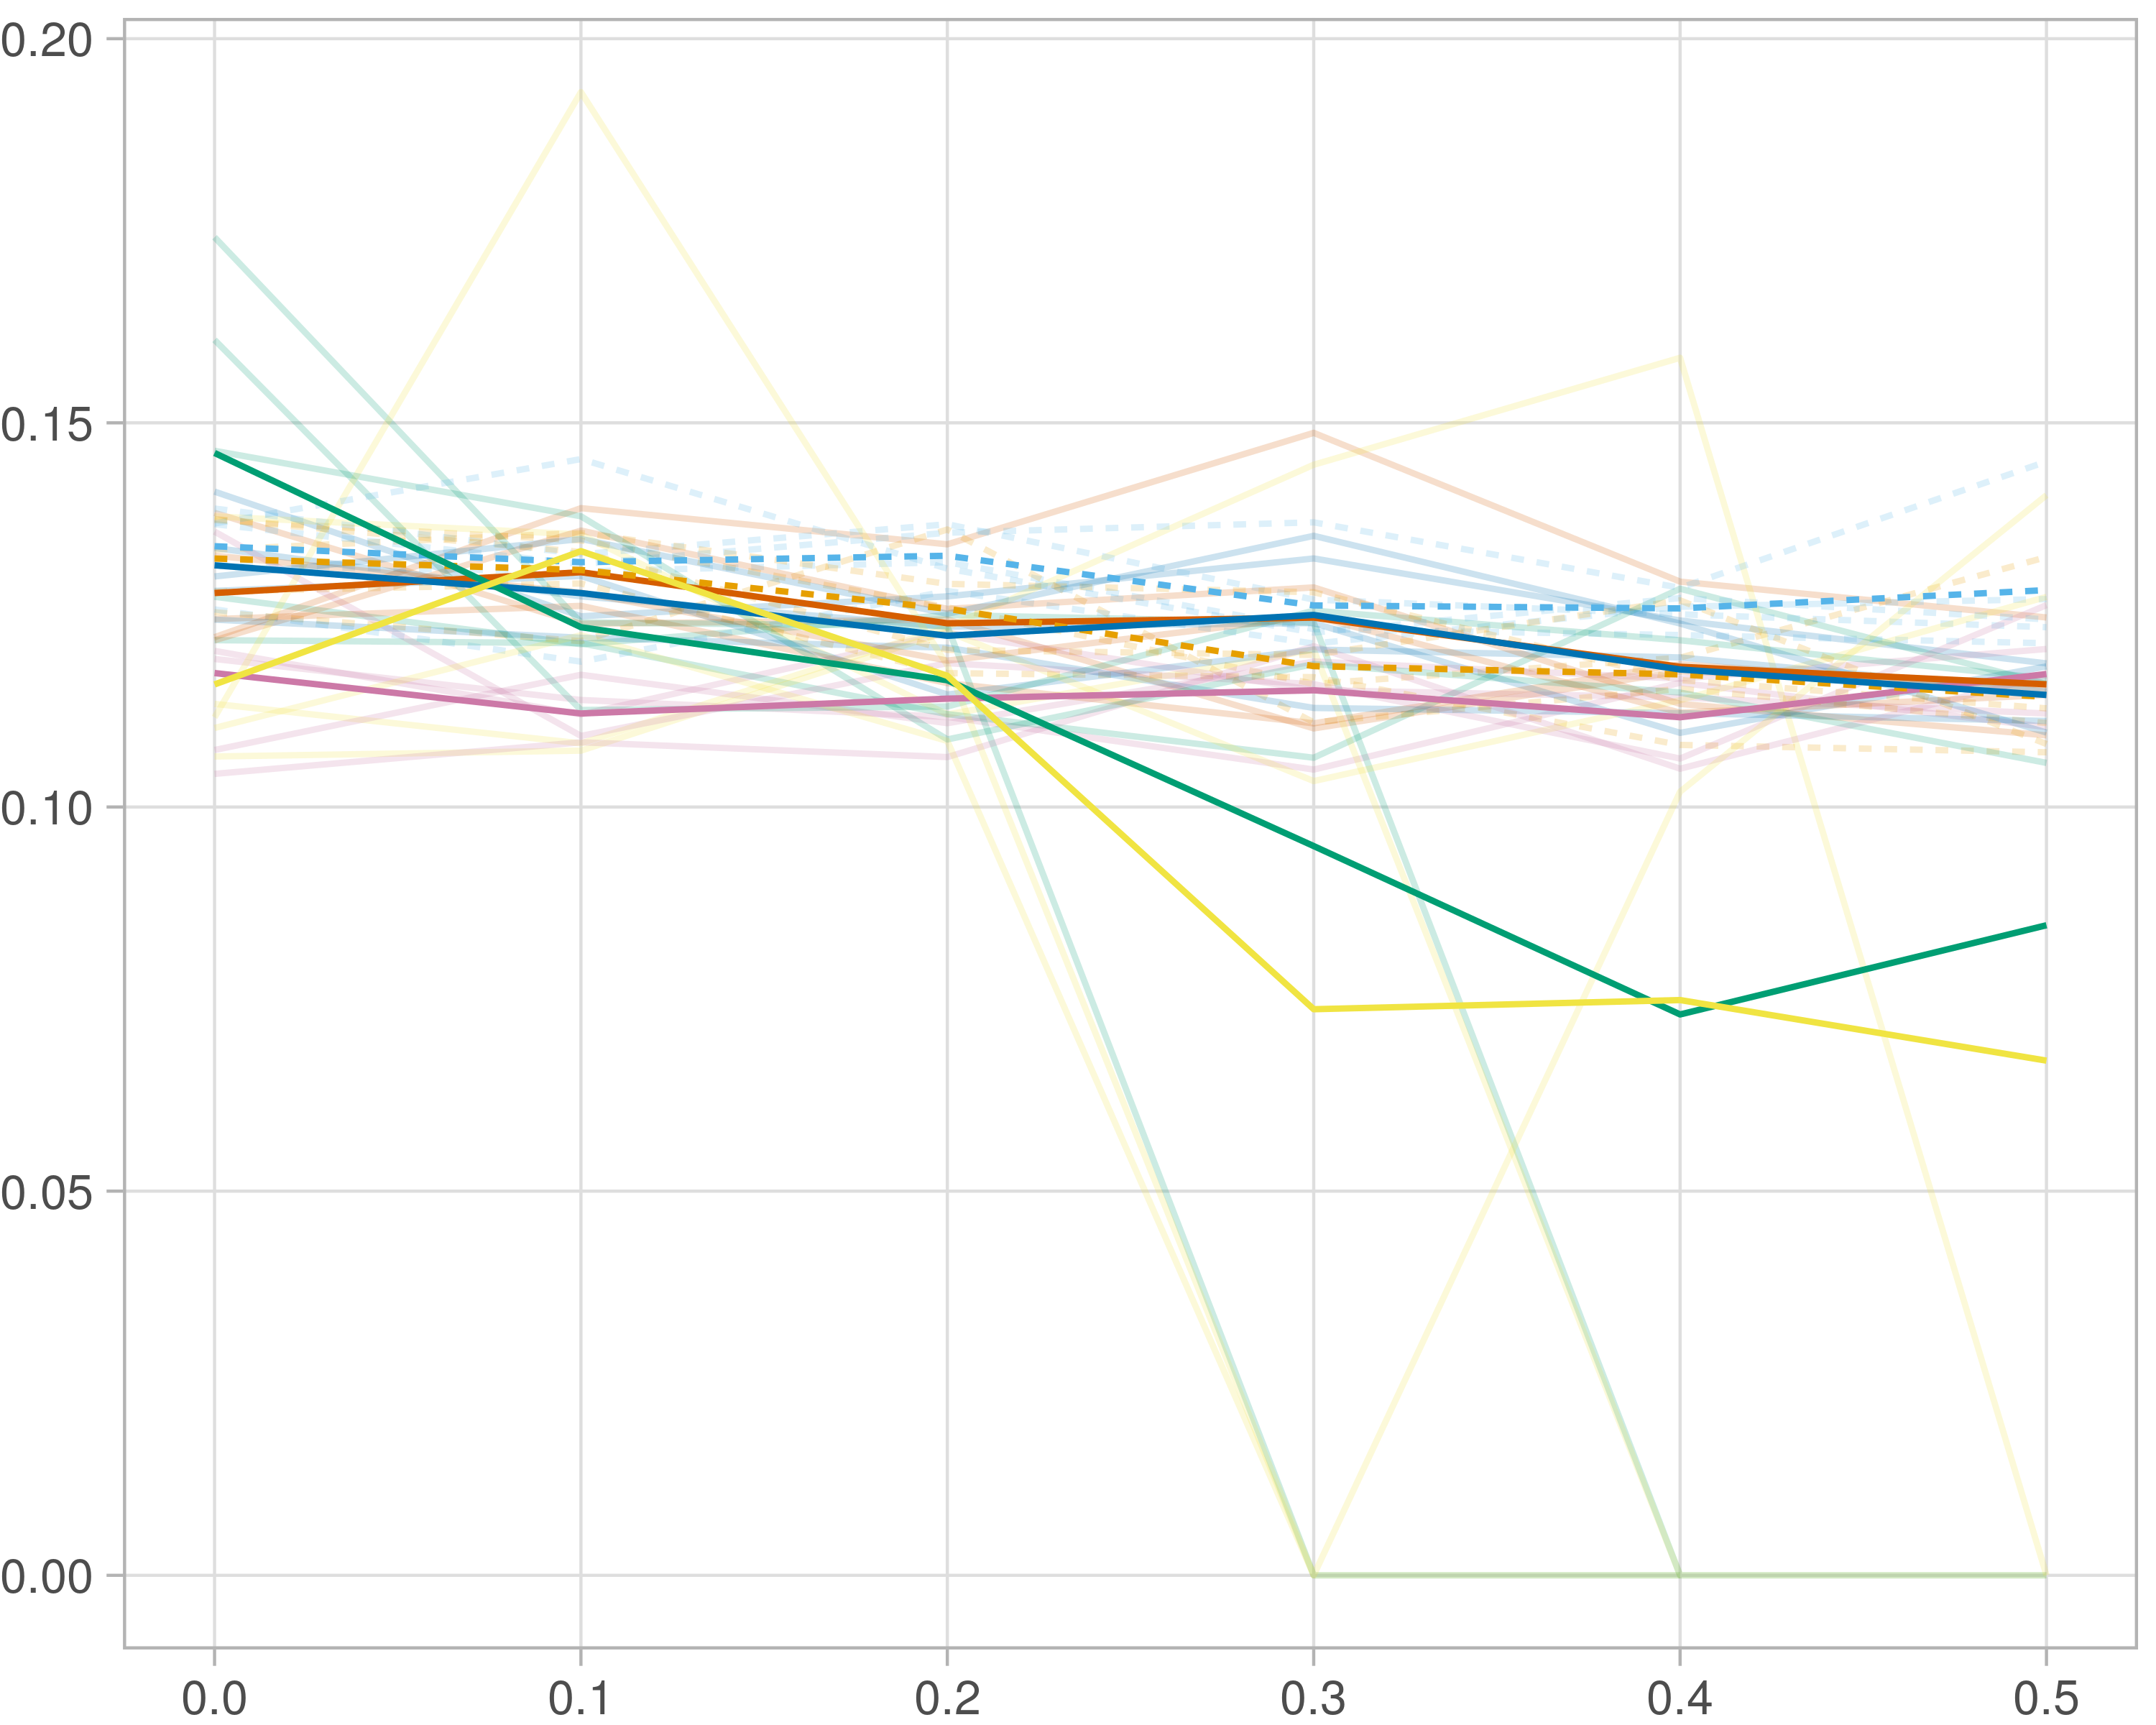

## F1-score (reference)

### Single-omics

#general setup  
dir <- "/workspaces/phd_dissertation/kimono/analysis/data/derived_data/"  
  
#load library  
setwd(dir)  
  
dat_raw <- fread("220411_all_project_info.csv")  
  
#dat_raw <- cbind(dat_raw[,c(1,2,3,16,18)],nodes=dat_raw$V6+dat_raw$V8+dat_raw$V10)  
#dat_raw <- dat_raw[dat_raw$iteration == 1,]  
  
dat_raw$method <- gsub(pattern = "_moran|_mos|_mor|_so|_sor",replacement = "",x = dat_raw$method)  
  
dat <- dat_raw[tolower(dat_raw$method) %in% c("galasso_false","galasso_true","knn_kimono","salasso_false","salasso_true","cocolasso","hmlasso"),]  
  
  
#ggplot(dat, aes(x=clustering, y=n_genes+n_methylation+n_cnv, color=as.factor(method)) )+  
# geom_point(alpha=0.5) + facet_grid(experiment~noise)  
  
#ggplot(dat, aes(y=clustering, x=missingness, color=as.factor(method)) )+  
# geom_point(alpha=0.5) + facet_grid(experiment~noise)  
  
#ggplot(dat, aes(x=missingness, y=clustering,fill=as.factor(method)))+  
# scale_y_continuous(trans='sqrt') + geom_boxplot() + facet_grid(experiment~noise)  
  
  
dat$method <- as.factor(dat$method)   
dat <- dat %>% mutate(method = fct_relevel(method, "knn_kimono", "galasso_false" ,"galasso_true" , "salasso_false" , "salasso_true" ,"cocolasso", "hmlasso" ))  
dat$experiment <- as.factor(dat$experiment)  
dat <- dat %>% mutate(experiment = fct_relevel(experiment, "so", "moran" ,"mos" , "sor" , "mor"))  
  
palette_OkabeIto <- c( "#CC79A7", "#D55E00", "#E69F00","#0072B2", "#56B4E9", "#009E73", "#F0E442")  
  
dat <- aggregate(dat[, -c(1:8)], list('noise'=dat$noise,  
 'missingness'=dat$missingness,  
 'method'=dat$method,  
 'experiment'=dat$experiment), function(x){mean(x,na.rm=TRUE)})  
  
dat_raw$method <- as.factor(dat_raw$method)   
dat_raw <- dat_raw %>% mutate(method = fct_relevel(method, "knn_kimono", "galasso_false" ,"galasso_true" , "salasso_false" , "salasso_true" ,"cocolasso", "hmlasso" ))  
dat_raw$experiment <- as.factor(dat_raw$experiment)  
dat_raw <- dat_raw %>% mutate(experiment = fct_relevel(experiment, "so", "moran" ,"mos" , "sor" , "mor"))  
  
dat_raw <- dat_raw[ dat_raw$noise==1.5 & dat_raw$experiment %in% 'so' & !dat_raw$method %in% "bdcoco_lasso",]  
dat <- dat[ dat$noise==1.5 & dat$experiment %in% 'so' & !dat$method %in% "bdcoco_lasso",]  
  
dat_raw$adaptive <- grepl(pattern = "true",x = dat_raw$method)  
dat$adaptive <- grepl(pattern = "true",x = dat$method)  
  
p <- ggplot(dat_raw,   
 aes(y= (f1_score_reference), x=missingness,color=as.factor(method)))+  
   
 geom_line(aes( group = interaction(method, iteration),linetype=adaptive),alpha = 0.2)+  
 facet_grid(noise~experiment, scales="free")+  
 scale_color_manual(values = palette_OkabeIto)+  
 scale_fill_manual(values = palette_OkabeIto)+   
 theme_light() +  
 theme(legend.position="bottom",  
 axis.text.x = element_text(size = 8),  
 axis.text.y = element_text(size = 8),  
 strip.background = element_blank(),   
 plot.margin = unit(c(-0.5, -0.5, 0, 0), "cm")  
 ) +  
 ylab("#Nodes")   
  
to.plot4 <- p + geom_line(data = dat,   
 aes(y= (f1_score_reference), x=missingness, color=as.factor(method),linetype=adaptive)) +   
 theme(strip.background = element_blank(), panel.grid.minor = element_blank(),  
 legend.position = "none",  
 axis.title.x=element_blank(),  
 #axis.text.x=element_blank(),  
 #axis.ticks.x=element_blank(),  
 axis.title.y=element_blank(),  
 #axis.text.y=element_blank(),  
 #axis.ticks.y=element_blank(),   
 plot.margin = unit(c(-0.5, -0.5, 0, 0), "cm")  
 )  
  
to.plot4

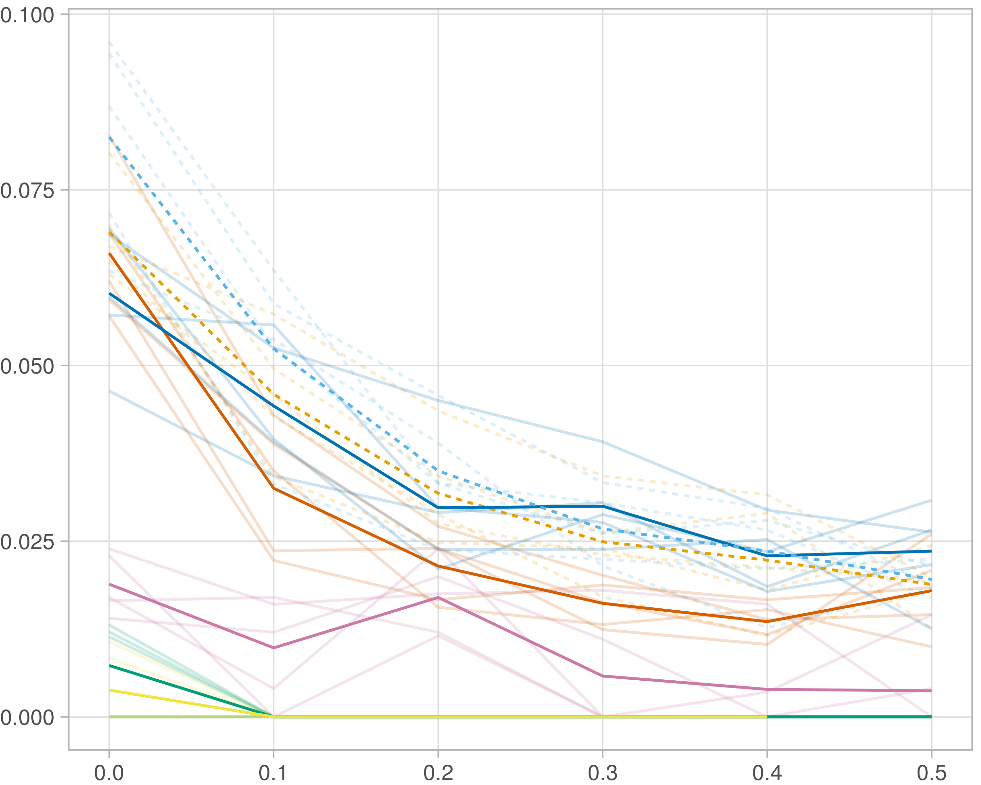

### Multi-omics

#general setup  
dir <- "/workspaces/phd_dissertation/kimono/analysis/data/derived_data/"  
  
#load library  
setwd(dir)  
  
dat_raw <- fread("220411_all_project_info.csv")  
  
#dat_raw <- cbind(dat_raw[,c(1,2,3,16,18)],nodes=dat_raw$V6+dat_raw$V8+dat_raw$V10)  
#dat_raw <- dat_raw[dat_raw$iteration == 1,]  
  
dat_raw$method <- gsub(pattern = "_moran|_mos|_mor|_so|_sor",replacement = "",x = dat_raw$method)  
  
dat <- dat_raw[tolower(dat_raw$method) %in% c("galasso_false","galasso_true","knn_kimono","salasso_false","salasso_true","cocolasso","hmlasso"),]  
  
  
#ggplot(dat, aes(x=clustering, y=n_genes+n_methylation+n_cnv, color=as.factor(method)) )+  
# geom_point(alpha=0.5) + facet_grid(experiment~noise)  
  
#ggplot(dat, aes(y=clustering, x=missingness, color=as.factor(method)) )+  
# geom_point(alpha=0.5) + facet_grid(experiment~noise)  
  
#ggplot(dat, aes(x=missingness, y=clustering,fill=as.factor(method)))+  
# scale_y_continuous(trans='sqrt') + geom_boxplot() + facet_grid(experiment~noise)  
  
  
dat$method <- as.factor(dat$method)   
dat <- dat %>% mutate(method = fct_relevel(method, "knn_kimono", "galasso_false" ,"galasso_true" , "salasso_false" , "salasso_true" ,"cocolasso", "hmlasso" ))  
dat$experiment <- as.factor(dat$experiment)  
dat <- dat %>% mutate(experiment = fct_relevel(experiment, "so", "moran" ,"mos" , "sor" , "mor"))  
  
palette_OkabeIto <- c( "#CC79A7", "#D55E00", "#E69F00","#0072B2", "#56B4E9", "#009E73", "#F0E442")  
  
dat <- aggregate(dat[, -c(1:8)], list('noise'=dat$noise,  
 'missingness'=dat$missingness,  
 'method'=dat$method,  
 'experiment'=dat$experiment), function(x){mean(x,na.rm=TRUE)})  
  
dat_raw$method <- as.factor(dat_raw$method)   
dat_raw <- dat_raw %>% mutate(method = fct_relevel(method, "knn_kimono", "galasso_false" ,"galasso_true" , "salasso_false" , "salasso_true" ,"cocolasso", "hmlasso" ))  
dat_raw$experiment <- as.factor(dat_raw$experiment)  
dat_raw <- dat_raw %>% mutate(experiment = fct_relevel(experiment, "so", "moran" ,"mos" , "sor" , "mor"))  
  
dat_raw <- dat_raw[ dat_raw$noise==1.5 & dat_raw$experiment %in% 'moran' & !dat_raw$method %in% "bdcoco_lasso",]  
dat <- dat[ dat$noise==1.5 & dat$experiment %in% 'moran' & !dat$method %in% "bdcoco_lasso",]  
  
dat_raw$adaptive <- grepl(pattern = "true",x = dat_raw$method)  
dat$adaptive <- grepl(pattern = "true",x = dat$method)  
  
p <- ggplot(dat_raw,   
 aes(y= (f1_score_reference), x=missingness,color=as.factor(method)))+  
   
 geom_line(aes( group = interaction(method, iteration),linetype=adaptive),alpha = 0.2)+  
 facet_grid(noise~experiment, scales="free")+  
 scale_color_manual(values = palette_OkabeIto)+  
 scale_fill_manual(values = palette_OkabeIto)+   
 theme_light() +  
 theme(legend.position="bottom",  
 axis.text.x = element_text(size = 8),  
 axis.text.y = element_text(size = 8),  
 strip.background = element_blank(),   
 plot.margin = unit(c(-0.5, -0.5, 0, 0), "cm")  
 ) +  
 ylab("#Nodes")   
  
to.plot4 <- p + geom_line(data = dat,   
 aes(y= (f1_score_reference), x=missingness, color=as.factor(method),linetype=adaptive)) +   
 theme(strip.background = element_blank(), panel.grid.minor = element_blank(),  
 legend.position = "none",  
 axis.title.x=element_blank(),  
 #axis.text.x=element_blank(),  
 #axis.ticks.x=element_blank(),  
 axis.title.y=element_blank(),  
 #axis.text.y=element_blank(),  
 #axis.ticks.y=element_blank(),   
 plot.margin = unit(c(-0.5, -0.5, 0, 0), "cm")  
 )  
  
to.plot4

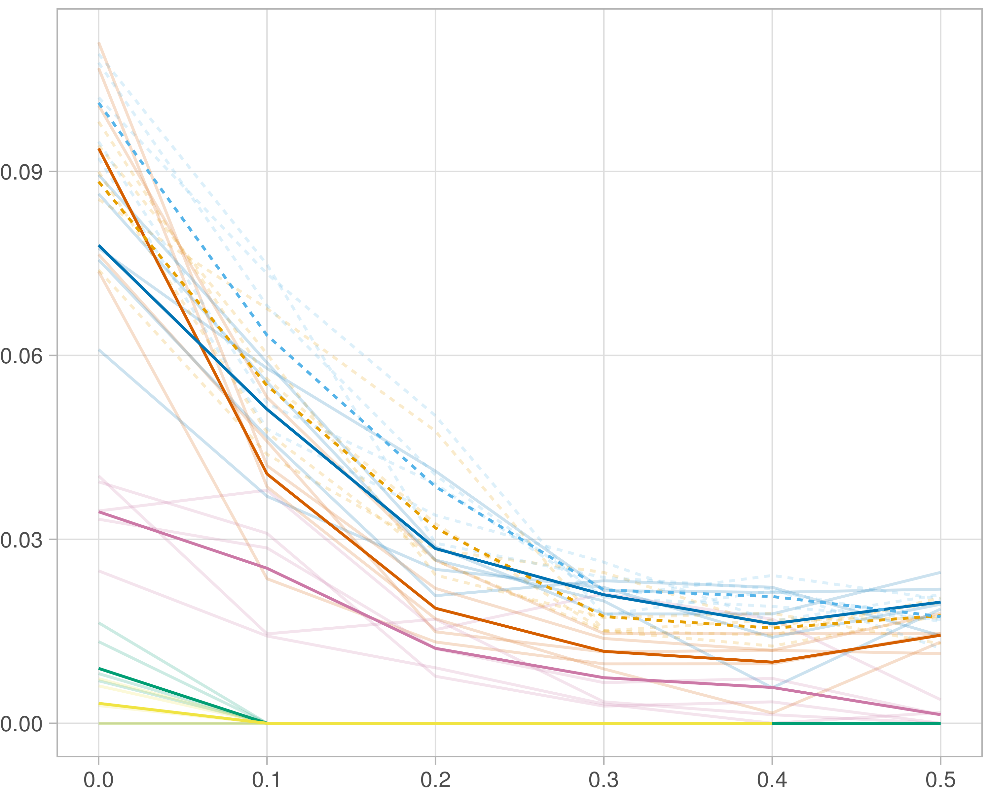

### Block-wise

#general setup  
dir <- "/workspaces/phd_dissertation/kimono/analysis/data/derived_data/"  
  
#load library  
setwd(dir)  
  
dat_raw <- fread("220411_all_project_info.csv")  
  
#dat_raw <- cbind(dat_raw[,c(1,2,3,16,18)],nodes=dat_raw$V6+dat_raw$V8+dat_raw$V10)  
#dat_raw <- dat_raw[dat_raw$iteration == 1,]  
  
dat_raw$method <- gsub(pattern = "_moran|_mos|_mor|_so|_sor",replacement = "",x = dat_raw$method)  
  
dat <- dat_raw[tolower(dat_raw$method) %in% c("galasso_false","galasso_true","knn_kimono","salasso_false","salasso_true","cocolasso","hmlasso"),]  
  
  
#ggplot(dat, aes(x=clustering, y=n_genes+n_methylation+n_cnv, color=as.factor(method)) )+  
# geom_point(alpha=0.5) + facet_grid(experiment~noise)  
  
#ggplot(dat, aes(y=clustering, x=missingness, color=as.factor(method)) )+  
# geom_point(alpha=0.5) + facet_grid(experiment~noise)  
  
#ggplot(dat, aes(x=missingness, y=clustering,fill=as.factor(method)))+  
# scale_y_continuous(trans='sqrt') + geom_boxplot() + facet_grid(experiment~noise)  
  
  
dat$method <- as.factor(dat$method)   
dat <- dat %>% mutate(method = fct_relevel(method, "knn_kimono", "galasso_false" ,"galasso_true" , "salasso_false" , "salasso_true" ,"cocolasso", "hmlasso" ))  
dat$experiment <- as.factor(dat$experiment)  
dat <- dat %>% mutate(experiment = fct_relevel(experiment, "so", "moran" ,"mos" , "sor" , "mor"))  
  
palette_OkabeIto <- c( "#CC79A7", "#D55E00", "#E69F00","#0072B2", "#56B4E9", "#009E73", "#F0E442")  
  
dat <- aggregate(dat[, -c(1:8)], list('noise'=dat$noise,  
 'missingness'=dat$missingness,  
 'method'=dat$method,  
 'experiment'=dat$experiment), function(x){mean(x,na.rm=TRUE)})  
  
dat_raw$method <- as.factor(dat_raw$method)   
dat_raw <- dat_raw %>% mutate(method = fct_relevel(method, "knn_kimono", "galasso_false" ,"galasso_true" , "salasso_false" , "salasso_true" ,"cocolasso", "hmlasso" ))  
dat_raw$experiment <- as.factor(dat_raw$experiment)  
dat_raw <- dat_raw %>% mutate(experiment = fct_relevel(experiment, "so", "moran" ,"mos" , "sor" , "mor"))  
  
dat_raw <- dat_raw[ dat_raw$noise==1.5 & dat_raw$experiment %in% 'mos' & !dat_raw$method %in% "bdcoco_lasso",]  
dat <- dat[ dat$noise==1.5 & dat$experiment %in% 'mos' & !dat$method %in% "bdcoco_lasso",]  
  
dat_raw$adaptive <- grepl(pattern = "true",x = dat_raw$method)  
dat$adaptive <- grepl(pattern = "true",x = dat$method)  
  
p <- ggplot(dat_raw,   
 aes(y= (f1_score_reference), x=missingness,color=as.factor(method)))+  
   
 geom_line(aes( group = interaction(method, iteration),linetype=adaptive),alpha = 0.2)+  
 facet_grid(noise~experiment, scales="free")+  
 scale_color_manual(values = palette_OkabeIto)+  
 scale_fill_manual(values = palette_OkabeIto)+   
 theme_light() +  
 theme(legend.position="bottom",  
 axis.text.x = element_text(size = 8),  
 axis.text.y = element_text(size = 8),  
 strip.background = element_blank(),   
 plot.margin = unit(c(-0.5, -0.5, 0, 0), "cm")  
 ) +  
 ylab("#Nodes")   
  
to.plot4 <- p + geom_line(data = dat,   
 aes(y= (f1_score_reference), x=missingness, color=as.factor(method),linetype=adaptive)) +   
 theme(strip.background = element_blank(), panel.grid.minor = element_blank(),  
 legend.position = "none",  
 axis.title.x=element_blank(),  
 #axis.text.x=element_blank(),  
 #axis.ticks.x=element_blank(),  
 axis.title.y=element_blank(),  
 #axis.text.y=element_blank(),  
 #axis.ticks.y=element_blank(),   
 plot.margin = unit(c(-0.5, -0.5, 0, 0), "cm")  
 )  
  
to.plot4

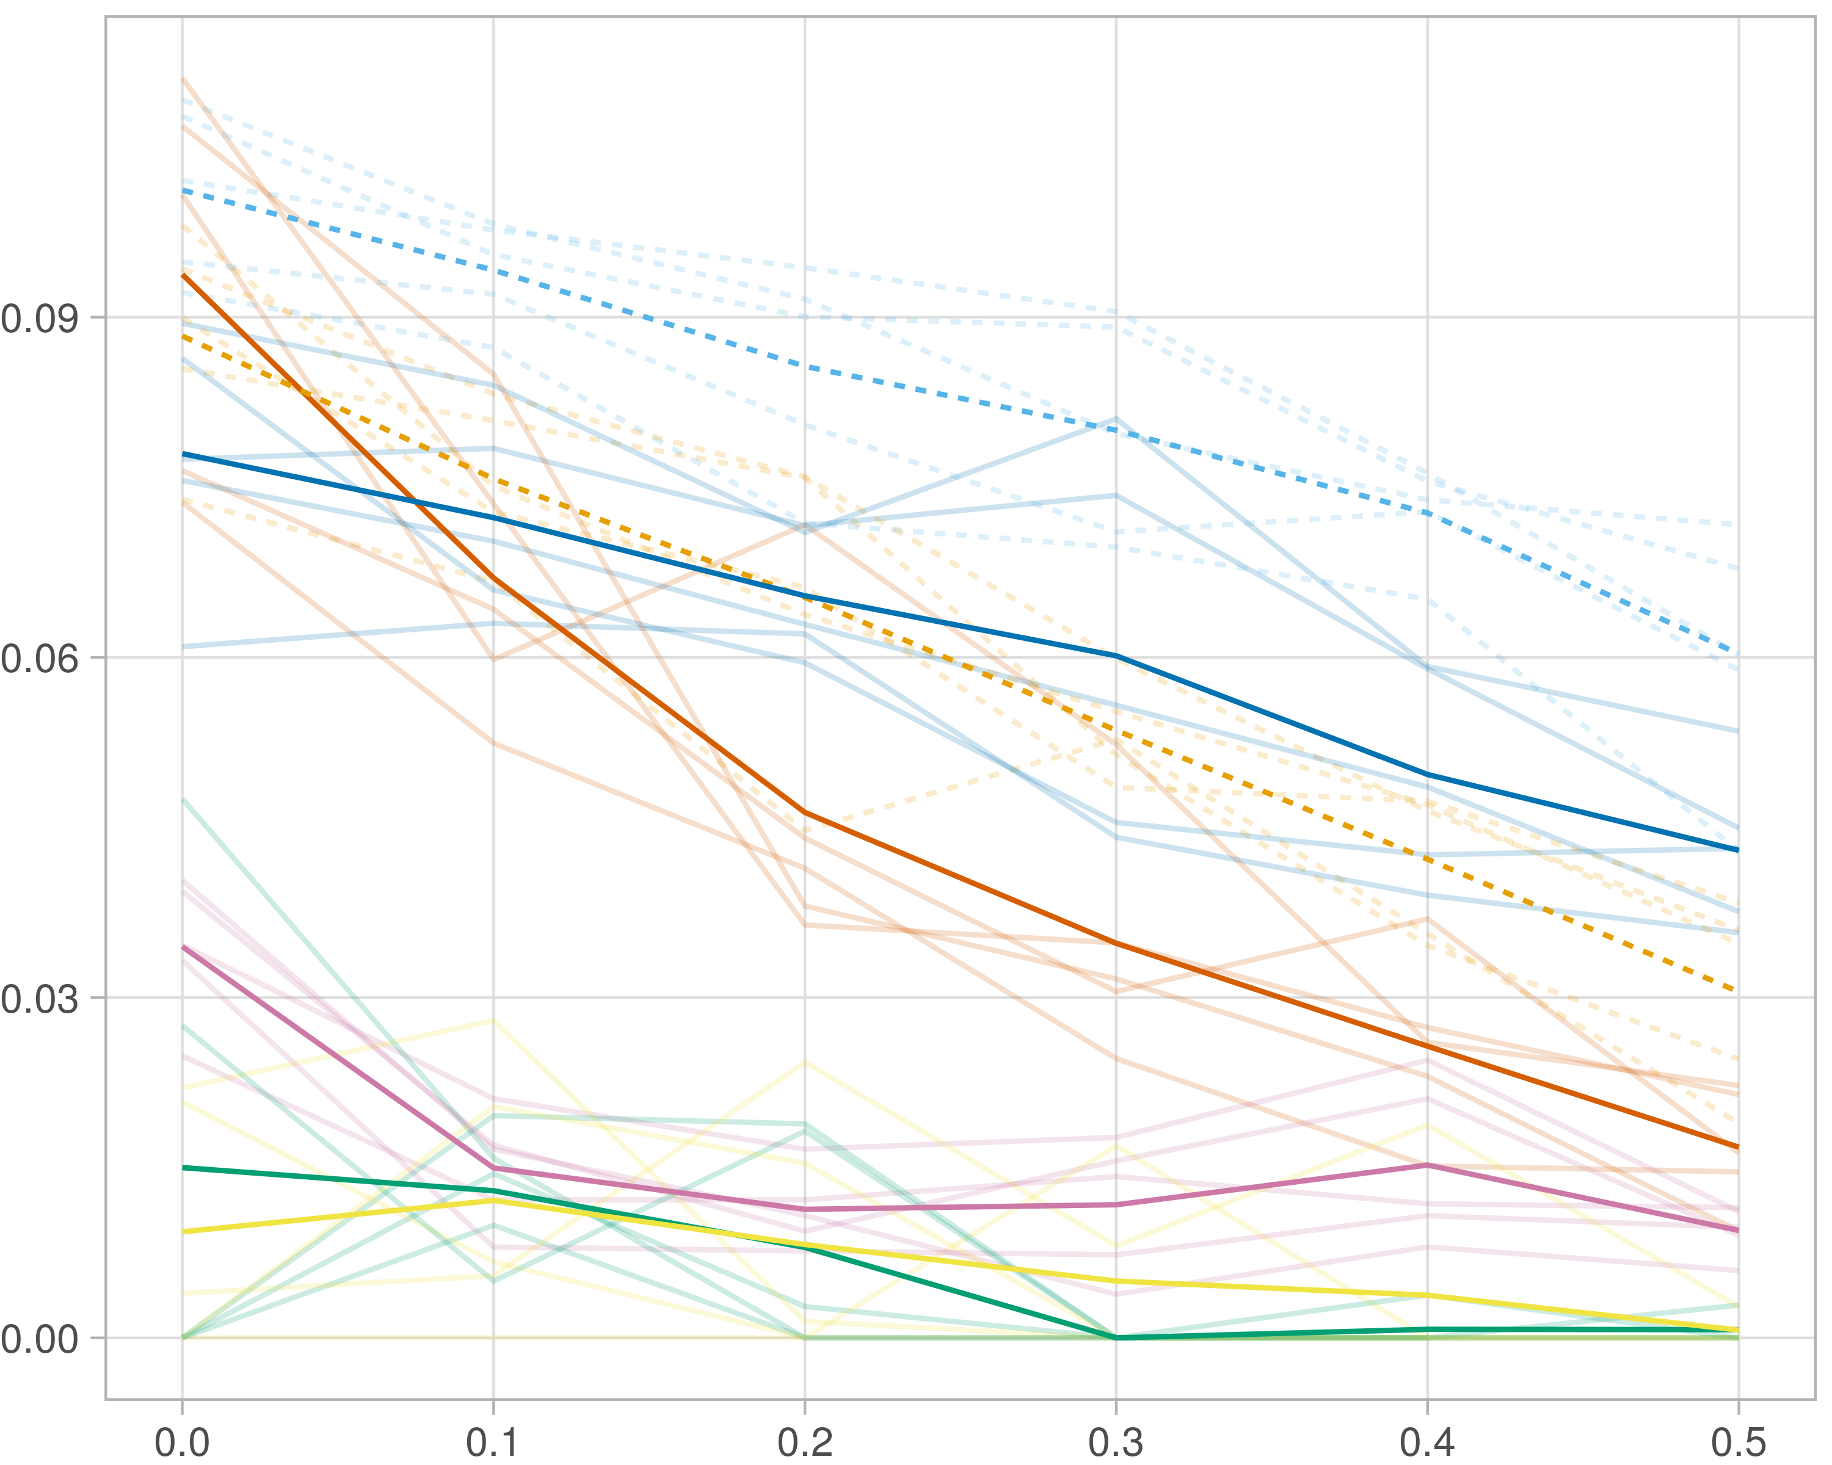

## F1-score (stability selection)

### Single-omics

#general setup  
dir <- "/workspaces/phd_dissertation/kimono/analysis/data/derived_data/"  
  
#load library  
setwd(dir)  
  
dat_raw <- fread("220411_all_project_info.csv")  
  
#dat_raw <- cbind(dat_raw[,c(1,2,3,16,18)],nodes=dat_raw$V6+dat_raw$V8+dat_raw$V10)  
#dat_raw <- dat_raw[dat_raw$iteration == 1,]  
  
dat_raw$method <- gsub(pattern = "_moran|_mos|_mor|_so|_sor",replacement = "",x = dat_raw$method)  
  
dat <- dat_raw[tolower(dat_raw$method) %in% c("galasso_false","galasso_true","knn_kimono","salasso_false","salasso_true","cocolasso","hmlasso"),]  
  
  
#ggplot(dat, aes(x=clustering, y=n_genes+n_methylation+n_cnv, color=as.factor(method)) )+  
# geom_point(alpha=0.5) + facet_grid(experiment~noise)  
  
#ggplot(dat, aes(y=clustering, x=missingness, color=as.factor(method)) )+  
# geom_point(alpha=0.5) + facet_grid(experiment~noise)  
  
#ggplot(dat, aes(x=missingness, y=clustering,fill=as.factor(method)))+  
# scale_y_continuous(trans='sqrt') + geom_boxplot() + facet_grid(experiment~noise)  
  
  
dat$method <- as.factor(dat$method)   
dat <- dat %>% mutate(method = fct_relevel(method, "knn_kimono", "galasso_false" ,"galasso_true" , "salasso_false" , "salasso_true" ,"cocolasso", "hmlasso" ))  
dat$experiment <- as.factor(dat$experiment)  
dat <- dat %>% mutate(experiment = fct_relevel(experiment, "so", "moran" ,"mos" , "sor" , "mor"))  
  
palette_OkabeIto <- c( "#CC79A7", "#D55E00", "#E69F00","#0072B2", "#56B4E9", "#009E73", "#F0E442")  
  
dat <- aggregate(dat[, -c(1:8)], list('noise'=dat$noise,  
 'missingness'=dat$missingness,  
 'method'=dat$method,  
 'experiment'=dat$experiment), function(x){mean(x,na.rm=TRUE)})  
  
dat_raw$method <- as.factor(dat_raw$method)   
dat_raw <- dat_raw %>% mutate(method = fct_relevel(method, "knn_kimono", "galasso_false" ,"galasso_true" , "salasso_false" , "salasso_true" ,"cocolasso", "hmlasso" ))  
dat_raw$experiment <- as.factor(dat_raw$experiment)  
dat_raw <- dat_raw %>% mutate(experiment = fct_relevel(experiment, "so", "moran" ,"mos" , "sor" , "mor"))  
  
dat_raw <- dat_raw[ dat_raw$noise==1.5 & dat_raw$experiment %in% 'so' & !dat_raw$method %in% "bdcoco_lasso",]  
dat <- dat[ dat$noise==1.5 & dat$experiment %in% 'so' & !dat$method %in% "bdcoco_lasso",]  
  
dat_raw$adaptive <- grepl(pattern = "true",x = dat_raw$method)  
dat$adaptive <- grepl(pattern = "true",x = dat$method)  
  
p <- ggplot(dat_raw,   
 aes(y= (f1_score_stability), x=missingness,color=as.factor(method)))+  
   
 geom_line(aes( group = interaction(method, iteration),linetype=adaptive),alpha = 0.2)+  
 facet_grid(noise~experiment, scales="free")+  
 scale_color_manual(values = palette_OkabeIto)+  
 scale_fill_manual(values = palette_OkabeIto)+   
 theme_light() +  
 theme(legend.position="bottom",  
 axis.text.x = element_text(size = 8),  
 axis.text.y = element_text(size = 8),  
 strip.background = element_blank(),   
 plot.margin = unit(c(-0.5, -0.5, 0, 0), "cm")  
 ) +  
 ylab("#Nodes")   
  
to.plot5 <- p + geom_line(data = dat,   
 aes(y= (f1_score_stability), x=missingness, color=as.factor(method),linetype=adaptive)) +   
 theme(strip.background = element_blank(), panel.grid.minor = element_blank(),  
 legend.position = "none",  
 axis.title.x=element_blank(),  
 #axis.text.x=element_blank(),  
 #axis.ticks.x=element_blank(),  
 axis.title.y=element_blank(),  
 #axis.text.y=element_blank(),  
 #axis.ticks.y=element_blank(),   
 plot.margin = unit(c(-0.5, -0.5, 0, 0), "cm")  
 )  
  
to.plot5

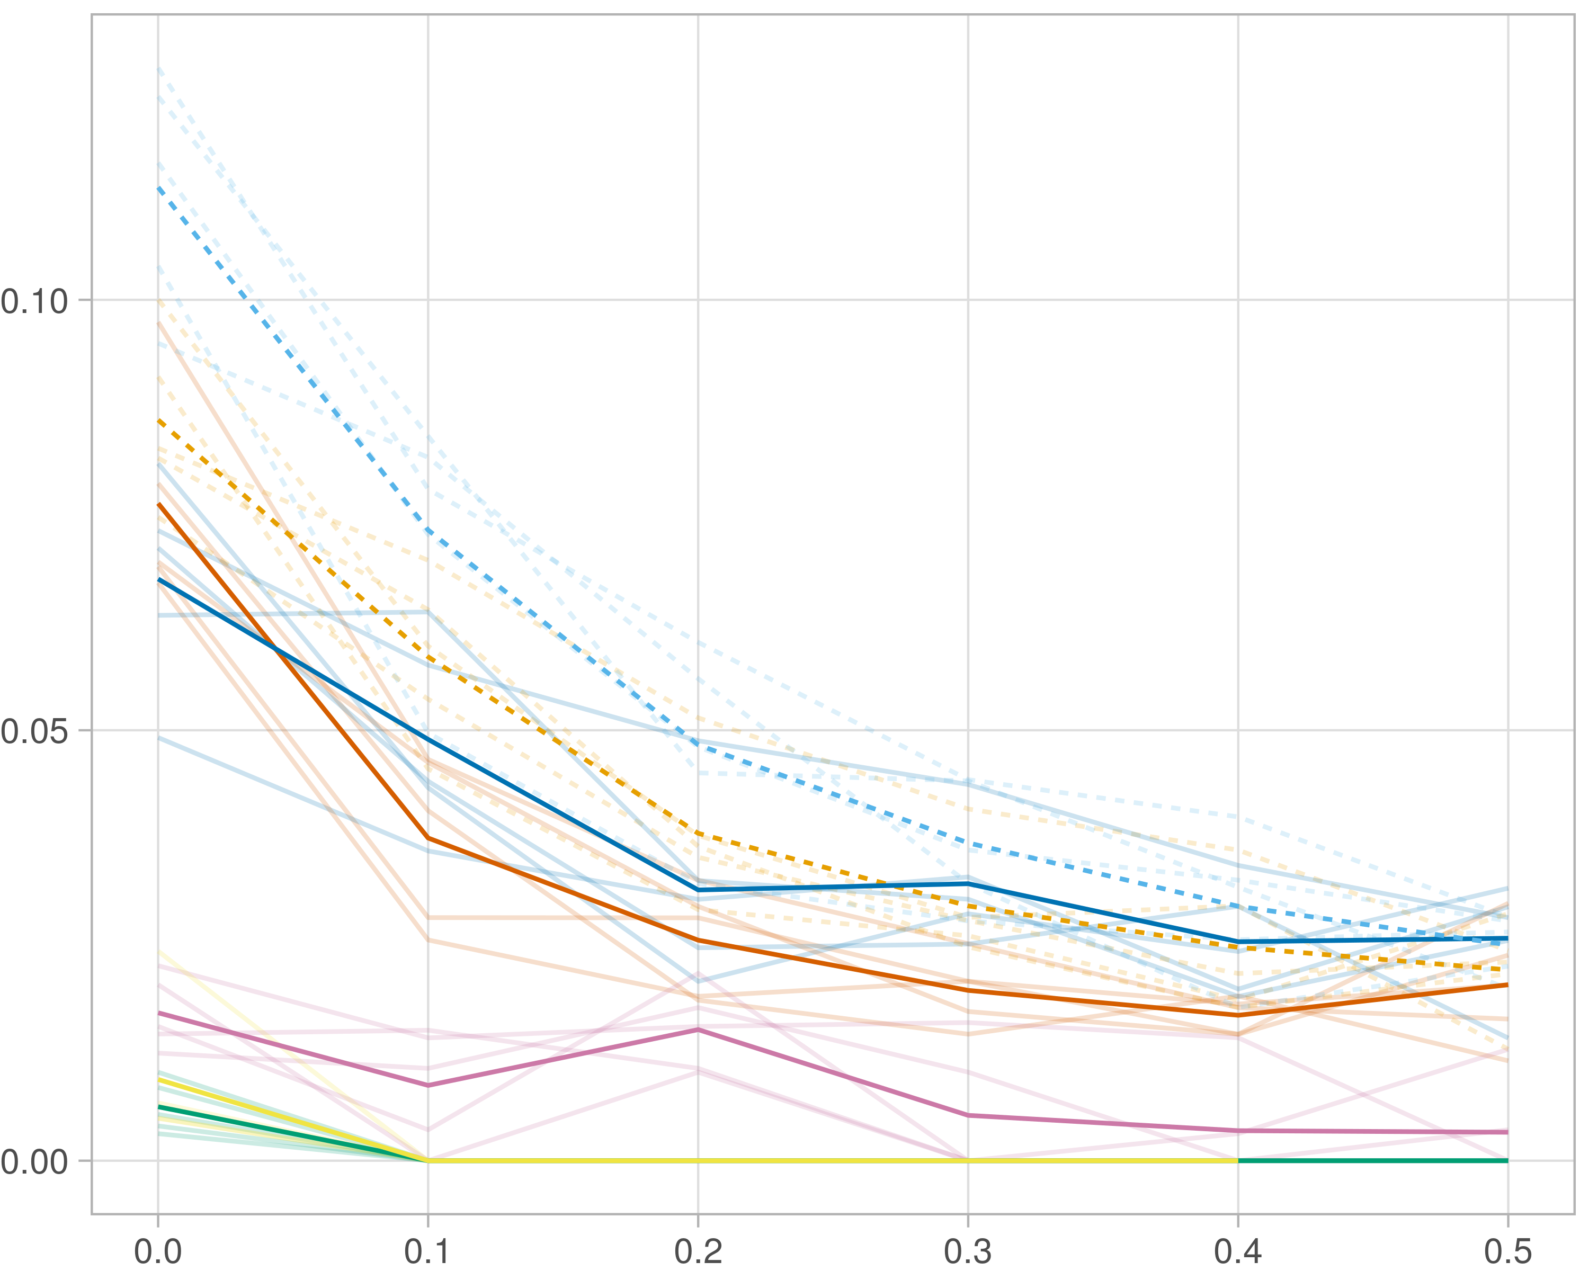

### Multi-omics

#general setup  
dir <- "/workspaces/phd_dissertation/kimono/analysis/data/derived_data/"  
  
#load library  
setwd(dir)  
  
dat_raw <- fread("220411_all_project_info.csv")  
  
#dat_raw <- cbind(dat_raw[,c(1,2,3,16,18)],nodes=dat_raw$V6+dat_raw$V8+dat_raw$V10)  
#dat_raw <- dat_raw[dat_raw$iteration == 1,]  
  
dat_raw$method <- gsub(pattern = "_moran|_mos|_mor|_so|_sor",replacement = "",x = dat_raw$method)  
  
dat <- dat_raw[tolower(dat_raw$method) %in% c("galasso_false","galasso_true","knn_kimono","salasso_false","salasso_true","cocolasso","hmlasso"),]  
  
  
#ggplot(dat, aes(x=clustering, y=n_genes+n_methylation+n_cnv, color=as.factor(method)) )+  
# geom_point(alpha=0.5) + facet_grid(experiment~noise)  
  
#ggplot(dat, aes(y=clustering, x=missingness, color=as.factor(method)) )+  
# geom_point(alpha=0.5) + facet_grid(experiment~noise)  
  
#ggplot(dat, aes(x=missingness, y=clustering,fill=as.factor(method)))+  
# scale_y_continuous(trans='sqrt') + geom_boxplot() + facet_grid(experiment~noise)  
  
  
dat$method <- as.factor(dat$method)   
dat <- dat %>% mutate(method = fct_relevel(method, "knn_kimono", "galasso_false" ,"galasso_true" , "salasso_false" , "salasso_true" ,"cocolasso", "hmlasso" ))  
dat$experiment <- as.factor(dat$experiment)  
dat <- dat %>% mutate(experiment = fct_relevel(experiment, "so", "moran" ,"mos" , "sor" , "mor"))  
  
palette_OkabeIto <- c( "#CC79A7", "#D55E00", "#E69F00","#0072B2", "#56B4E9", "#009E73", "#F0E442")  
  
dat <- aggregate(dat[, -c(1:8)], list('noise'=dat$noise,  
 'missingness'=dat$missingness,  
 'method'=dat$method,  
 'experiment'=dat$experiment), function(x){mean(x,na.rm=TRUE)})  
  
dat_raw$method <- as.factor(dat_raw$method)   
dat_raw <- dat_raw %>% mutate(method = fct_relevel(method, "knn_kimono", "galasso_false" ,"galasso_true" , "salasso_false" , "salasso_true" ,"cocolasso", "hmlasso" ))  
dat_raw$experiment <- as.factor(dat_raw$experiment)  
dat_raw <- dat_raw %>% mutate(experiment = fct_relevel(experiment, "so", "moran" ,"mos" , "sor" , "mor"))  
  
dat_raw <- dat_raw[ dat_raw$noise==1.5 & dat_raw$experiment %in% 'moran' & !dat_raw$method %in% "bdcoco_lasso",]  
dat <- dat[ dat$noise==1.5 & dat$experiment %in% 'moran' & !dat$method %in% "bdcoco_lasso",]  
  
dat_raw$adaptive <- grepl(pattern = "true",x = dat_raw$method)  
dat$adaptive <- grepl(pattern = "true",x = dat$method)  
  
p <- ggplot(dat_raw,   
 aes(y= (f1_score_stability), x=missingness,color=as.factor(method)))+  
   
 geom_line(aes( group = interaction(method, iteration),linetype=adaptive),alpha = 0.2)+  
 facet_grid(noise~experiment, scales="free")+  
 scale_color_manual(values = palette_OkabeIto)+  
 scale_fill_manual(values = palette_OkabeIto)+   
 theme_light() +  
 theme(legend.position="bottom",  
 axis.text.x = element_text(size = 8),  
 axis.text.y = element_text(size = 8),  
 strip.background = element_blank(),   
 plot.margin = unit(c(-0.5, -0.5, 0, 0), "cm")  
 ) +  
 ylab("#Nodes")   
  
to.plot5 <- p + geom_line(data = dat,   
 aes(y= (f1_score_stability), x=missingness, color=as.factor(method),linetype=adaptive)) +   
 theme(strip.background = element_blank(), panel.grid.minor = element_blank(),  
 legend.position = "none",  
 axis.title.x=element_blank(),  
 #axis.text.x=element_blank(),  
 #axis.ticks.x=element_blank(),  
 axis.title.y=element_blank(),  
 #axis.text.y=element_blank(),  
 #axis.ticks.y=element_blank(),   
 plot.margin = unit(c(-0.5, -0.5, 0, 0), "cm")  
 )  
  
to.plot5

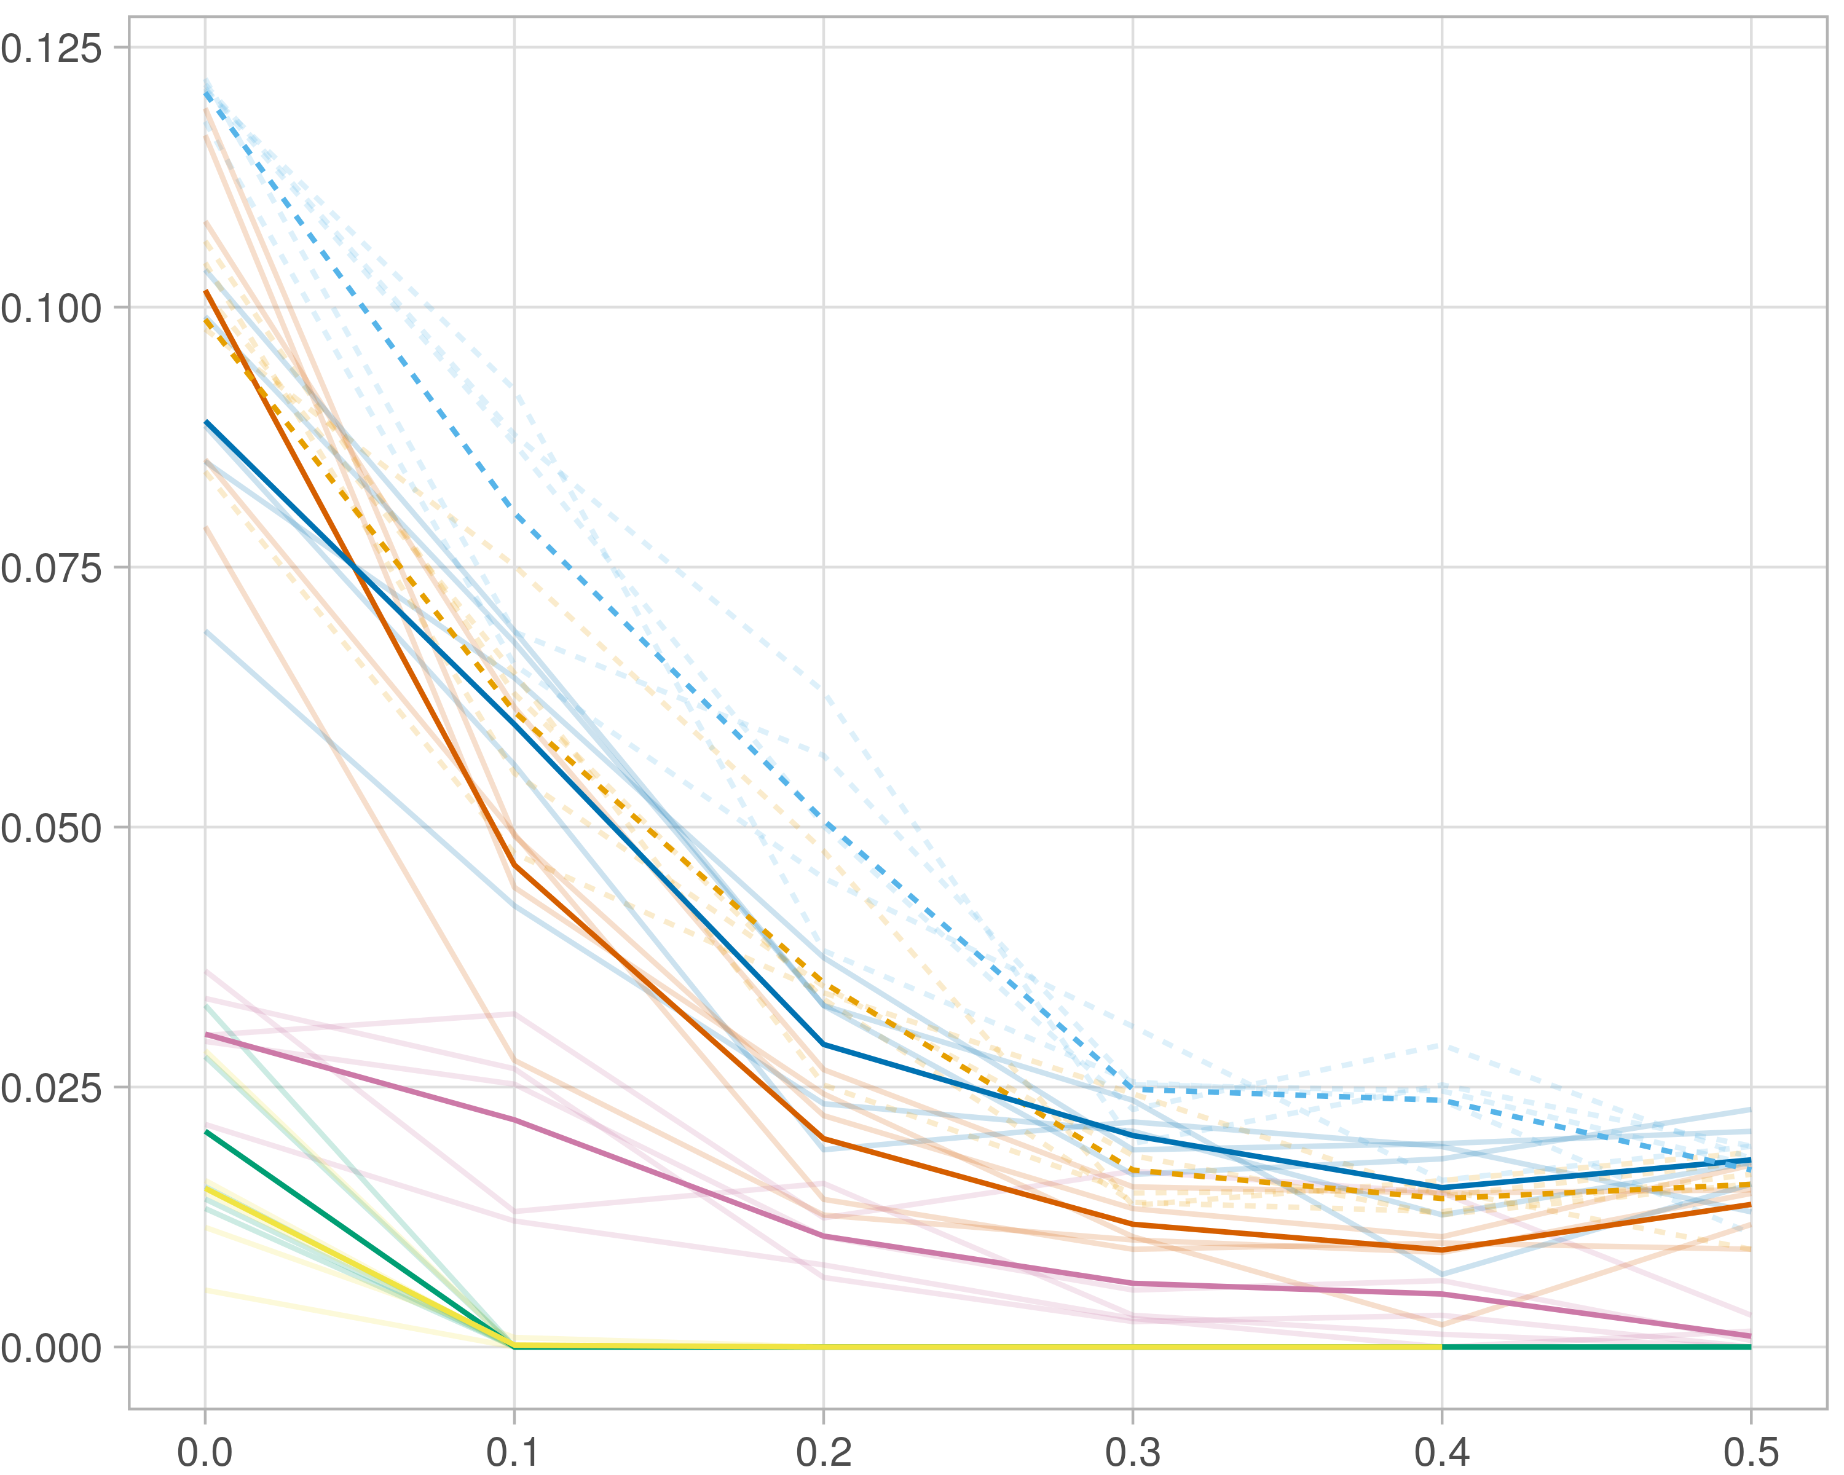

### Block-wise

#general setup  
dir <- "/workspaces/phd_dissertation/kimono/analysis/data/derived_data/"  
  
#load library  
setwd(dir)  
  
dat_raw <- fread("220411_all_project_info.csv")  
  
#dat_raw <- cbind(dat_raw[,c(1,2,3,16,18)],nodes=dat_raw$V6+dat_raw$V8+dat_raw$V10)  
#dat_raw <- dat_raw[dat_raw$iteration == 1,]  
  
dat_raw$method <- gsub(pattern = "_moran|_mos|_mor|_so|_sor",replacement = "",x = dat_raw$method)  
  
dat <- dat_raw[tolower(dat_raw$method) %in% c("galasso_false","galasso_true","knn_kimono","salasso_false","salasso_true","cocolasso","hmlasso"),]  
  
  
#ggplot(dat, aes(x=clustering, y=n_genes+n_methylation+n_cnv, color=as.factor(method)) )+  
# geom_point(alpha=0.5) + facet_grid(experiment~noise)  
  
#ggplot(dat, aes(y=clustering, x=missingness, color=as.factor(method)) )+  
# geom_point(alpha=0.5) + facet_grid(experiment~noise)  
  
#ggplot(dat, aes(x=missingness, y=clustering,fill=as.factor(method)))+  
# scale_y_continuous(trans='sqrt') + geom_boxplot() + facet_grid(experiment~noise)  
  
  
dat$method <- as.factor(dat$method)   
dat <- dat %>% mutate(method = fct_relevel(method, "knn_kimono", "galasso_false" ,"galasso_true" , "salasso_false" , "salasso_true" ,"cocolasso", "hmlasso" ))  
dat$experiment <- as.factor(dat$experiment)  
dat <- dat %>% mutate(experiment = fct_relevel(experiment, "so", "moran" ,"mos" , "sor" , "mor"))  
  
palette_OkabeIto <- c( "#CC79A7", "#D55E00", "#E69F00","#0072B2", "#56B4E9", "#009E73", "#F0E442")  
  
dat <- aggregate(dat[, -c(1:8)], list('noise'=dat$noise,  
 'missingness'=dat$missingness,  
 'method'=dat$method,  
 'experiment'=dat$experiment), function(x){mean(x,na.rm=TRUE)})  
  
dat_raw$method <- as.factor(dat_raw$method)   
dat_raw <- dat_raw %>% mutate(method = fct_relevel(method, "knn_kimono", "galasso_false" ,"galasso_true" , "salasso_false" , "salasso_true" ,"cocolasso", "hmlasso" ))  
dat_raw$experiment <- as.factor(dat_raw$experiment)  
dat_raw <- dat_raw %>% mutate(experiment = fct_relevel(experiment, "so", "moran" ,"mos" , "sor" , "mor"))  
  
dat_raw <- dat_raw[ dat_raw$noise==1.5 & dat_raw$experiment %in% 'mos' & !dat_raw$method %in% "bdcoco_lasso",]  
dat <- dat[ dat$noise==1.5 & dat$experiment %in% 'mos' & !dat$method %in% "bdcoco_lasso",]  
  
dat_raw$adaptive <- grepl(pattern = "true",x = dat_raw$method)  
dat$adaptive <- grepl(pattern = "true",x = dat$method)  
  
p <- ggplot(dat_raw,   
 aes(y= (f1_score_stability), x=missingness,color=as.factor(method)))+  
   
 geom_line(aes( group = interaction(method, iteration),linetype=adaptive),alpha = 0.2)+  
 facet_grid(noise~experiment, scales="free")+  
 scale_color_manual(values = palette_OkabeIto)+  
 scale_fill_manual(values = palette_OkabeIto)+   
 theme_light() +  
 theme(legend.position="bottom",  
 axis.text.x = element_text(size = 8),  
 axis.text.y = element_text(size = 8),  
 strip.background = element_blank(),   
 plot.margin = unit(c(-0.5, -0.5, 0, 0), "cm")  
 ) +  
 ylab("#Nodes")   
  
to.plot5 <- p + geom_line(data = dat,   
 aes(y= (f1_score_stability), x=missingness, color=as.factor(method),linetype=adaptive)) +   
 theme(strip.background = element_blank(), panel.grid.minor = element_blank(),  
 legend.position = "none",  
 axis.title.x=element_blank(),  
 #axis.text.x=element_blank(),  
 #axis.ticks.x=element_blank(),  
 axis.title.y=element_blank(),  
 #axis.text.y=element_blank(),  
 #axis.ticks.y=element_blank(),   
 plot.margin = unit(c(-0.5, -0.5, 0, 0), "cm")  
 )  
  
to.plot5

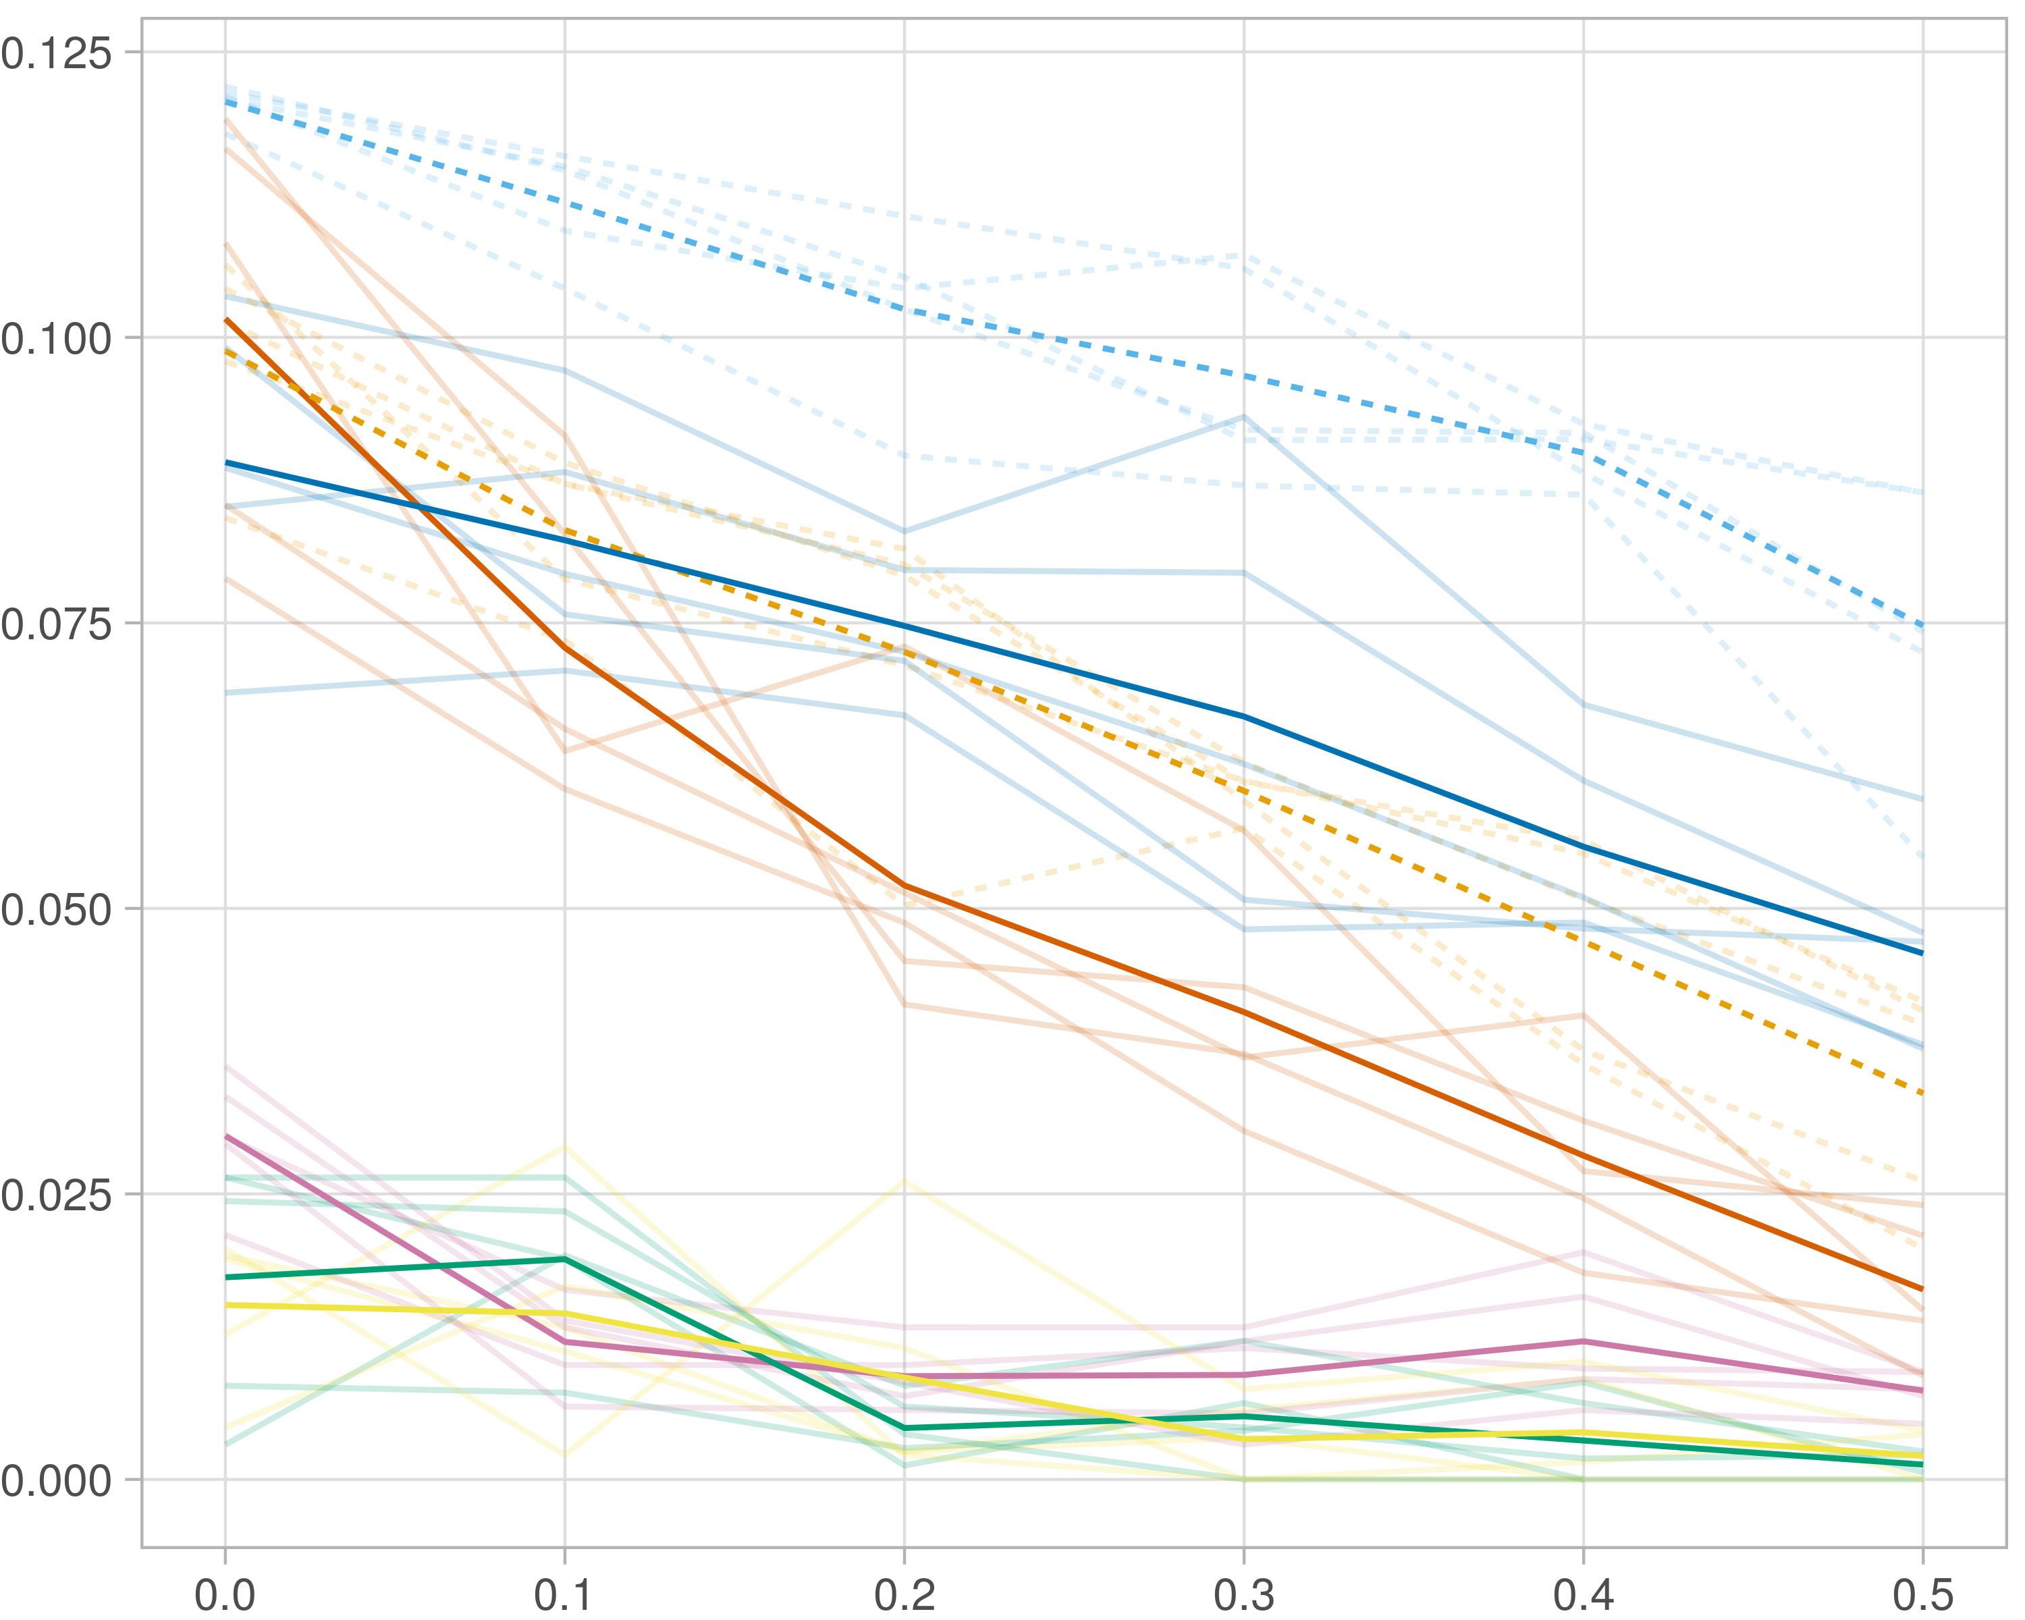

# Betweeness

## Single-omics

library(tidyverse)  
library(data.table)  
library(reshape)  
library(ggforestplot)  
  
## Transparent colors  
## Mark Gardener 2015  
## www.dataanalytics.org.uk  
  
t_col <- function(color, percent = 50, name = NULL) {  
 # color = color name  
 # percent = % transparency  
 # name = an optional name for the color  
   
 ## Get RGB values for named color  
 rgb.val <- col2rgb(color)  
   
 ## Make new color using input color as base and alpha set by transparency  
 t.col <- rgb(rgb.val[1], rgb.val[2], rgb.val[3],  
 max = 255,  
 alpha = (100 - percent) * 255 / 100,  
 names = name)  
   
 ## Save the color  
 invisible(t.col)  
}  
  
#general setup  
dir <- "/workspaces/phd_dissertation/kimono/analysis/data/raw_data/BRCA/breast_cancer/networks/"  
  
#load library  
setwd(dir)  
  
#get all files for one missingness and one noise lvl  
get_files_missingness <- function(files_dir,missingness,noise){  
 files <- list.files(files_dir)  
 files[files %like% paste0("noise_",noise,"_missing_",missingness,"_")]  
}  
  
#load -> scale -> extract betweeness  
get_scaled_betweeness_DT <- function(file_iteration){  
 dat <- fread(file_iteration)  
 #scale betweeness by (N-1)(N-2) |N = number of nodes  
 N <- length(dat$V1)  
 dat$Betweenness <- dat$Betweenness / ((N-1)*(N-2))  
 dat <- dat[,c(2,4)]   
 dat  
}  
  
#load -> scale -> extract betweeness  
get_scaled_betweeness_DT <- function(file_iteration){  
 dat <- fread(file_iteration)  
 #scale betweeness by (N-1)(N-2) |N = number of nodes  
 N <- length(dat$V1)  
 dat$Betweenness <- dat$Betweenness / ((N-1)*(N-2))  
 dat <- dat[,c(2,4)]   
 dat  
}  
  
#combine multiple seed interations  
get_betweeness_missingness <- function(files_dir,iterations){  
 sub_result <- c()  
 sub_result <- paste(files_dir,iterations[1],sep='/') %>% get_scaled_betweeness_DT()  
 for (i in 2:length(iterations)) {  
 tmp_DT <- paste(files_dir,iterations[i],sep='/') %>% get_scaled_betweeness_DT()  
 colnames(tmp_DT) <- c('Node',i)  
 sub_result <- merge(sub_result,tmp_DT, by = 'Node',all = TRUE)  
 }  
 data.table(sub_result[,1] , rowMeans(sub_result[,-1]))  
}  
  
#############################################3333  
  
#benchmarks  
noise_lvls <- c(0)  
missingness_lvls <- c(0,0.1,0.2,0.3,0.4,0.5)  
  
#method  
  
#experiment_list <- c("multi_omics_random","multi_omics_sample","single_omics")  
experiment_list <- c("moran","mos","so")  
method_list <- c("galasso_false","galasso_true","knn_kimono","salasso_false","salasso_true","cocolasso","hmlasso")  
  
overall <- c()  
  
for (experiment in experiment_list) {  
 for (method in method_list) {  
 files_dir <- paste(dir,method,experiment,sep="/")  
 tryCatch(  
 expr = {   
 for (noise in noise_lvls) {  
   
 result <- c()  
 tmp_missingness <- get_files_missingness(files_dir,missingness_lvls[1],noise)  
 result <- get_betweeness_missingness(files_dir,tmp_missingness)  
 colnames(result) <- c('Node',missingness_lvls[1])  
   
 for (i in 2:length(missingness_lvls)) {  
 tryCatch(  
 expr = {  
   
 tmp_missingness <- get_files_missingness(files_dir,missingness_lvls[i],noise)  
 tmp_DT <- get_betweeness_missingness(files_dir,tmp_missingness)  
 colnames(tmp_DT) <- c('Node',missingness_lvls[i])  
 result <- merge(result,tmp_DT, by = 'Node',all = TRUE)  
   
 },  
 error = function(e){  
   
 },  
 warning = function(w){  
   
 },  
 finally = {  
   
 }  
 )   
 }  
   
   
 r <- result[order(result[,2],decreasing = TRUE),][1:200]  
 r[is.na(r)] <- 0  
   
 tmp_dat <- data.frame(melt(r), method, noise,experiment)  
   
 overall <- rbind(tmp_dat,overall)  
   
 }  
 },  
 error = function(e){  
   
 },  
 warning = function(w){  
   
 },  
 finally = {  
   
 }  
 )   
 }  
}  
  
##plotting  
overall$method %>% unique

[1] "hmlasso" "cocolasso" "salasso_true" "salasso_false"  
[5] "knn_kimono" "galasso_true" "galasso_false"

exclude <- overall$noise %in% c(0)   
  
gg_dat <- overall[ exclude,]  
#ggplot(gg_dat, aes(x=variable, y=value,fill=method))+  
# scale_y_continuous(trans='sqrt') + geom_boxplot() + facet_grid(experiment~noise)  
  
gg_dat$method <- as.factor(gg_dat$method)  
gg_dat <- gg_dat %>% mutate(method = fct_relevel(method, "knn_kimono" , "galasso_false", "galasso_true" ,"salasso_false", "salasso_true" , "cocolasso" , "hmlasso" ))  
gg_dat$stripe <- as.numeric(gg_dat$method)  
  
my_grey <- t_col(color = "grey",percent = 90)  
  
palette_OkabeIto <- c( "#CC79A7", "#D55E00", "#E69F00","#0072B2", "#56B4E9", "#009E73", "#F0E442")  
  
levels(gg_dat$method) <- c( "knn_KiMONo" , "GALasso" ,"GALasso\n (adaptive weights)", "SALasso", "SALasso \n(adaptive weights)", "CoCoLasso", "HMLasso")  
  
gg_dat <- gg_dat[gg_dat$experiment=='so',]  
  
p <- ggplot(gg_dat, aes(x=method, y=value*100, fill=variable)) + geom_boxplot(lwd=0.3,outlier.size = 0.1) +  
   
 theme_light() +  
   
 scale_fill_brewer(palette="YlOrBr",   
 guide = guide_coloursteps(barwidth=3.5), name = "Missingness:") +  
 ylab("Betweeness") +  
 xlab("")+   
 theme(legend.position ="none",  
 panel.grid.minor = element_blank(),  
 axis.text.x = element_blank(),  
 axis.title.y=element_blank(),  
 axis.text.y = element_text( vjust = 1, hjust=1),  
 plot.background = element_rect(fill = "transparent",  
 colour = NA_character_),  
 panel.background = element_rect(fill = "transparent",  
 colour = NA_character_))   
  
p

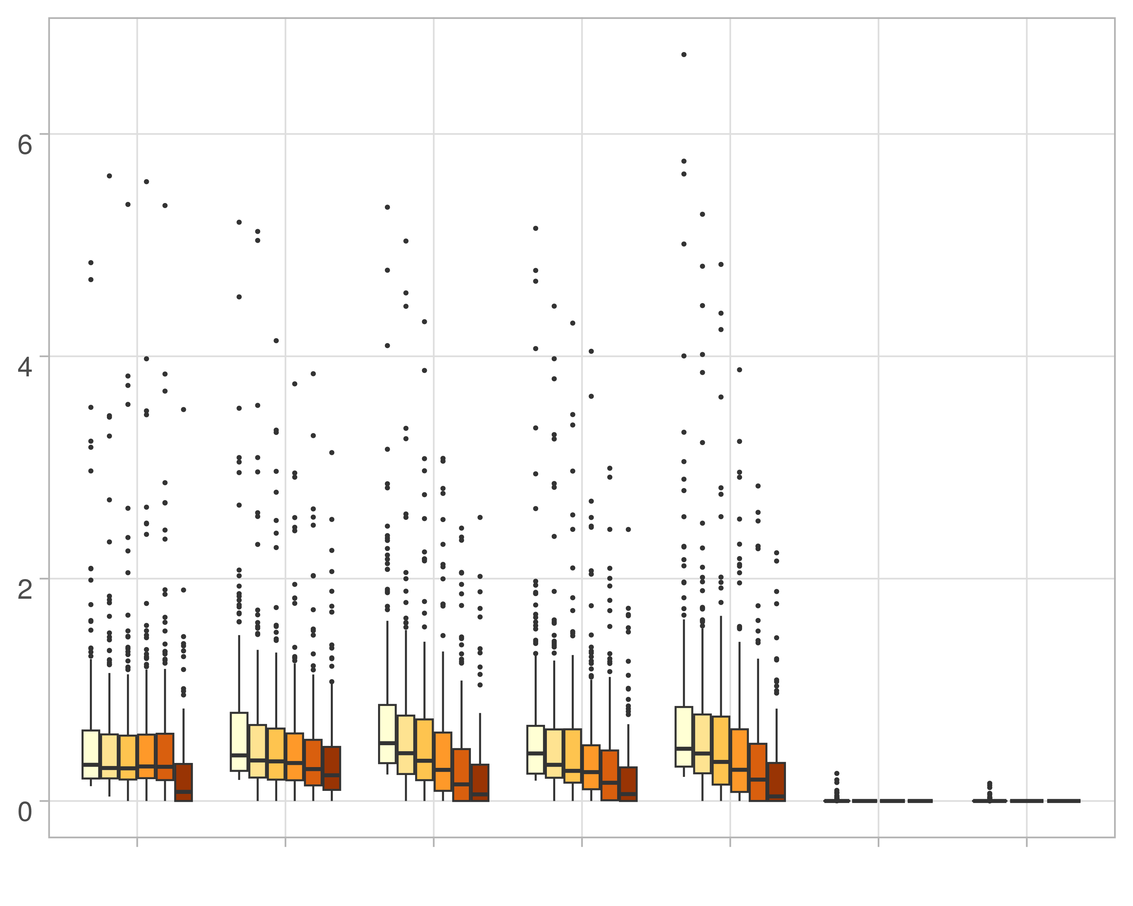

## Multi-omics

gg_dat <- overall[ exclude,]  
#ggplot(gg_dat, aes(x=variable, y=value,fill=method))+  
# scale_y_continuous(trans='sqrt') + geom_boxplot() + facet_grid(experiment~noise)  
  
gg_dat$method <- as.factor(gg_dat$method)  
gg_dat <- gg_dat %>% mutate(method = fct_relevel(method, "knn_kimono" , "galasso_false", "galasso_true" ,"salasso_false", "salasso_true" , "cocolasso" , "hmlasso" ))  
gg_dat$stripe <- as.numeric(gg_dat$method)  
  
my_grey <- t_col(color = "grey",percent = 90)  
  
palette_OkabeIto <- c( "#CC79A7", "#D55E00", "#E69F00","#0072B2", "#56B4E9", "#009E73", "#F0E442")  
  
levels(gg_dat$method) <- c( "knn_KiMONo" , "GALasso" ,"GALasso\n (adaptive weights)", "SALasso", "SALasso \n(adaptive weights)", "CoCoLasso", "HMLasso")  
  
gg_dat <- gg_dat[gg_dat$experiment=='moran',]  
  
p <- ggplot(gg_dat, aes(x=method, y=value*100, fill=variable)) + geom_boxplot(lwd=0.3,outlier.size = 0.1) +  
   
 theme_light() +  
   
 scale_fill_brewer(palette="YlOrBr",   
 guide = guide_coloursteps(barwidth=3.5), name = "Missingness:") +  
 ylab("Betweeness") +  
 xlab("")+   
 theme(legend.position ="none",  
 panel.grid.minor = element_blank(),  
 axis.text.x = element_blank(),  
 axis.title.y=element_blank(),  
 axis.text.y = element_text( vjust = 1, hjust=1),  
 plot.background = element_rect(fill = "transparent",  
 colour = NA_character_),  
 panel.background = element_rect(fill = "transparent",  
 colour = NA_character_))   
  
p

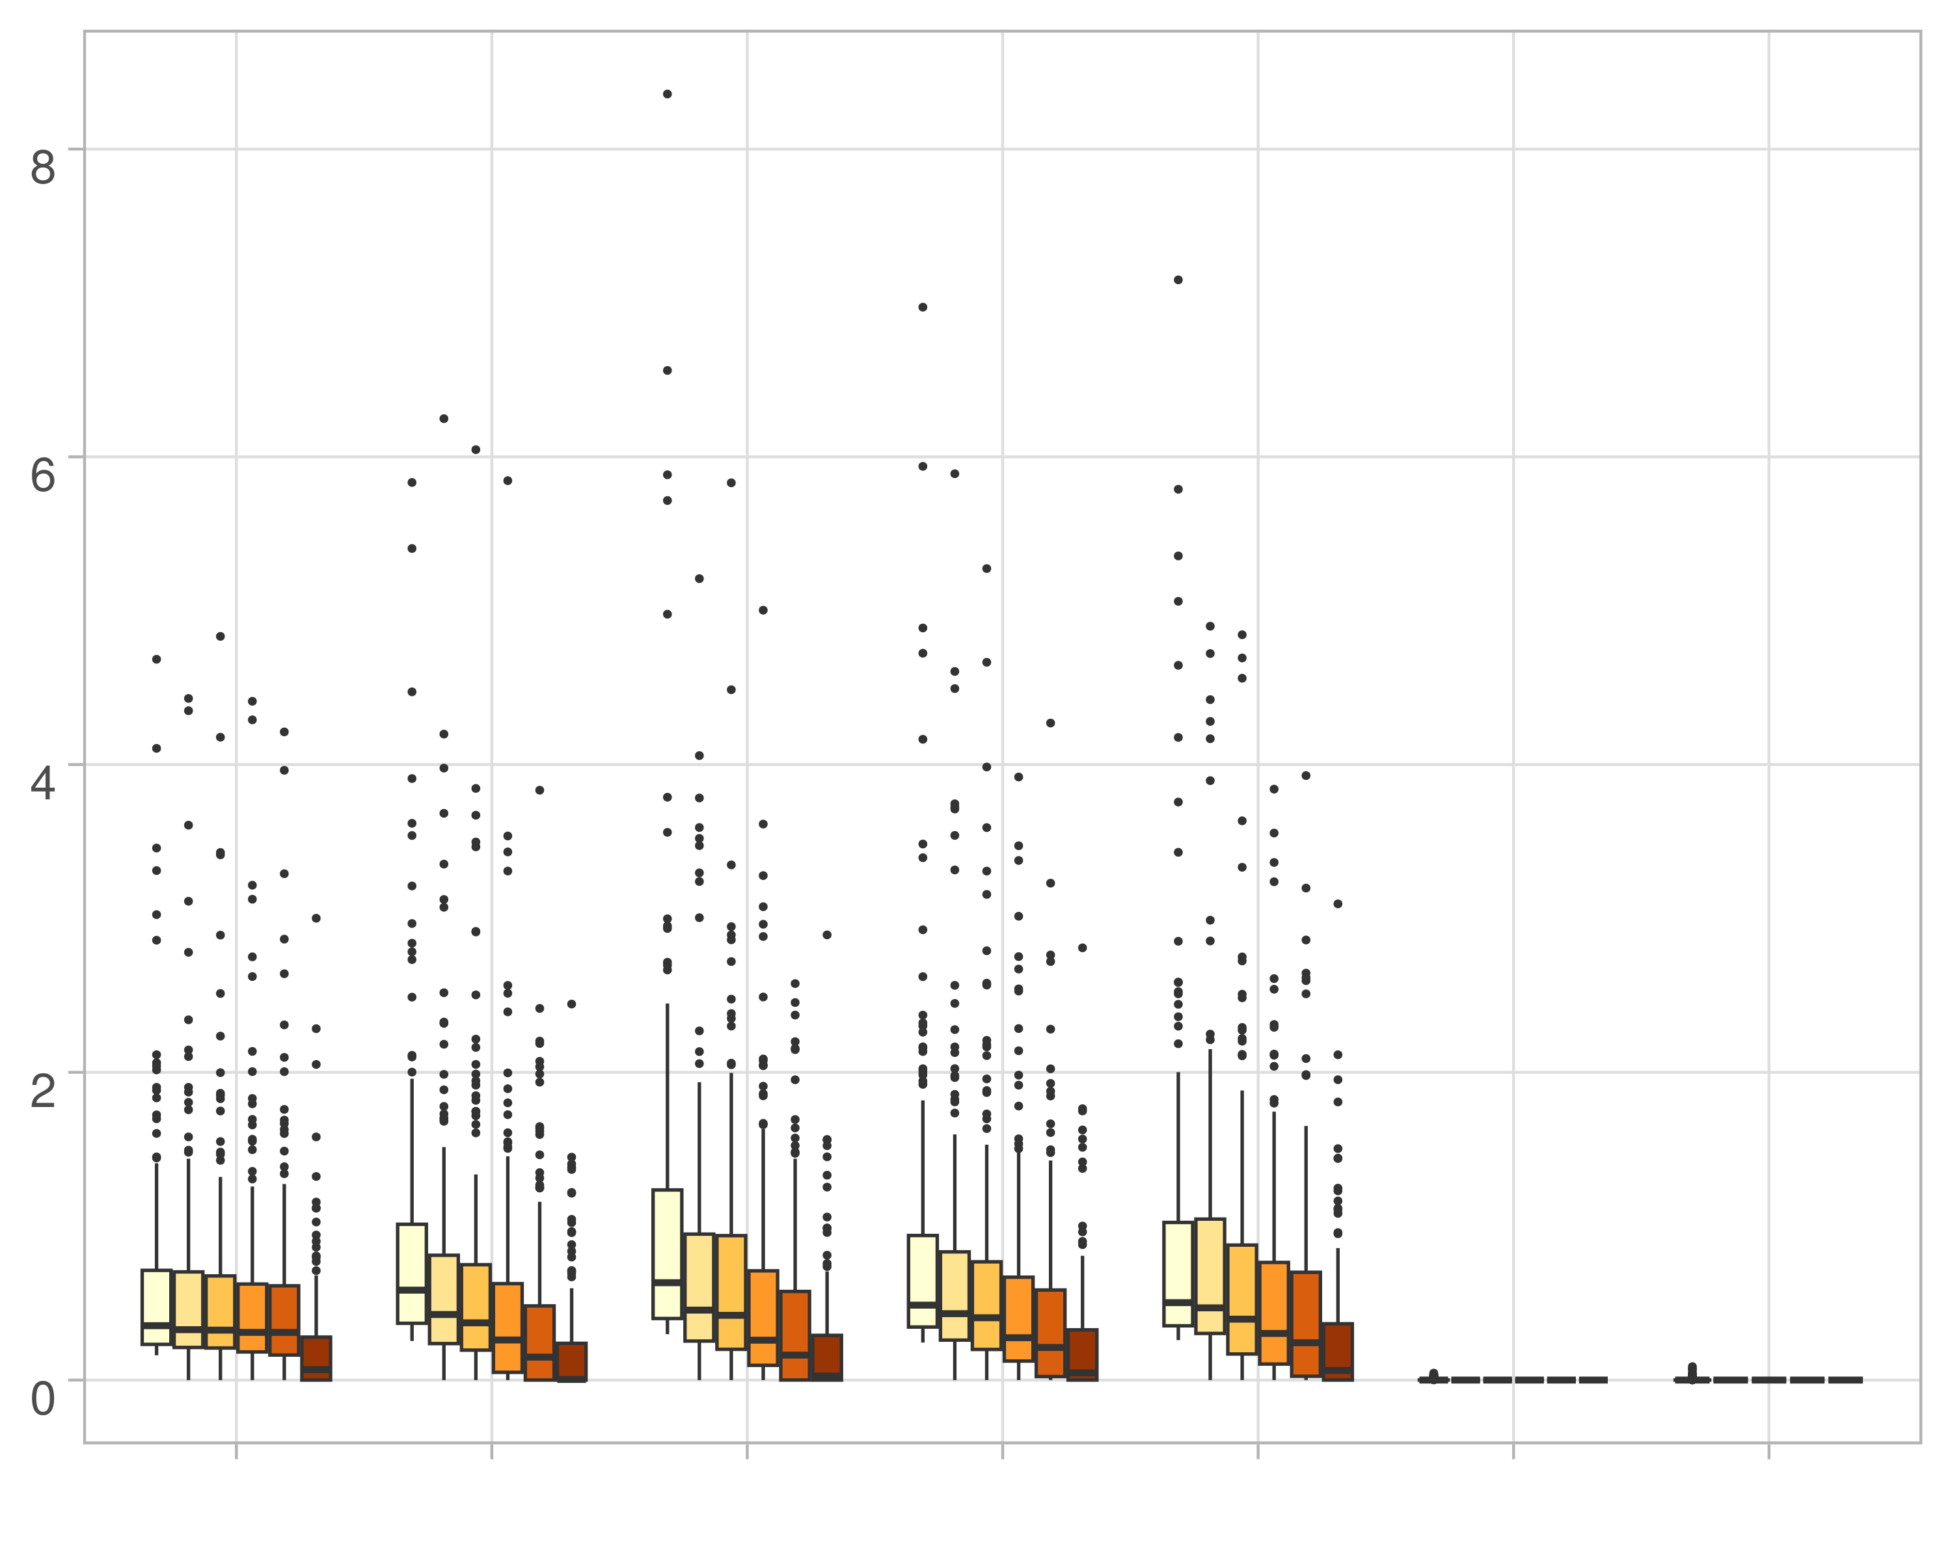

## Block-wise

gg_dat <- overall[ exclude,]  
#ggplot(gg_dat, aes(x=variable, y=value,fill=method))+  
# scale_y_continuous(trans='sqrt') + geom_boxplot() + facet_grid(experiment~noise)  
  
gg_dat$method <- as.factor(gg_dat$method)  
gg_dat <- gg_dat %>% mutate(method = fct_relevel(method, "knn_kimono" , "galasso_false", "galasso_true" ,"salasso_false", "salasso_true" , "cocolasso" , "hmlasso" ))  
gg_dat$stripe <- as.numeric(gg_dat$method)  
  
my_grey <- t_col(color = "grey",percent = 90)  
  
palette_OkabeIto <- c( "#CC79A7", "#D55E00", "#E69F00","#0072B2", "#56B4E9", "#009E73", "#F0E442")  
  
levels(gg_dat$method) <- c( "knn_KiMONo" , "GALasso" ,"GALasso\n (adaptive weights)", "SALasso", "SALasso \n(adaptive weights)", "CoCoLasso", "HMLasso")  
  
gg_dat <- gg_dat[gg_dat$experiment=='mos',]  
  
p <- ggplot(gg_dat, aes(x=method, y=value*100, fill=variable)) + geom_boxplot(lwd=0.3,outlier.size = 0.1) +  
   
 theme_light() +  
 scale_fill_brewer(palette="YlOrBr",   
   
 guide = guide_coloursteps(barwidth=3.5), name = "Missingness:") +  
 ylab("Betweeness") +  
 xlab("")+   
 theme(legend.position ="none",  
 panel.grid.minor = element_blank(),  
 axis.text.x = element_blank(),  
 axis.title.y=element_blank(),  
 axis.text.y = element_text( vjust = 1, hjust=1),  
 plot.background = element_rect(fill = "transparent",  
 colour = NA_character_),  
 panel.background = element_rect(fill = "transparent",  
 colour = NA_character_))   
  
p

